Lesson 5 Practice Problems

  - Draw a line that you think is a good fit for this data. For this data, the inputs are the horizontal values, and the outputs are the vertical values.
  - 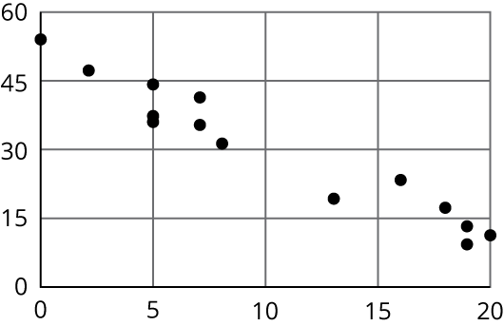
  - Use your line of fit to estimate what you would expect the output value to be when the input is 10.
- Here is a scatter plot that shows the most popular videos in a 10-year span.
- 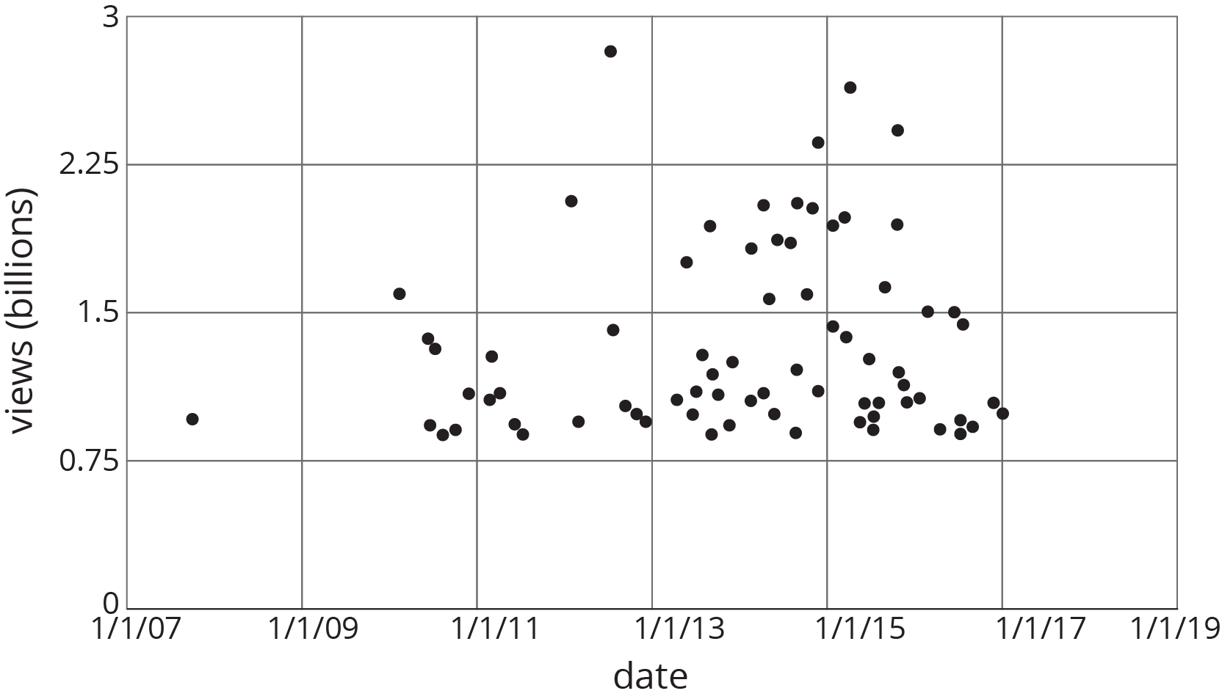
  - Use the scatter plot to estimate the number of views for the most popular video in this 10-year span.
  - Estimate when the 4th most popular video was released.
- (From Unit 6, Lesson 3.)
- A recipe for bread calls for 1 teaspoon of yeast for every 2 cups of flour.
  - Name two quantities in this situation that are in a functional relationship.
  - Write an equation that represents the function.
  - Draw the graph of the function. Label at least two points with input-output pairs.
- (From Unit 5, Lesson 8.)
© CC BY Open Up Resources. Adaptations CC BY IM.

