Unit 1 Lesson 11: Scales without Units

1 One to One Hundred (Warm up)

Student Task Statement
A map of a park says its scale is 1 to 100.
- What do you think that means?
- Give an example of how this scale could tell us about measurements in the park.

2 Apollo Lunar Module

Images for Launch
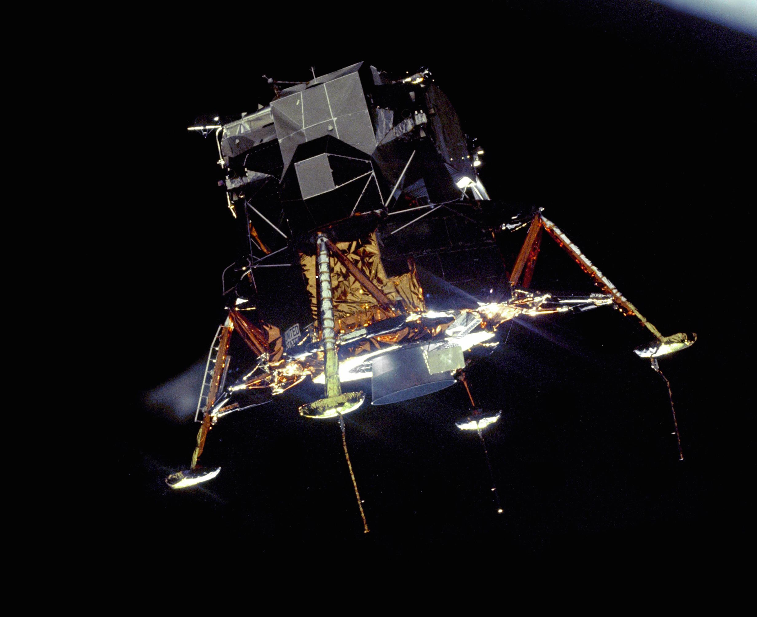

Student Task Statement
Your teacher will give you a drawing of the Apollo Lunar Module. It is drawn at a scale of 1 to 50.
- The “legs” of the spacecraft are its landing gear. Use the drawing to estimate the actual length of each leg on the sides. Write your answer to the nearest 10 centimeters. Explain or show your reasoning.
- Use the drawing to estimate the actual height of the Apollo Lunar Module to the nearest 10 centimeters. Explain or show your reasoning.
- Neil Armstrong was 71 inches tall when he went to the surface of the Moon in the Apollo Lunar Module. How tall would he be in the drawing if he were drawn with his height to scale? Show your reasoning.
- Sketch a stick figure to represent yourself standing next to the Apollo Lunar Module. Make sure the height of your stick figure is to scale. Show how you determined your height on the drawing.

Activity Synthesis
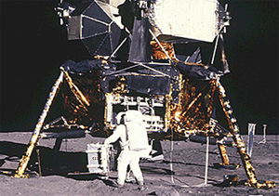

3 Same Drawing, Different Scales

Student Task Statement
A rectangular parking lot is 120 feet long and 75 feet wide.
- Lin made a scale drawing of the parking lot at a scale of 1 inch to 15 feet. The drawing she produced is 8 inches by 5 inches.
- Diego made another scale drawing of the parking lot at a scale of 1 to 180. The drawing he produced is also 8 inches by 5 inches.
- Explain or show how each scale would produce an 8 inch by 5 inch drawing.
- Make another scale drawing of the same parking lot at a scale of 1 inch to 20 feet. Be prepared to explain your reasoning.
- Express the scale of 1 inch to 20 feet as a scale without units. Explain your reasoning.
© CC BY Open Up Resources. Adaptations CC BY IM.

