Unit 7 Lesson 4: Solving for Unknown Angles

1 True or False: Length Relationships (Warm up)

Student Task Statement
Here are some line segments.
Decide if each of these equations is true or false. Be prepared to explain your reasoning.
$CD+BC=BD$
$AB+BD=CD+AD$
$AC−AB=AB$
$BD−CD=AC−AB$

2 Info Gap: Angle Finding

Student Task Statement
Your teacher will give you either a problem card or a data card. Do not show or read your card to your partner.
If your teacher gives you the problem card:
- Silently read your card and think about what information you need to be able to answer the question.
- Ask your partner for the specific information that you need.
- Explain how you are using the information to solve the problem.
- Continue to ask questions until you have enough information to solve the problem.
- Share the problem card and solve the problem independently.
- Read the data card and discuss your reasoning.
If your teacher gives you the data card:
- Silently read your card.
- Ask your partner “What specific information do you need?” and wait for them to ask for information.
- If your partner asks for information that is not on the card, do not do the calculations for them. Tell them you don’t have that information.
- Before sharing the information, ask “Why do you need that information?” Listen to your partner’s reasoning and ask clarifying questions.
- Read the problem card and solve the problem independently.
- Share the data card and discuss your reasoning.
Pause here so your teacher can review your work. Ask your teacher for a new set of cards and repeat the activity, trading roles with your partner.

3 What’s the Match?

Student Task Statement
Match each figure to an equation that represents what is seen in the figure. For each match, explain how you know they are a match.
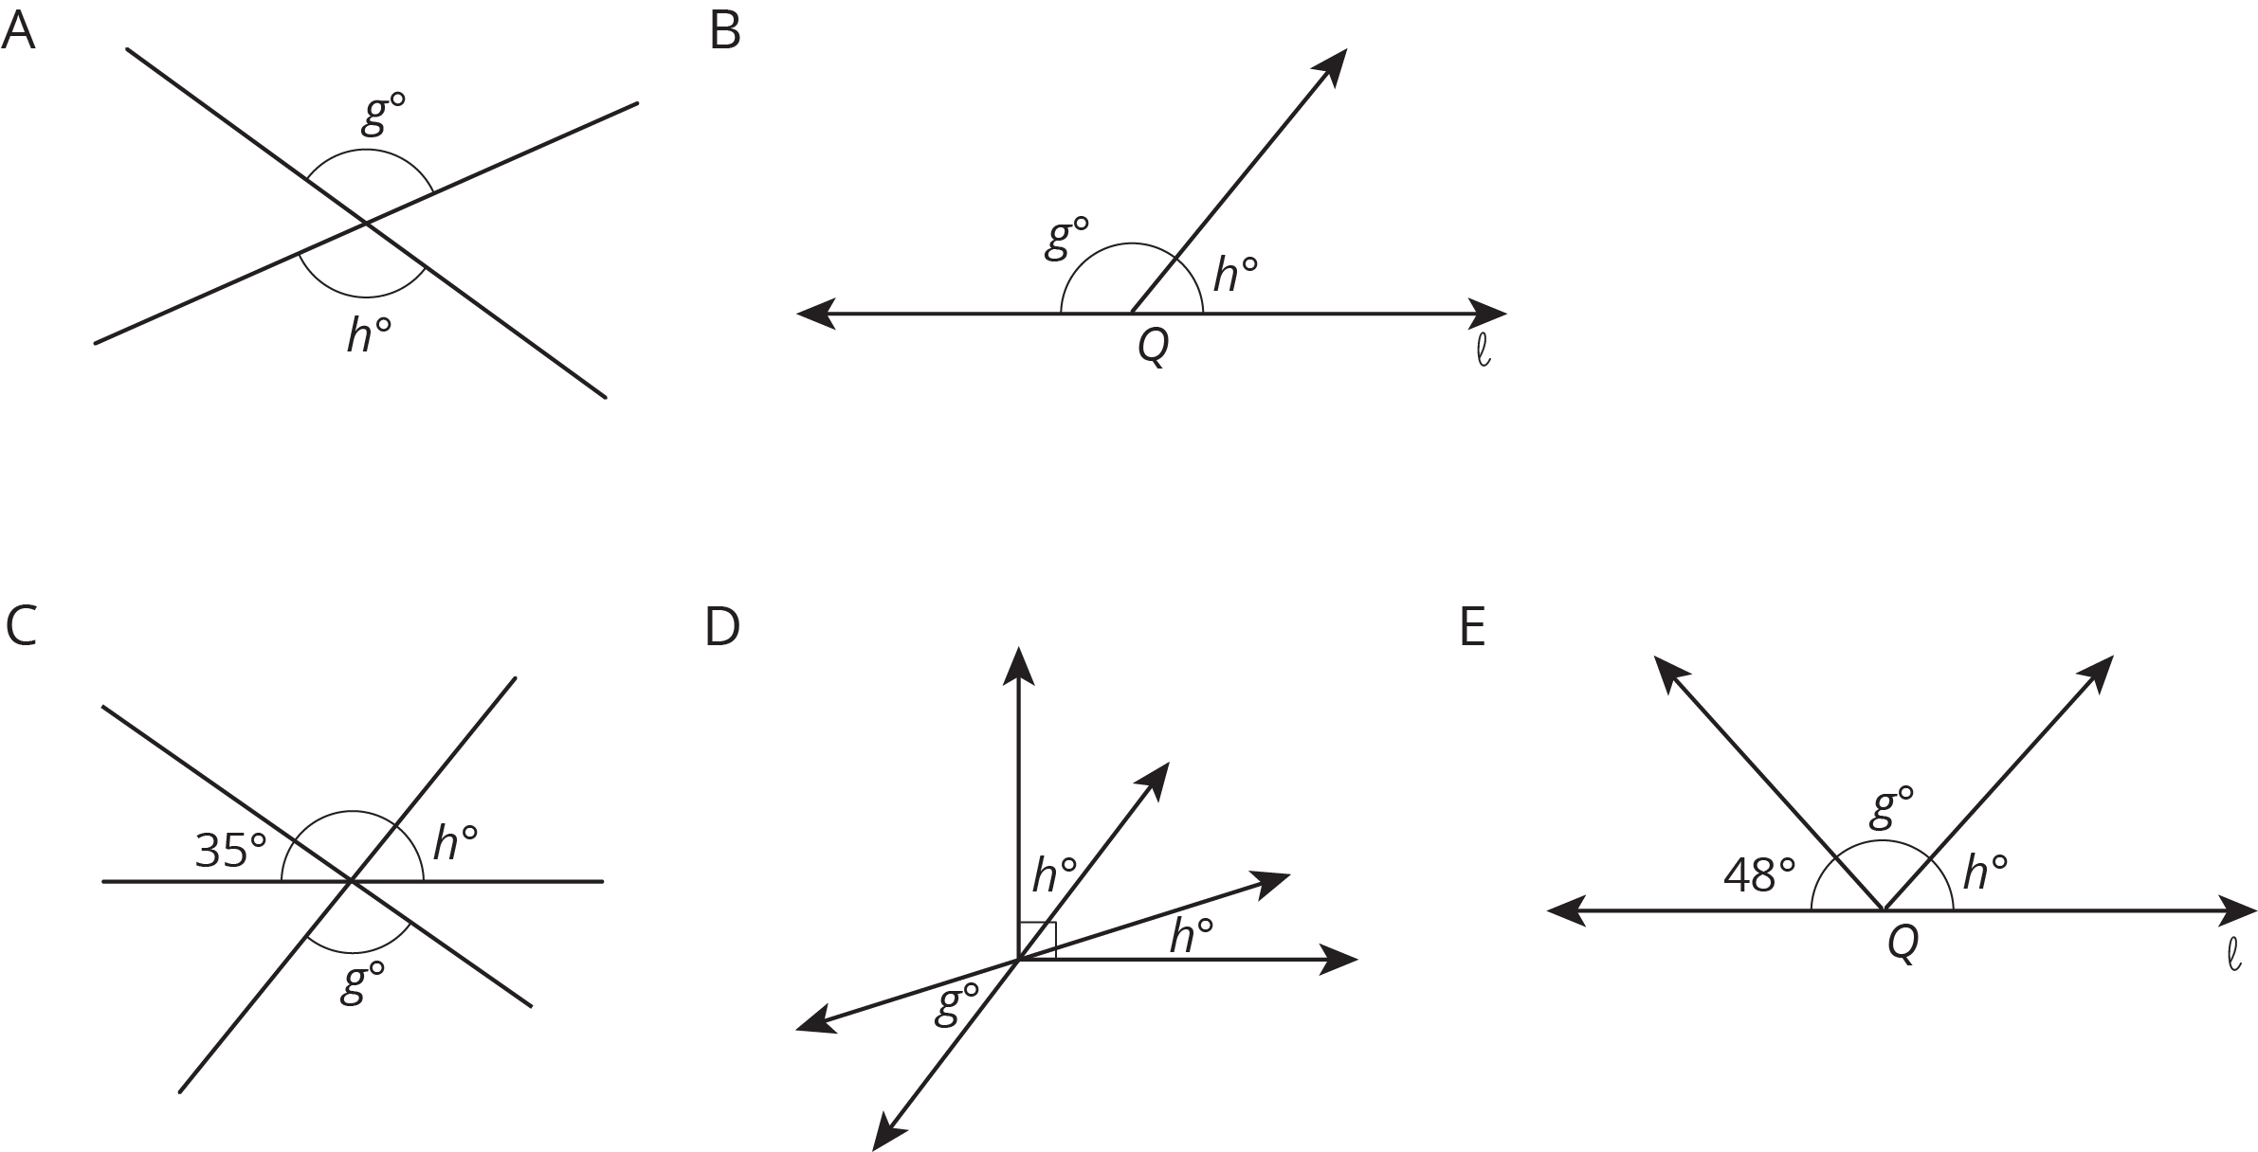

- $g+h=180$
- $g=h$
- $2h+g=90$
- $g+h+48=180$
- $g+h+35=180$

© CC BY Open Up Resources. Adaptations CC BY IM.

