Unit 6 Lesson 3: Types of Transformations

1 Why is it a Dilation? (Warm up)

Student Task Statement
Point $B$ was transformed using the coordinate rule $(x,y)→(3x,3y)$.
- Add these auxiliary points and lines to create 2 right triangles: Label the origin $P$. Plot points $M=(2,0)$ and $N=(6,0)$. Draw segments $PB^{′},MB,$ and $NB^{′}$.
- How do triangles $PMB$ and $PNB^{′}$ compare? How do you know?
- What must be true about the ratio $PB:PB^{′}$?

2 Congruent, Similar, Neither?

Student Task Statement
Match each image to its rule. Then, for each rule, decide whether it takes the original figure to a congruent figure, a similar figure, or neither. Explain or show your reasoning.

A
B

C

D
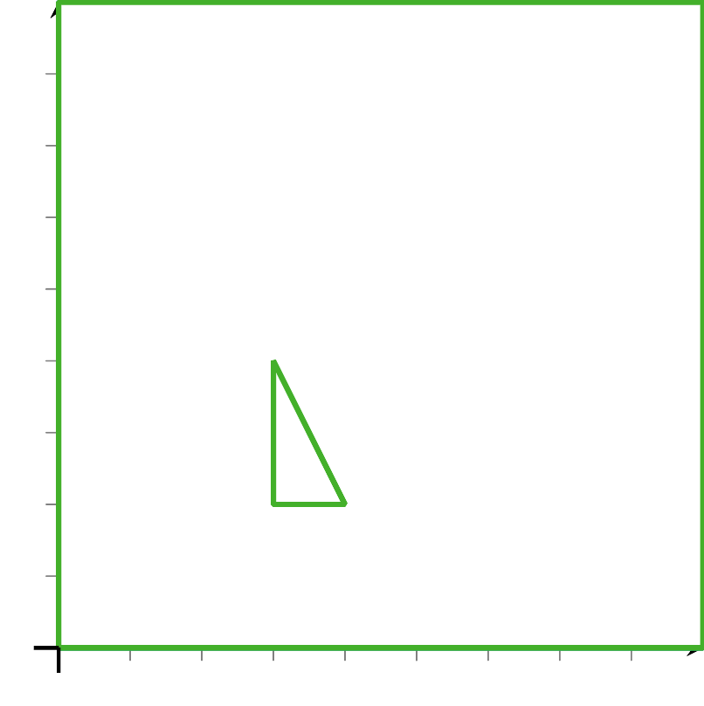
- $(x,y)→\left(\frac{x}{2},\frac{y}{2}\right)$
- $(x,y)→(y,\text{-}x)$
- $(x,y)→(\text{-}2x,y)$
- $(x,y)→(x−4,y−3)$

3 You Write the Rules

Student Task Statement
- Write a rule that will transform triangle $ABC$ to triangle $A^{′}B^{′}C^{′}$.
- Are $ABC$ and $A^{′}B^{′}C^{′}$ congruent? Similar? Neither? Explain how you know.
- Write a rule that will transform triangle $DEF$ to triangle $D^{′}E^{′}F^{′}$.
- Are $DEF$ and $D^{′}E^{′}F^{′}$ congruent? Similar? Neither? Explain how you know.
© CC BY 2019 by Illustrative Mathematics®

