Lesson 19: Compare Numbers and Images
- Let’s figure out which number is more.

Warm-up: Act It Out: Pass Out Snacks
Diego is passing out snacks to the students at his table.
He has 5 apples.
His teacher gives him 1 more apple.
How many apples does Diego have now?
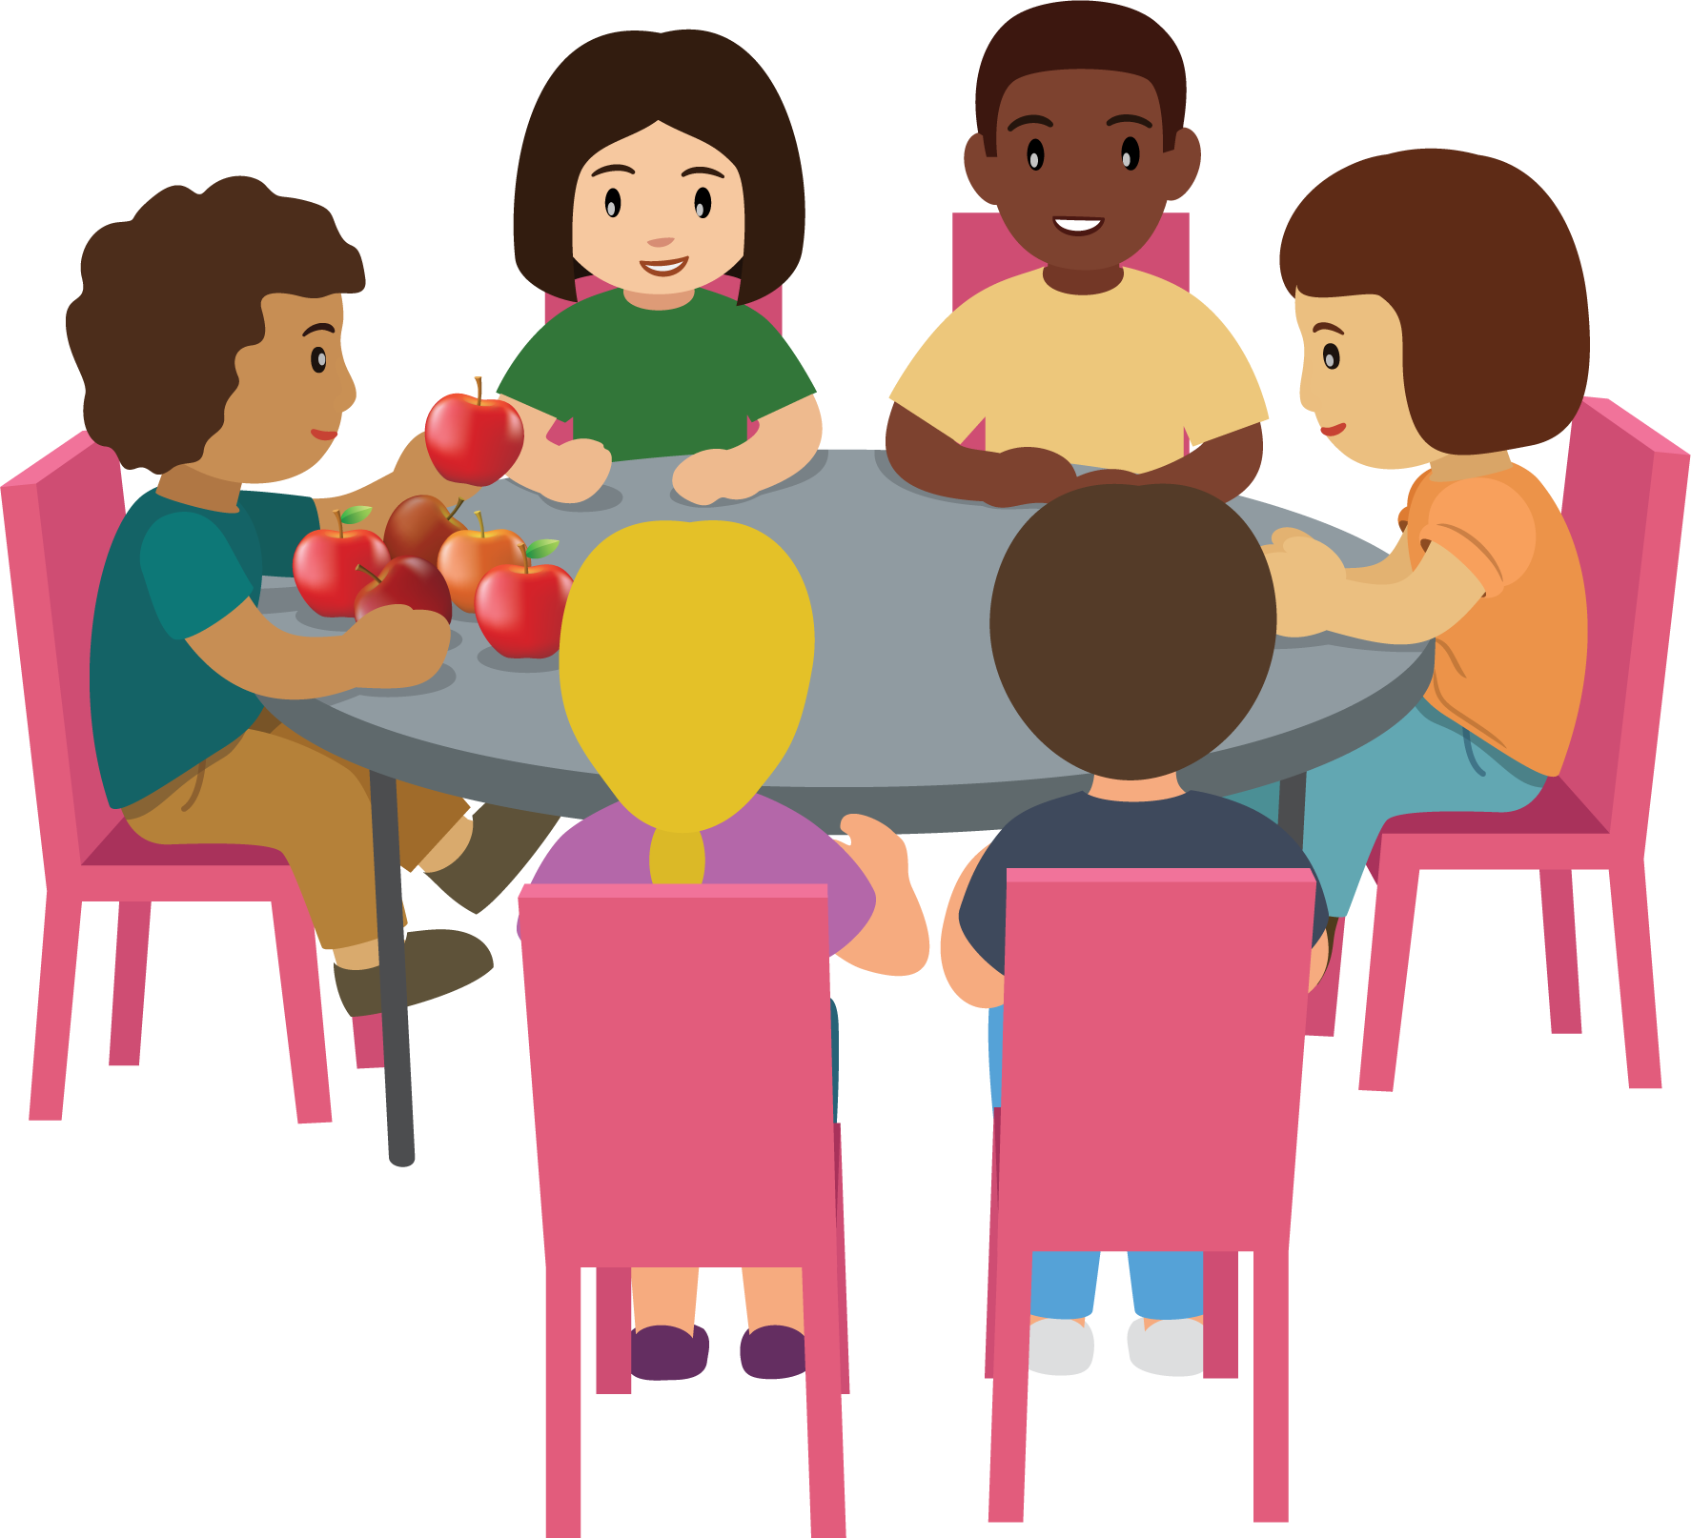

19.1: Which Has More?

- 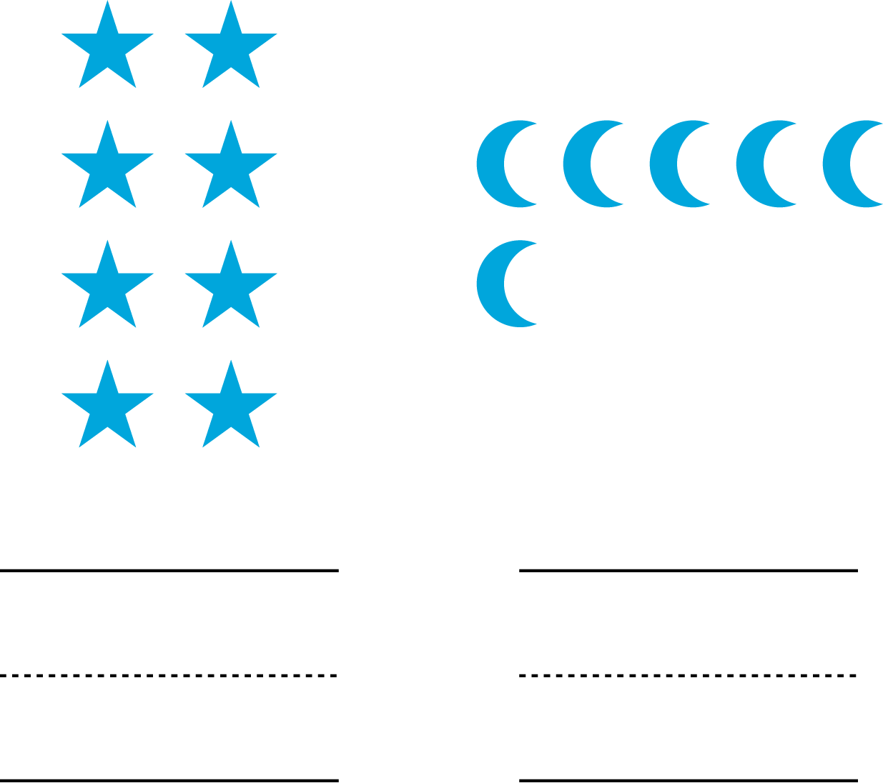

- 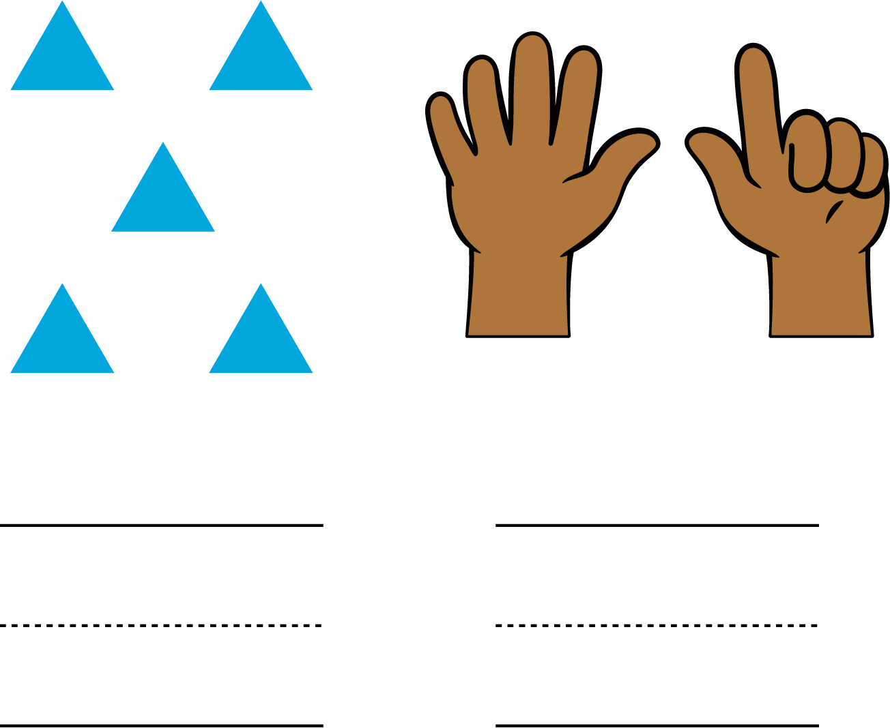

- 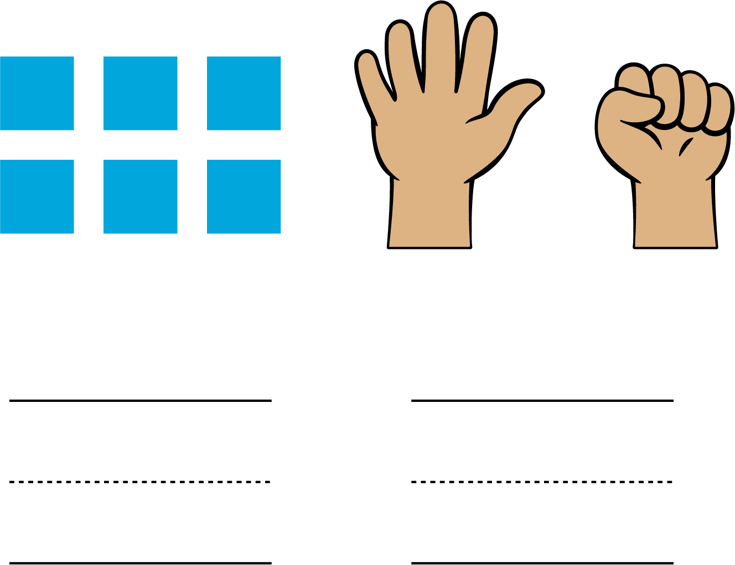

19.3: Centers: Choice Time
Choose a center.
Less, Same, More
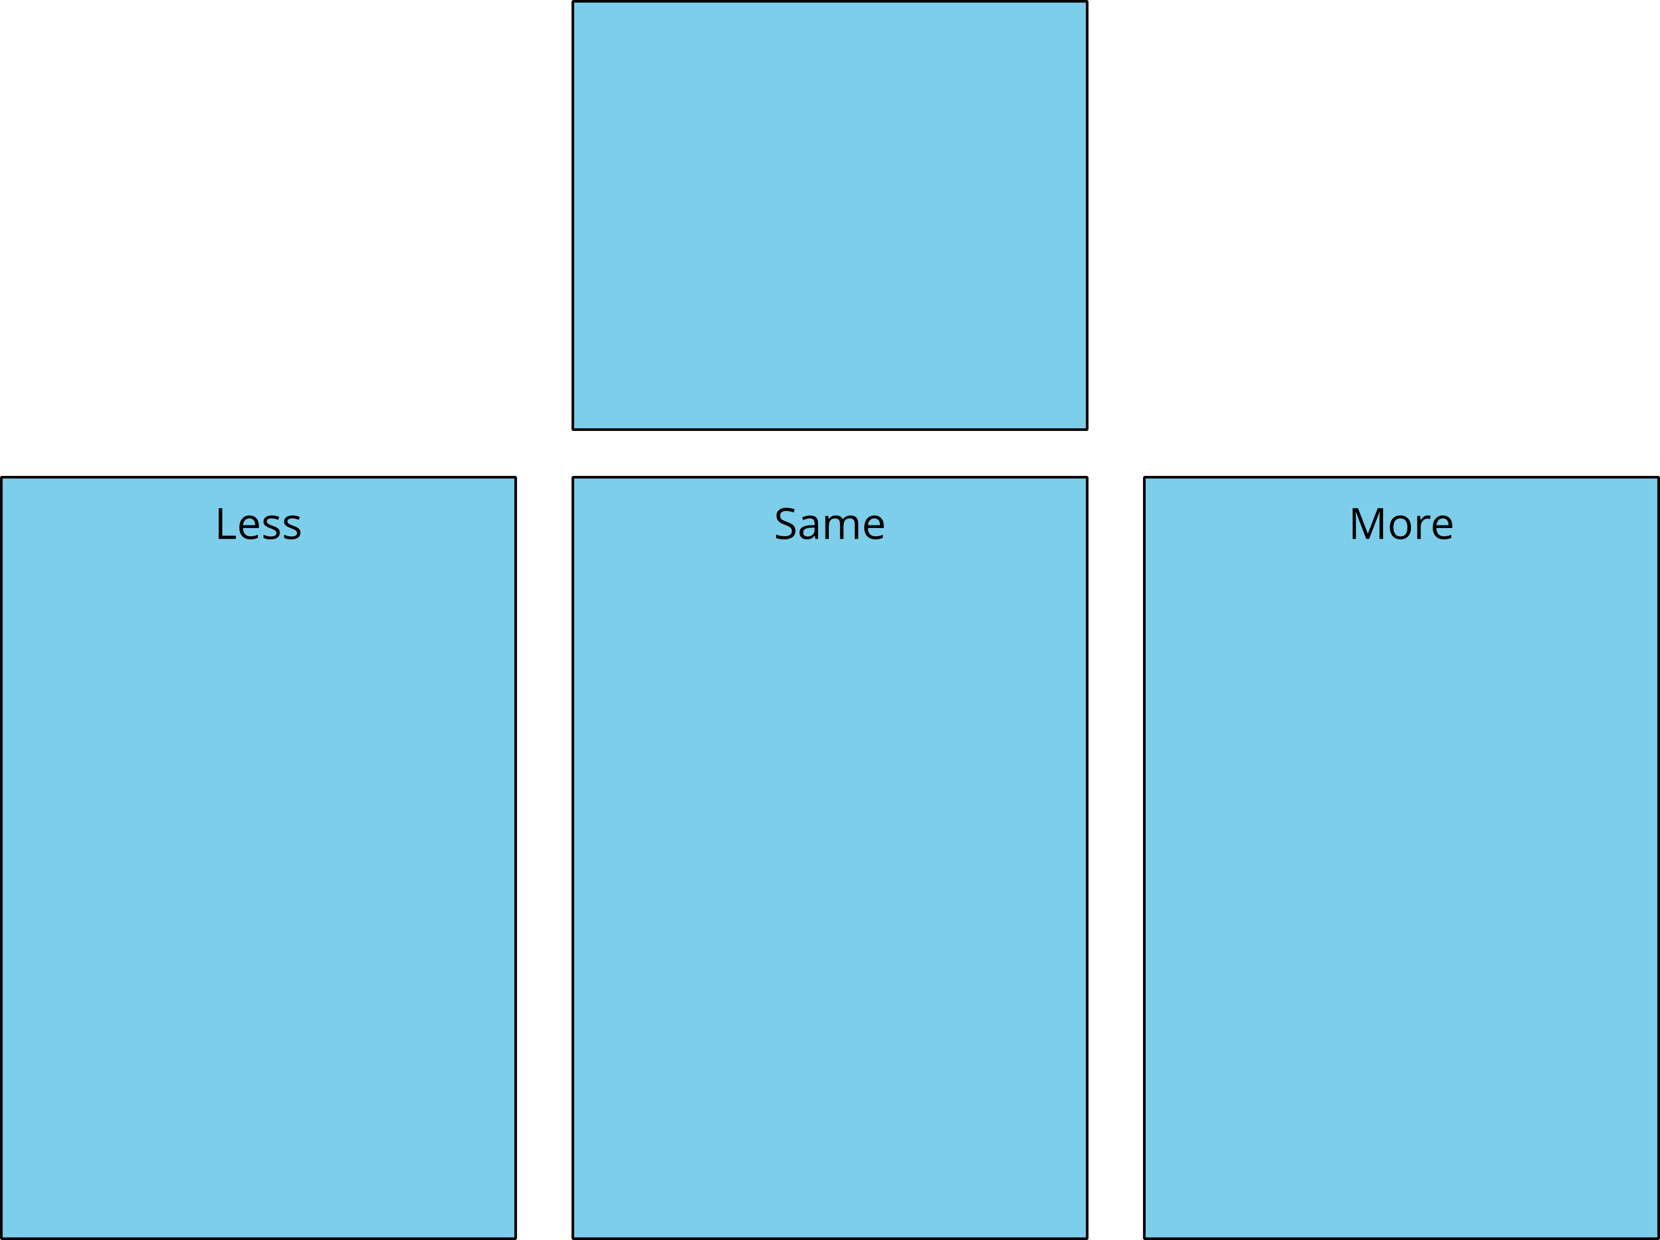
Math Libs
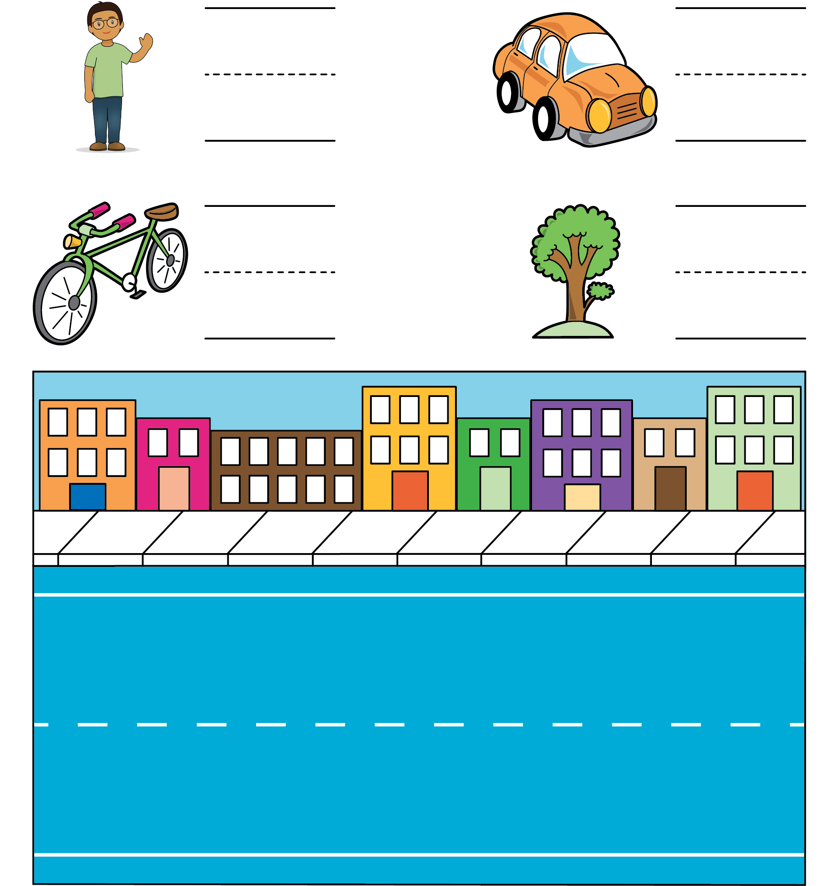
Number Race
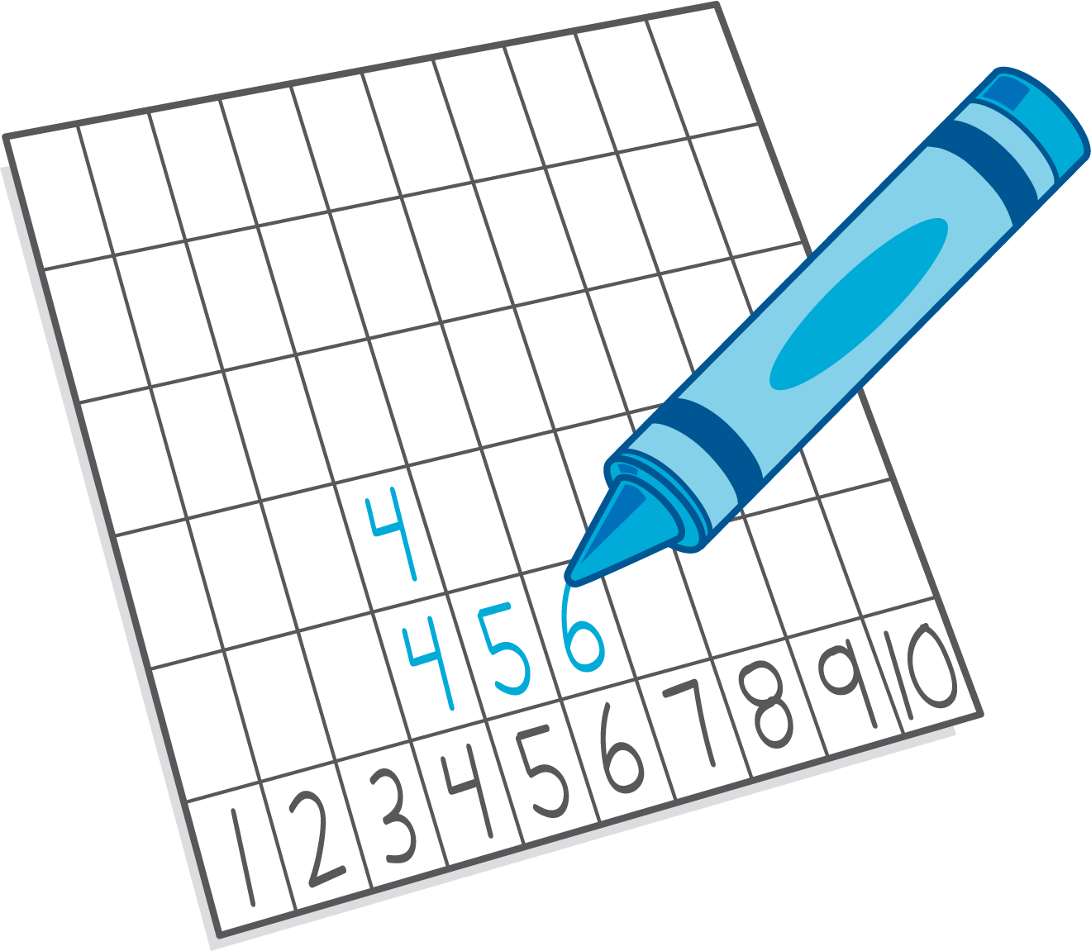
© CC BY 2021 Illustrative Mathematics®

