Unit 6 Lesson 13: Fingerprint Animals

WU How Many Do You See: Fingerprints or Animals? (Warm up)

Student Task Statement
How many do you see?
How do you see them?
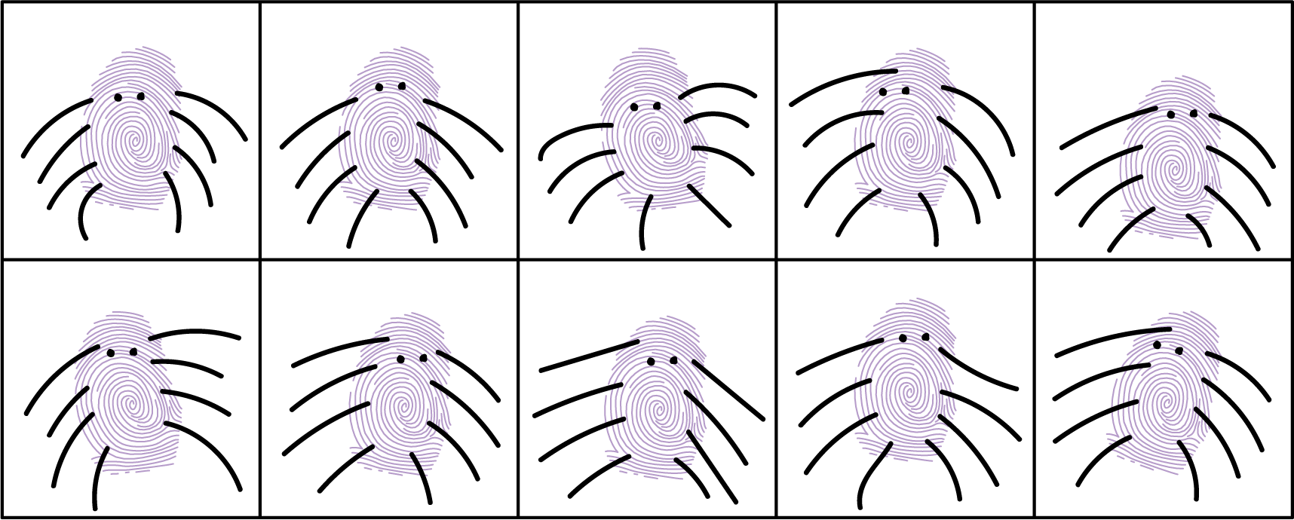

1 Fingerprint Zoo Book Pages

Student Task Statement
Let’s make pages for our book.
Student A: 11, 13, 18
Student B: 14, 16, 17
Student C: 12, 15, 19

2 Order Our Pages

Student Task Statement
© CC BY 2021 Illustrative Mathematics®

