Lesson 12 Practice Problems
- Write each expression in the form $a+bi$, where $a$ and $b$ are real numbers. You may plot the numbers in the complex plane as a guide.
  - $2⋅\sqrt{\text{-}4}$
  - $3i⋅2i$
  - $i^{4}$
  - $4−3\sqrt{\text{-}1}$
- 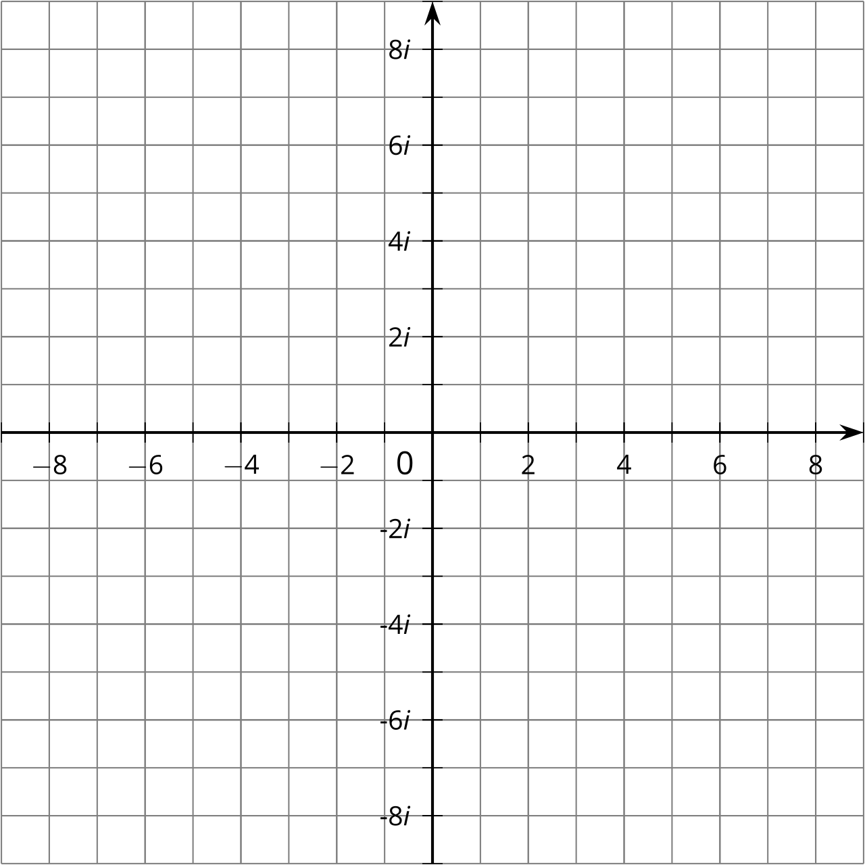
- Which expression is equivalent to $\left(3+9i\right)−\left(5−3i\right)$?
  - $\text{-}2−12i$
  - $\text{-}2+12i$
  - $15+27i$
  - $15−27i$
- What are $a$ and $b$ when you write $\sqrt{\text{-}16}$ in the form $a+bi$, where $a$ and $b$ are real numbers?
  - $a=0$, $b=\text{-}4$
  - $a=0$, $b=4$
  - $a=\text{-}4$, $b=0$
  - $a=4$, $b=0$
- Fill in the boxes to make a true statement:
30−3i−15+30i=7−12i
- Plot each number on the real number line, or explain why the number is not on the real number line.
  - $\sqrt{16}$
  - $\text{-}\sqrt{16}$
  - $\sqrt{\text{-}16}$
  - ${56}^{1/2}$
  - $\text{-}{56}^{1/2}$
  - ${\left(\text{-}56\right)}^{1/2}$
- (From Unit 3, Lesson 10.)
- Which expression is equivalent to $\sqrt{\text{-}4}$?
  - $\text{-}2i$
  - $\text{-}4i$
  - $2i$
  - $4i$
- (From Unit 3, Lesson 11.)
© CC BY 2019 by Illustrative Mathematics®

