Unit 7 Lesson 12: Estimating a Population Mean

1 Rolling Distribution (Warm up)

Student Task Statement
In the next activity, you will roll a standard number cube 35 times.
- Draw a dot plot that shows the distribution of values you might expect for the rolls. Explain your reasoning.
- 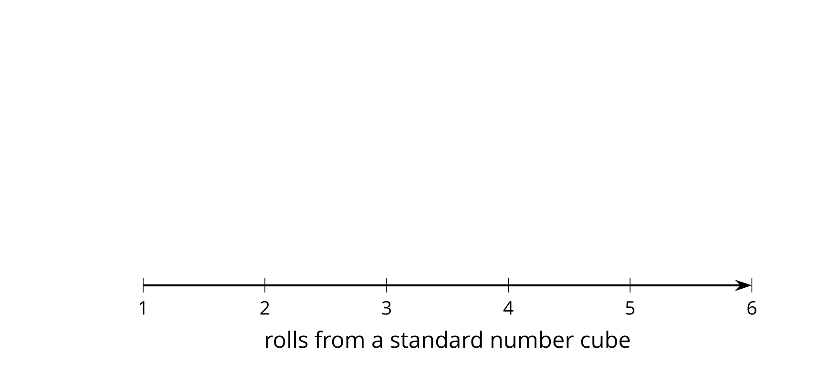
- If you rolled the number cube one million times and found the mean of all the values, what do you expect for the mean? Explain your reasoning.

2 Rolling for Means

Student Task Statement
Roll your number cube 35 times, recording the values as you do so.
- Every 5 values, find the mean.
- rolls | - 1 through 5 | - 6 through 10 | - 11 through 15 | - 16 through 20 | - 21 through 25 | - 26 through 30 | - 31 through 35
- mean
- Share your means with your group and create a dot plot of all the means from your group.
- 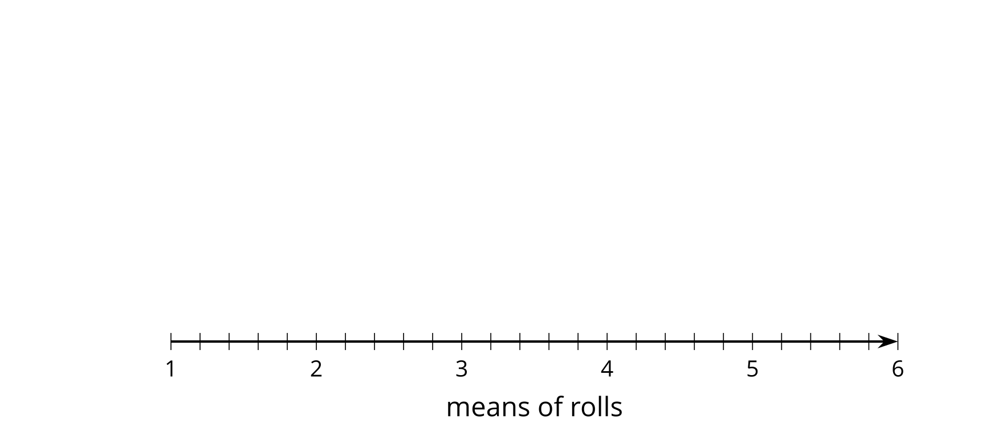
- What do you notice about the shape of the distribution of means?
- Using the dot plot of means, what do you think is a good estimate for the mean of all 140 rolls from your group? How does this value compare to your estimate from the warm-up?

3 Margin of Error for Means

Student Task Statement
As with the means of sample proportions, the means of sample means are usually within 2 standard deviations of the population mean when there is a large sample size or when the population distribution is approximately normal. For each situation:
- Use the sample means to estimate the mean of the population.
- Find the standard deviation of the sample means.
- Use the standard deviation of the sample means to estimate the margin of error.
- 10 samples of 25 gas stations are selected at random and the price of regular gasoline is recorded for each gas station. The sample means are shown for the 10 samples.
- $2.38 | - $2.42 | - $2.64 | - $2.35 | - $2.65 | - $2.47 | - $2.67 | - $2.59
- $2.63 | - $2.41

- The mean number of claimed UFO sightings are shown for 13 samples of 5 randomly selected months.
- 400.2 | - 427.4 | - 892.2 | - 640.6 | - 713.4 | - 614 | - 725.8 | - 477.2
- 460 | - 445.2 | - 476.8 | - 336.6 | - 536.4

- A company producing baseballs selects 10 baseballs at random 9 times a day and measures the diameter in centimeters. The mean of each of the 9 samples of 10 baseballs is shown.
- 7.5 | - 7.6 | - 7.2 | - 7.4 | - 7.2 | - 7.3 | - 7.5 | - 6.9
- 7.5

- A publisher takes 15 random samples of 10 people to determine the number of minutes they spend reading a newspaper. The sample mean is displayed for each of the samples.
- 11.1 | - 9.2 | - 8.1 | - 10.5 | - 10 | - 9.7 | - 7.7 | - 11.8
- 11.1 | - 7.6 | - 6.3 | - 9.4 | - 10.4 | - 8.7 | - 10.2

© CC BY 2019 by Illustrative Mathematics®

