Lesson 10 Practice Problems
- Select all the distribution shapes for which it is most often appropriate to use the mean.
  - bell-shaped
  - bimodal
  - skewed
  - symmetric
  - uniform
- For which distribution shape is it usually appropriate to use the median when summarizing the data?
  - bell-shaped
  - skewed
  - symmetric
  - uniform
- The number of writing instruments in some teachers' desks is displayed in the dot plot. Which is greater, the mean or the median? Explain your reasoning using the shape of the distribution.
- 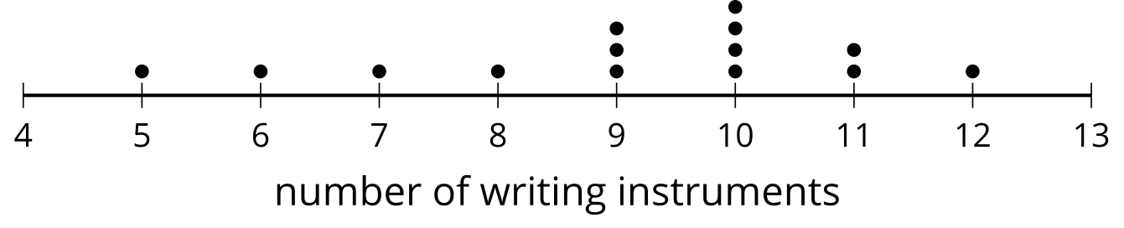
- A student has these scores on their assignments. The teacher is considering dropping a lowest score. What effect does eliminating the lowest value, 0, from the data set have on the mean and median?
- 0, 40, 60, 70, 75, 80, 85, 95, 95, 100
- (From Unit 1, Lesson 9.)

  - What is the five-number summary for the data 2, 2, 4, 4, 5, 5, 6, 7, 9, 15?
  - When the maximum, 15, is removed from the data set, what is the five-number summary?
- (From Unit 1, Lesson 9.)
- The box plot summarizes the test scores for 100 students:
- 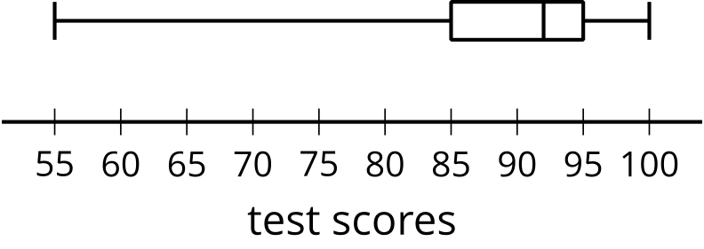
- Which term best describes the shape of the distribution?
  - bell-shaped
  - uniform
  - skewed
  - symmetric
- (From Unit 1, Lesson 4.)
- The histogram represents the distribution of lengths, in inches, of 25 catfish caught in a lake.
- 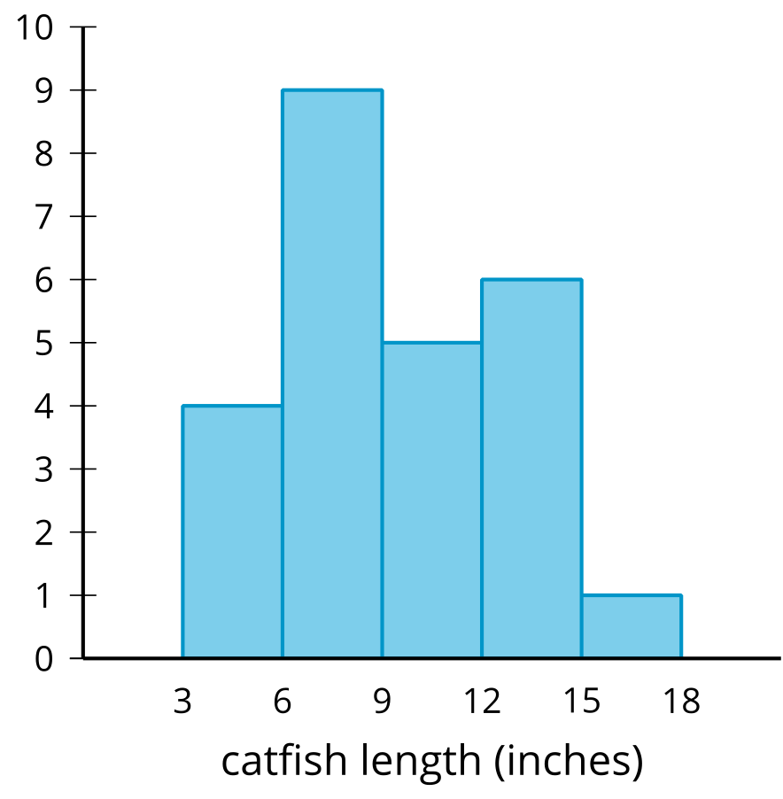
  - If possible, find the mean. If not possible, explain why not.
  - If possible, find the median. If not possible, explain why not.
  - Were any of the fish caught 12 inches long?
  - Were any of the fish caught 19 inches long?
- (From Unit 1, Lesson 2.)
© CC BY 2019 by Illustrative Mathematics®

