Lesson 1 Practice Problems
- Polygon $Q$ is a scaled copy of Polygon $P$.
- 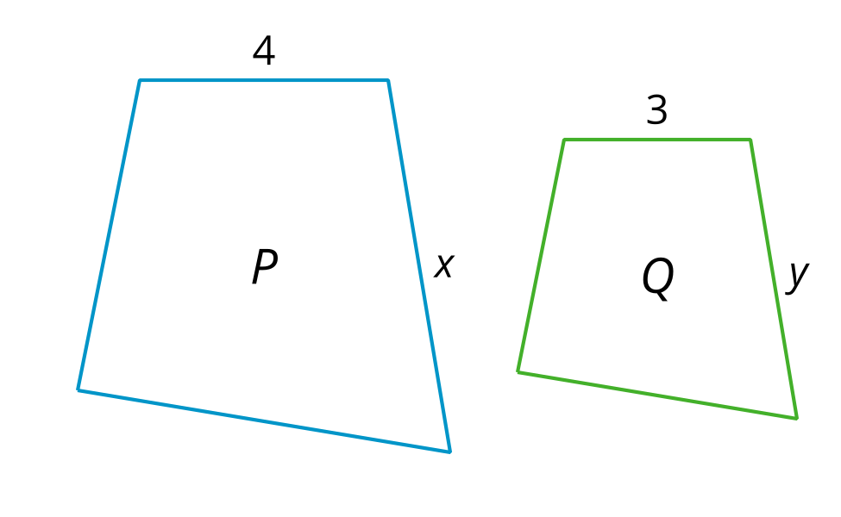
  - The value of $x$ is 6, what is the value of $y$?
  - What is the scale factor?
- Figure $f$ ​is a scaled copy of Figure $e$ .
- We know:
  - $AB=6$
  - $CD=3$
  - $XY=4$
  - $ZW=a$
- Select all true equations.
- 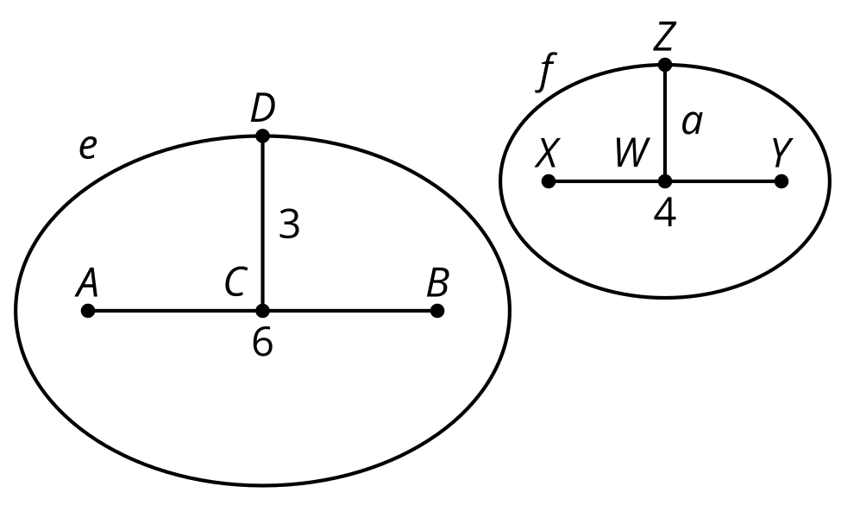
  - $\frac{6}{3}=\frac{4}{a}$
  - $\frac{6}{4}=\frac{3}{a}$
  - $\frac{3}{4}=\frac{6}{a}$
  - $\frac{6}{3}=\frac{a}{4}$
  - $\frac{6}{4}=\frac{a}{3}$
  - $\frac{3}{4}=\frac{a}{6}$
- Solve each equation.
  - $\frac{2}{5}=\frac{x}{15}$
  - $\frac{4}{3}=\frac{x}{7}$
  - $\frac{7}{5}=\frac{28}{x}$
  - $\frac{11}{4}=\frac{5}{x}$
- Select the shape that has 180 degree rotational symmetry.
  - Rhombus
  - Trapezoid
  - Isosceles trapezoid
  - Quadrilateral
- (From Unit 2, Lesson 14.)
- Name a quadrilateral in which the diagonal is also a line of symmetry. Explain how you know the diagonal is a line of symmetry.
- (From Unit 2, Lesson 14.)
- In isosceles triangle $DAC$, $AD$ is congruent to $AC$ and $AB$ is an angle bisector of angle $DAC$. How does Kiran know that $AB$ is a perpendicular bisector of segment $CD$?
- 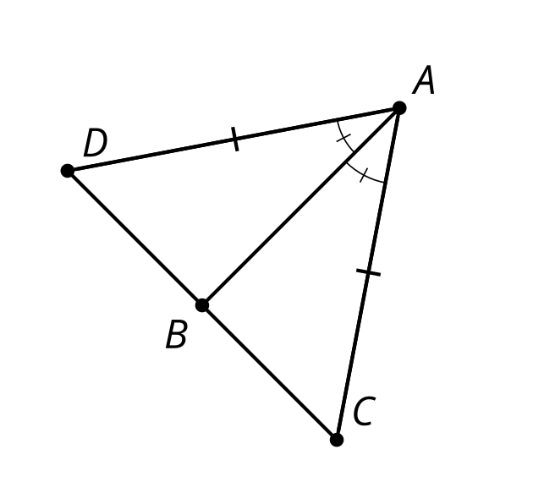
- (From Unit 2, Lesson 8.)
- In the figure shown, lines $f$ and $g$ are parallel. Select all angles that are congruent to angle 1.
- 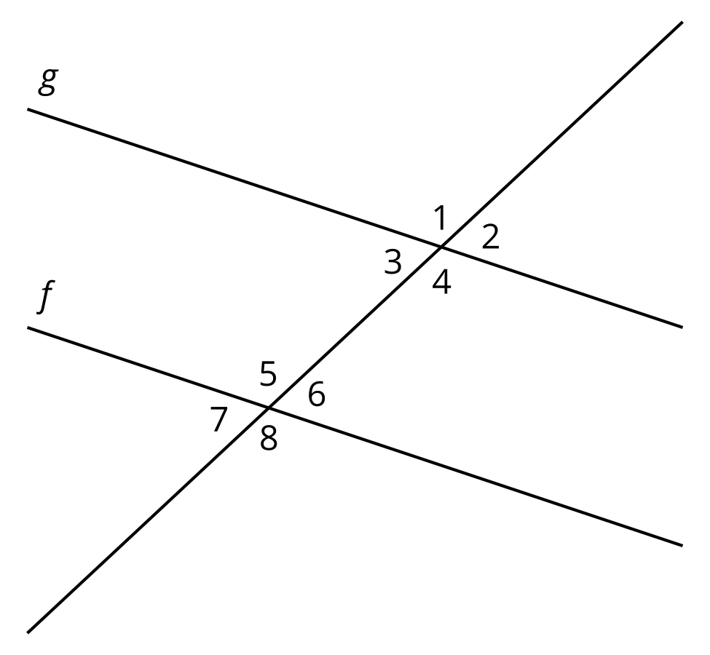
  - 1
  - 2
  - 3
  - 4
  - 5
  - 6
  - 7
  - 8
- (From Unit 1, Lesson 20.)
© CC BY 2019 by Illustrative Mathematics®

