Unit 4 Lesson 14: Practice an Algorithm Using Partial Quotients

WU Which One Doesn’t Belong: Different Ways (Warm up)

Student Task Statement
Which one doesn't belong?
A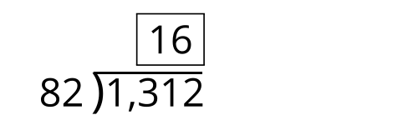
B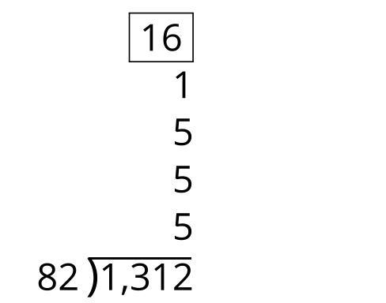
C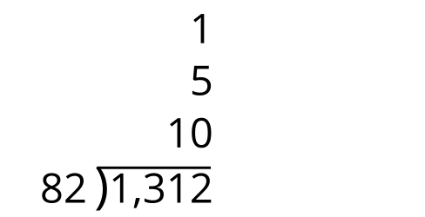
D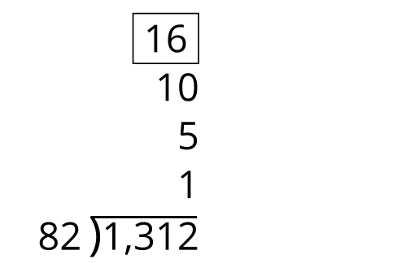

1 Find the Mistake

Student Task Statement
For each problem, describe where you see an error in the calculation. Then find the correct whole number quotient.
1.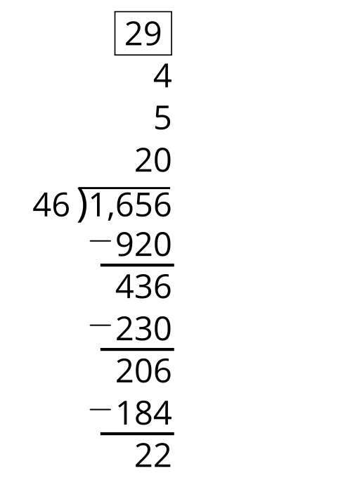
2.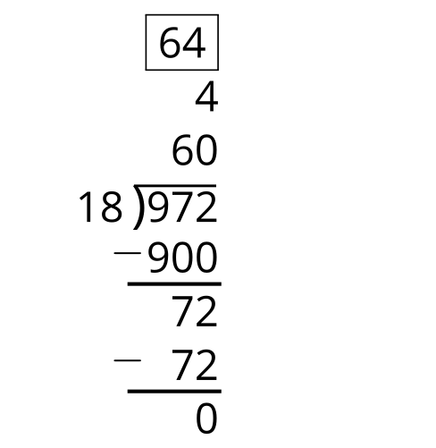
3.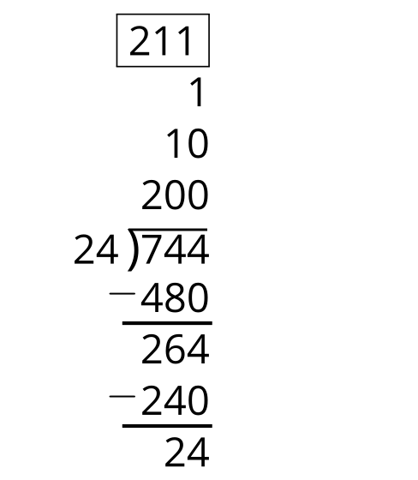

2 Practice Problems

Student Task Statement
Find the value of each expression. Then check in with a partner to review your work.
1.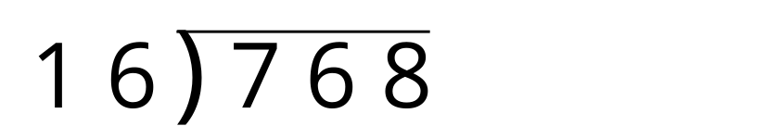

2.
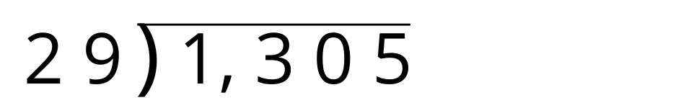
3.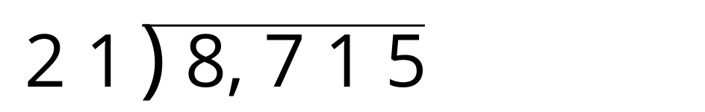
4.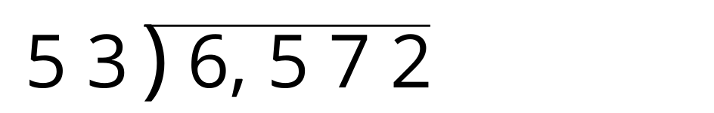
© CC BY 2021 Illustrative Mathematics®

