Lesson 6: Expressions for Volume

Standards Alignments
Addressing | 5.MD.C.5.a, 5.MD.C.5.b, 5.OA.A.1, 5.OA.A.2
Building Towards | 5.MD.C.5.b

Teacher-facing Learning Goals
- Find the volume of a right rectangular prism by multiplying the side lengths and connect that to finding volume by multiplying the area of the base by the height.
- Write and interpret numerical expressions in the context of the volume of a rectangular prism.

Student-facing Learning Goals
- Let’s write expressions for the volume of rectangular prisms.

Lesson Purpose
The purpose of this lesson is for students to use their understanding of the structure of rectangular prisms to find volume and write numerical expressions to represent volume.
In a previous lesson students learned to find the volume of a rectangular prism by multiplying the number of cubes in a base layer by the number of layers. They connected this understanding to multiplication of length, width and height to find volume. They also used a two-dimensional representation of a base and its corresponding height to find the volume of a rectangular prism.
In this lesson students write and interpret numerical expressions that represent the volume of rectangular prisms. Students use what they know about rectangular prisms to reason whether or not an expression represents its volume.
During the next lesson, students will describe which standard cubic unit they would use to measure the volume of objects that are shaped like rectangular prisms. Consider which objects students see on a regular basis in their communities that are shaped like rectangular prisms and bring picture of those objects to show students during the next lesson. If possible, consider going on a prism scavenger hunt around the community before the next lesson.
Math Community
Tell students they will reflect on their identified norms at the end of this lesson.

Access for:

Students with Disabilities
- Engagement (Activity 2)

English Learners
- MLR8 (Activity 1)

Instructional Routines
Card Sort (Activity 1), True or False (Warm-up)

Materials to Gather
- Connecting cubes: Activity 1

Materials to Copy
- Matching Prisms and Expressions (groups of 2): Activity 1

Lesson Timeline
Warm-up | 10 min
Activity 1 | 15 min
Activity 2 | 10 min
Activity 3 | 10 min
Lesson Synthesis | 10 min
Cool-down | 5 min

Teacher Reflection Question
As students matched expressions to images of prisms today, what evidence did you see that they are building on their understanding of the structure of rectangular prisms?

Cool-down
(to be completed at the end of the lesson) 5min
Choose the Expression

Student-facing Task Statement
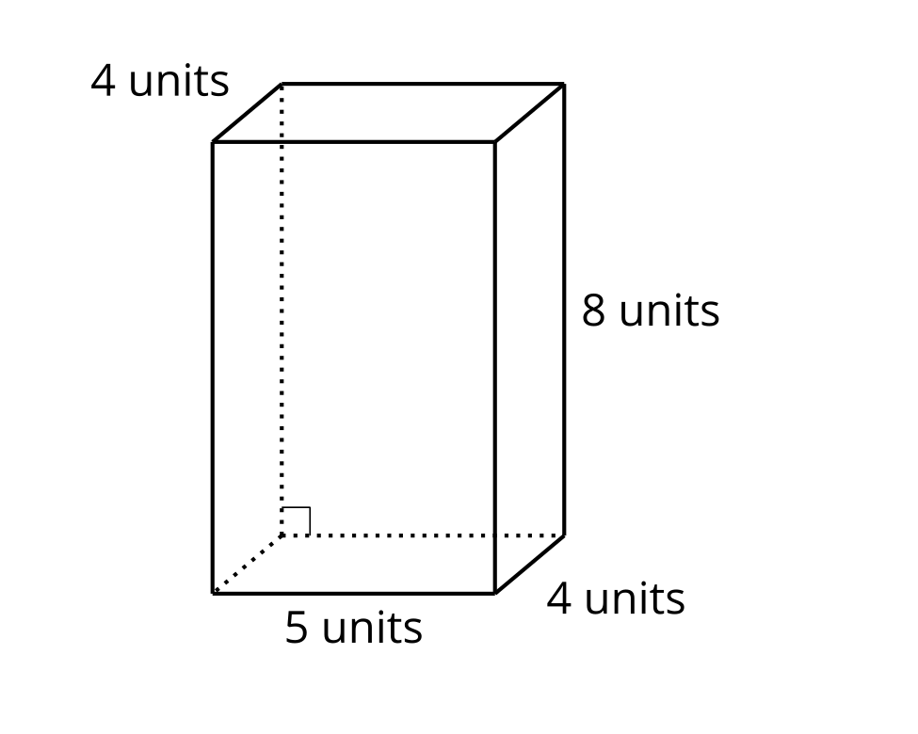
- Which of these expressions does not represent the volume of the rectangular prism in cubic units? Explain or show your reasoning.
- $4×5×8×4$
- $20×8$
- $\left(4×5\right)×8$
- $4×40$
- Choose one of the expressions from above and explain why it represents the volume of the prism in cubic units.

Student Responses
- $4×5×8×4$ because once you find the area of the base $\left(4×5\right)$, you only need to multiply it by the height, 8.
- Sample responses: $20×8$ because 20 represents the area of a base and 8 is the height of the prism with that base. $\left(4×5\right)×8$ because $4×5$ are the side lengths of a base and 8 is the height of the prism with that base. $4×40$ because 40 is the area of one of the bases and 4 is the height of the prism with that base.

