## Unit 2 Lesson 15: Off the Line

### 1 Estimation: Coin Weight (Warm up)

#### Student Task Statement

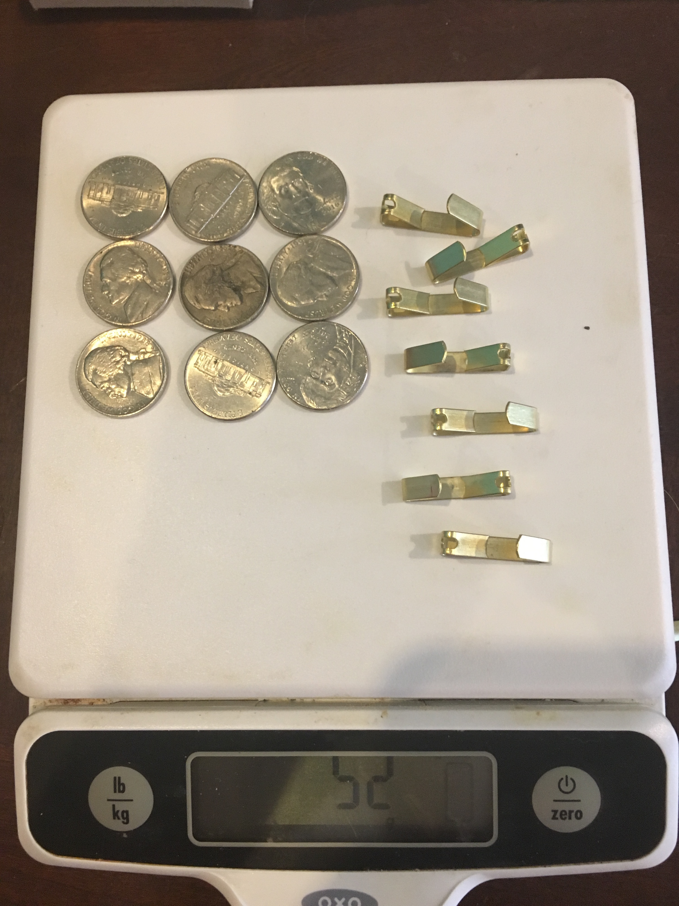

How much does a nickel weigh?

1. Record an estimate that is:

|  |  |  |
| --- | --- | --- |
| * too low | * about right | * too high |
|  |  |  |

1. Explain your reasoning.

### 2 Row Game: Equations

#### Student Task Statement

Work independently on your column. Partner A completes the questions in column A only and partner B completes the questions in column B only. Your answers in each row should match. Work on one row at a time and check if your answer matches your partner’s before moving on. If you don’t get the same answer, work together to find any mistakes.

Solve each equation.

|  |  |  |
| --- | --- | --- |
| **row** | column A | column B |
| **1** |  |  |
| **2** |  |  |
| **3** |  |  |
| **4** |  |  |
| **5** |  |  |
| **6** |  |  |

### 3 What Were They Thinking?

#### Student Task Statement

Read each student’s reasoning and answer the questions.

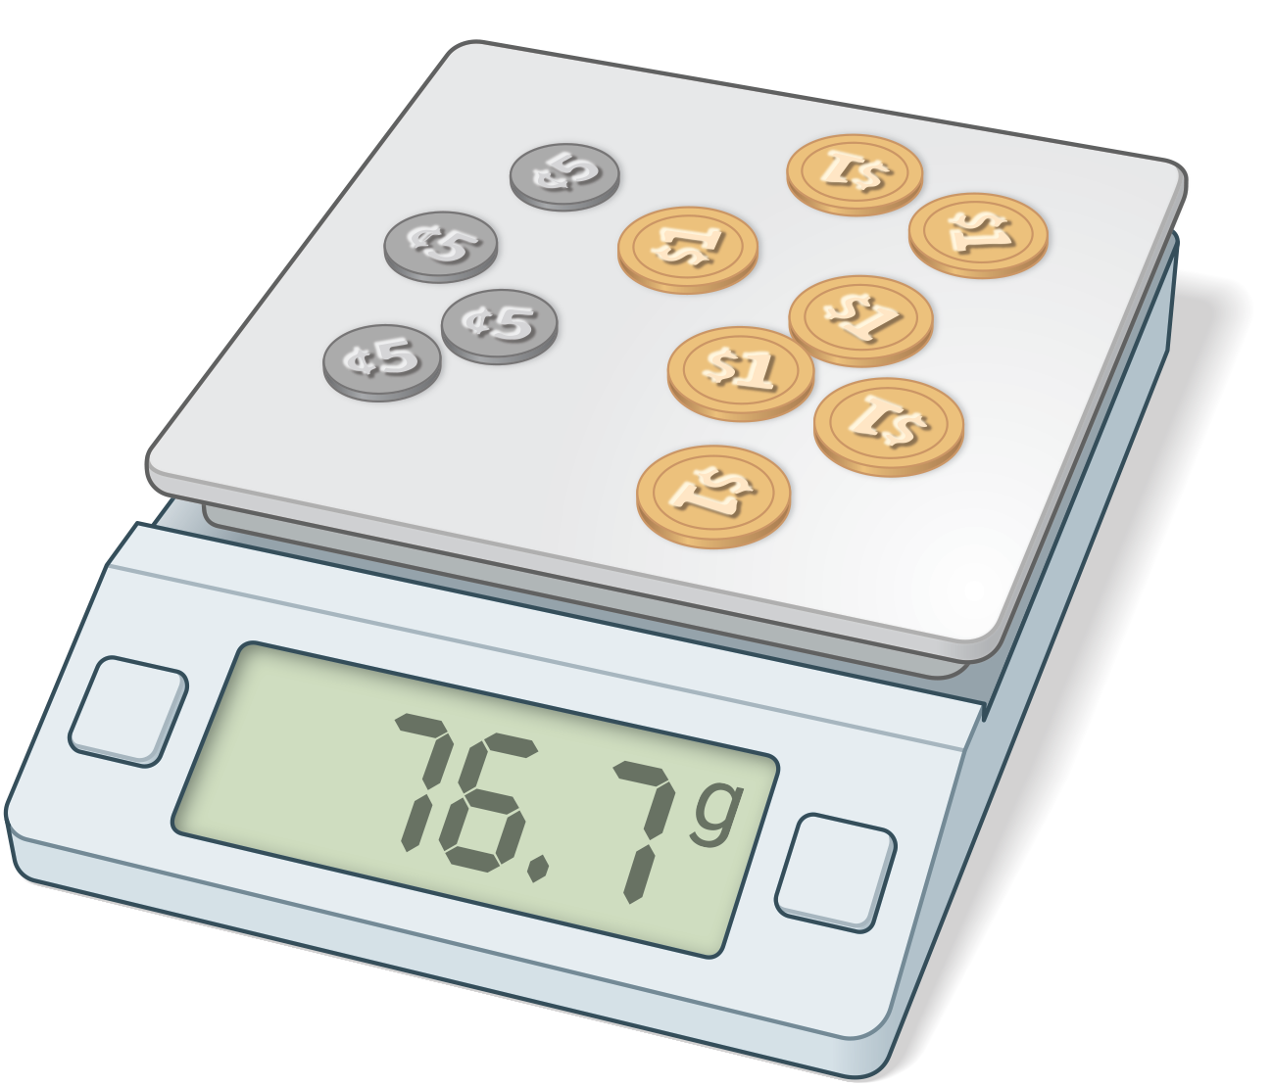

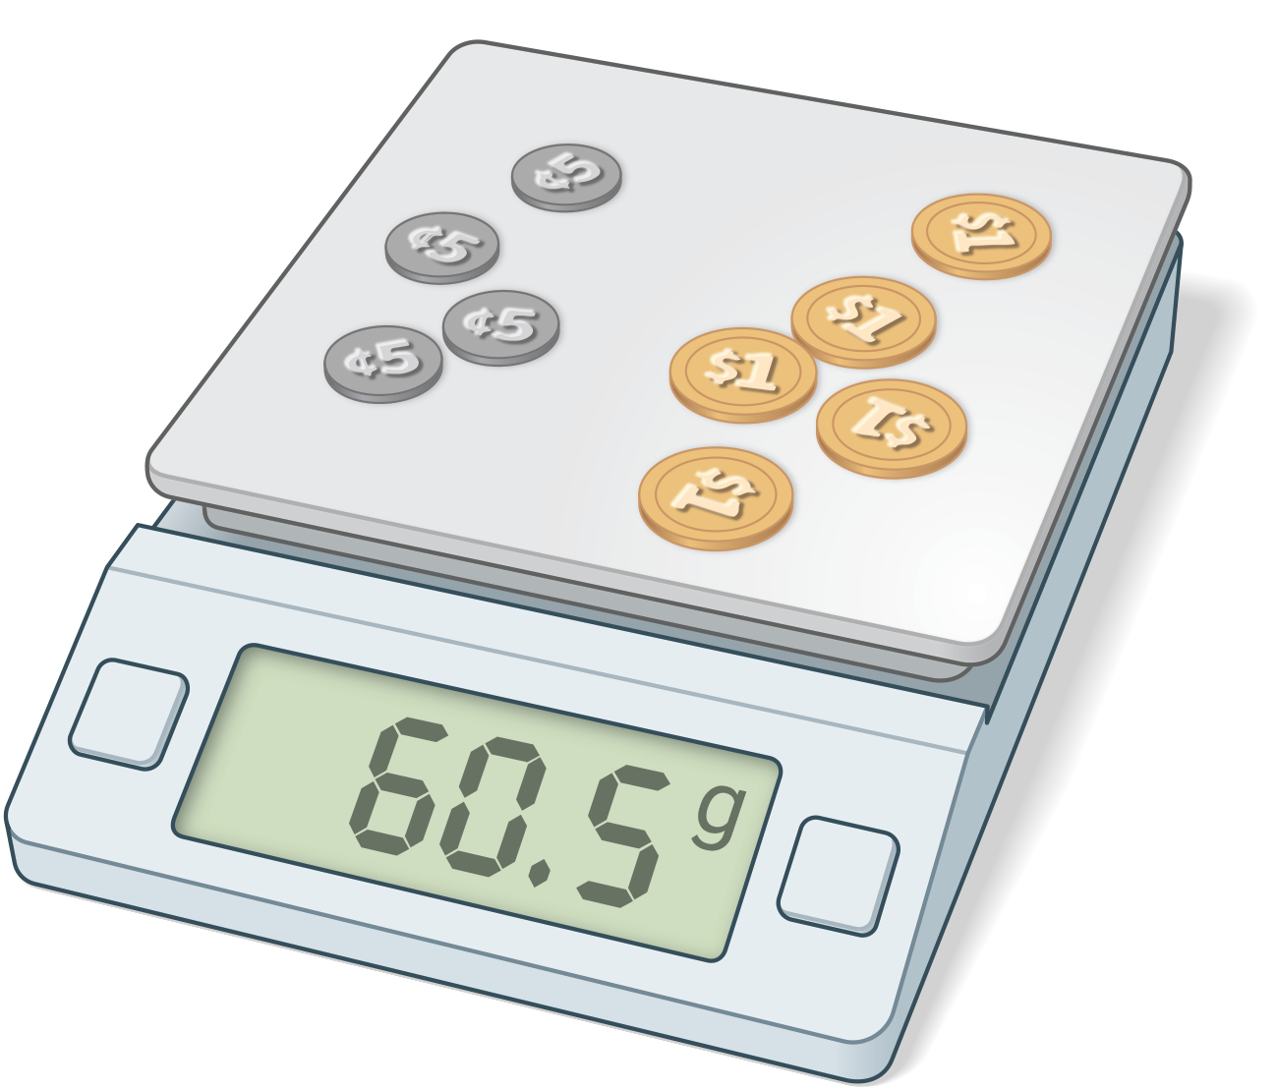

Jada says, “I know 4 nickels and 7 dollar coins weigh 76.7 grams. I know 4 nickels and 5 dollar coins weigh 60.5 grams. Here’s what else I can figure out based on that:

* 2 dollar coins weigh 16.2 grams.
* 1 dollar coin weighs 8.1 grams.
* 5 dollar coins weigh 40.5 grams.
* 4 nickels weigh 20 grams.
* 1 nickel weighs 5 grams.”

1. How did Jada figure out that 2 dollar coins weigh 16.2 grams?
2. Why might Jada have done that step first?
3. After Jada figured out how much 1 dollar coin weighed, why did she calculate how much 5 dollar coins weighed?
4. Once Jada knew how much 5 dollar coins weighed, how did she figure out how much 4 nickels weighed?

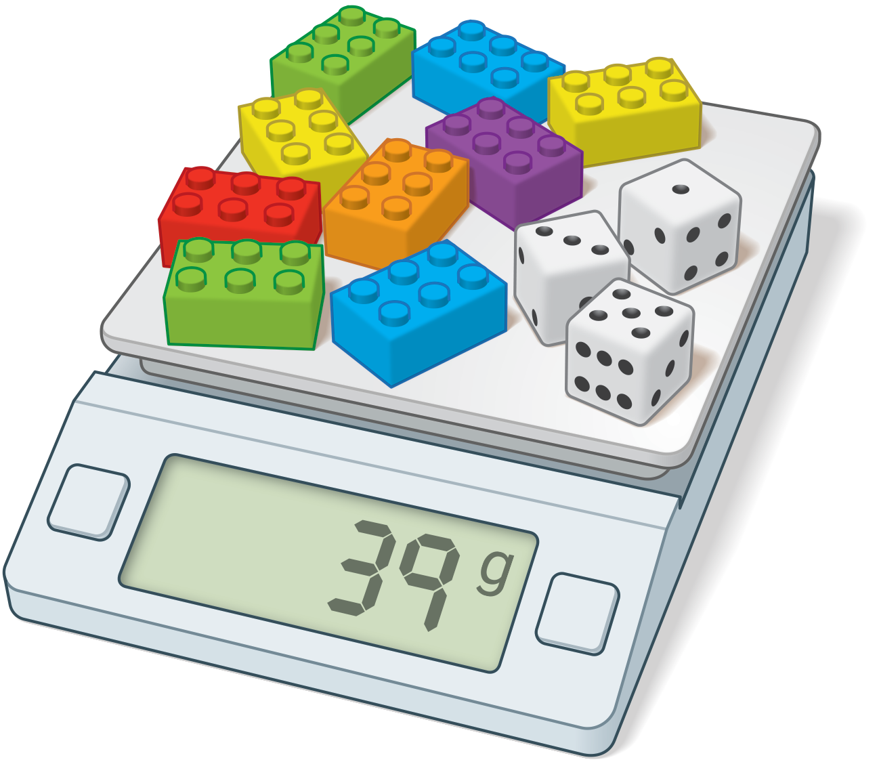

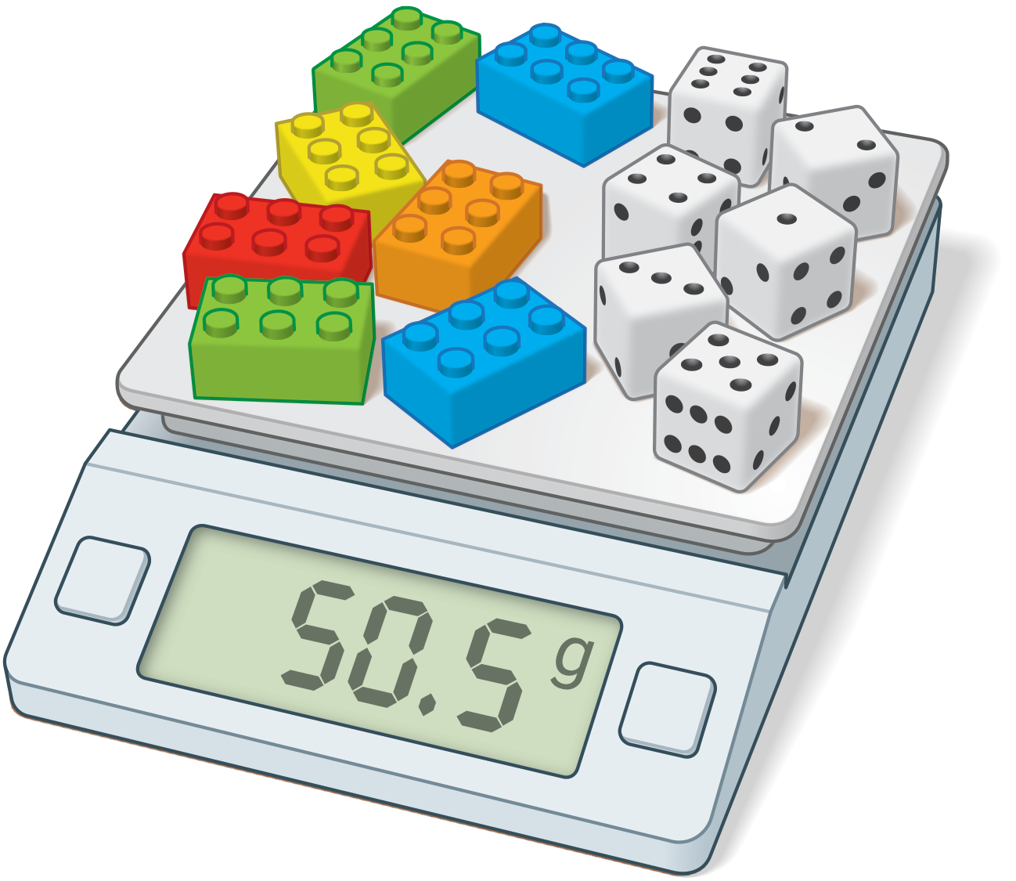

Priya says, “I know 9 plastic bricks and 3 number cubes weigh 39 grams, and 7 plastic bricks and 6 number cubes weigh 50.5 grams. Here’s what I can figure out based on that:

* The weight of 18 plastic bricks and 6 number cubes is 78 grams.
* The weight of 11 plastic brick is 27.5 grams.
* The weight of 1 plastic brick is 2.5 grams.
* The weight of 9 plastic bricks is 22.5 grams.
* The weight of 3 number cubes is 16.5 grams.
* The weight of 1 number cube is 5.5 grams.”

1. Why is Priya’s second step only about plastic bricks, not number cubes?
2. How does it help Priya to have a statement that’s just about plastic bricks, and not number cubes?
3. Why might Priya have started by finding the weight of 18 plastic bricks and 6 number cubes?
4. After Priya figured out how much 1 plastic brick weighed, why did she calculate how much 9 plastic bricks weighed?



© CC BY 2019 by Illustrative Mathematics®