Lesson 1: What is Area?
- Let’s compare the size of shapes.

Warm-up: How Many Do You See: Arrays
How many do you see? How do you see them?
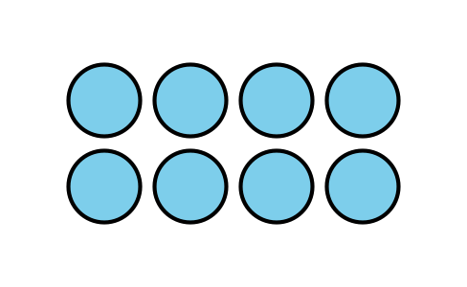
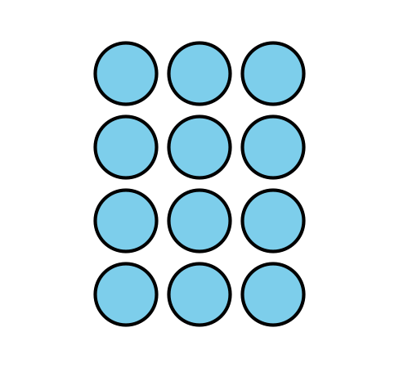
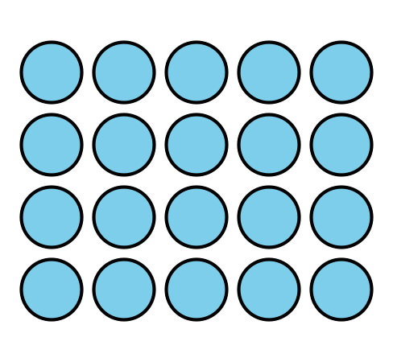

1.1: Compare Shapes
- Here are two triangles. Which triangle is larger?
- 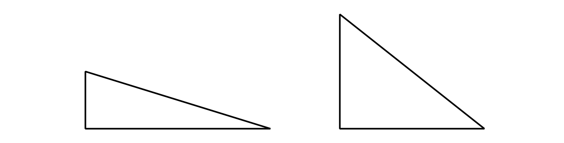
- In each pair of shapes, which shape is larger? Be prepared to explain your reasoning.

  - 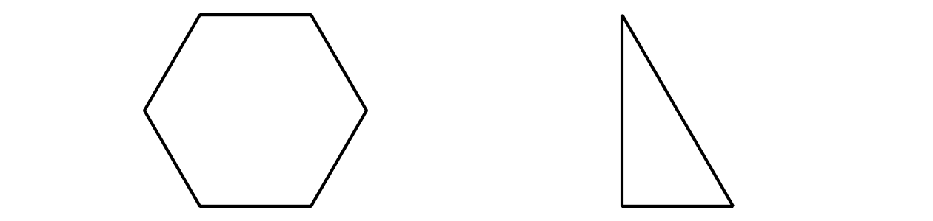

1.2: Pattern Blocks to Compare Shapes
Your teacher will give you handouts with some shapes on them.
Use pattern blocks to decide which shape covers the most space. Be ready to explain your reasoning.
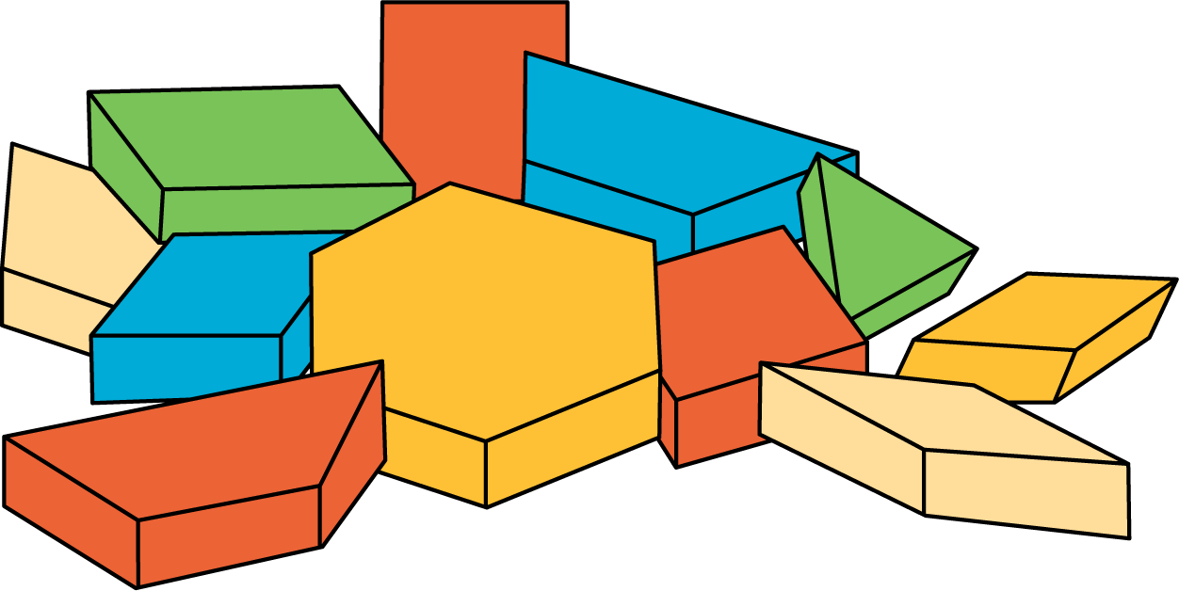
© CC BY 2021 Illustrative Mathematics®

