Unit 6 Lesson 13: Problems with Missing Information

WU Estimation Exploration: Giant Cantaloupe (Warm up)

Student Task Statement
A regular cantaloupe weighs between 1 and 5 kilograms.
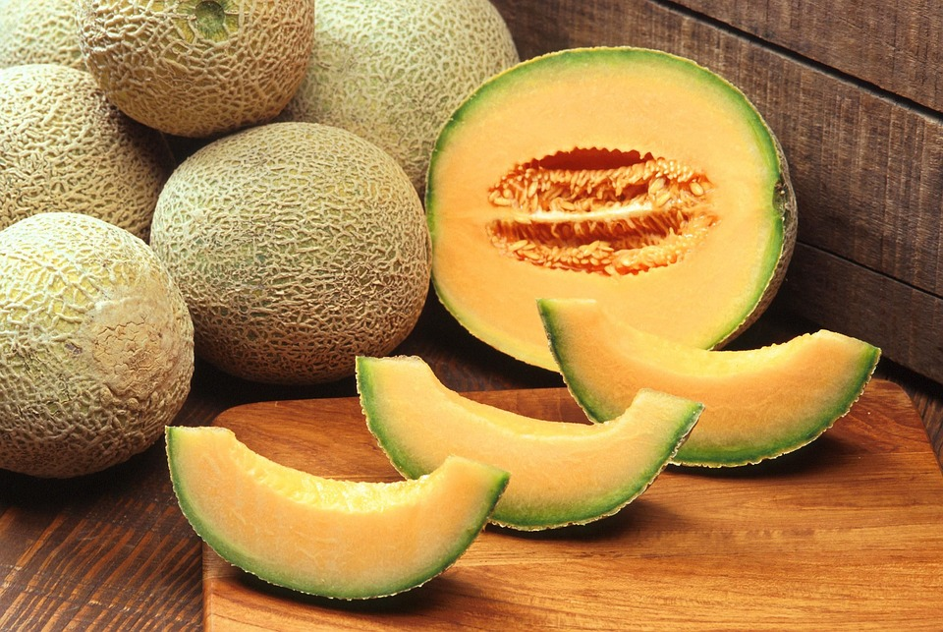
This cantaloupe melon was a winner at the 2010 Alaska State Fair. How many kilograms do you think it weighs?
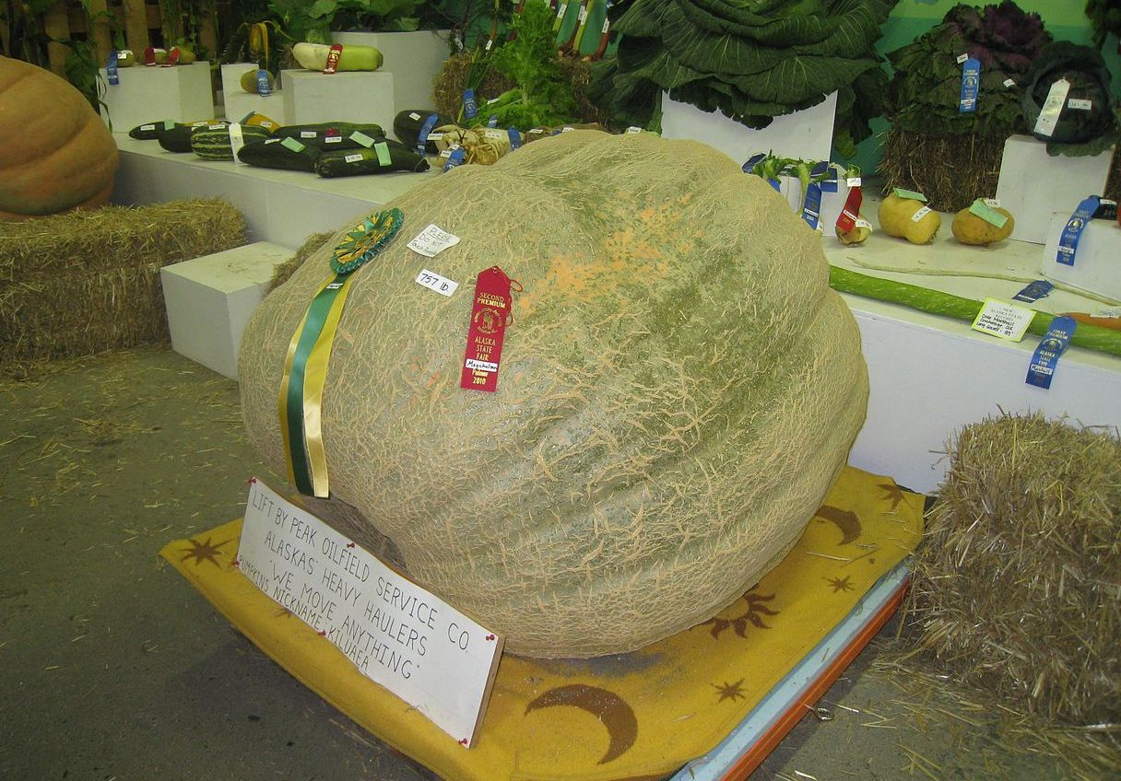
Record an estimate that is:
too low | about right | too high

1 Info Gap: Pumpkin Weigh-Off

Student Task Statement
Your teacher will give you either a problem card or a data card. Do not show or read your card to your partner.
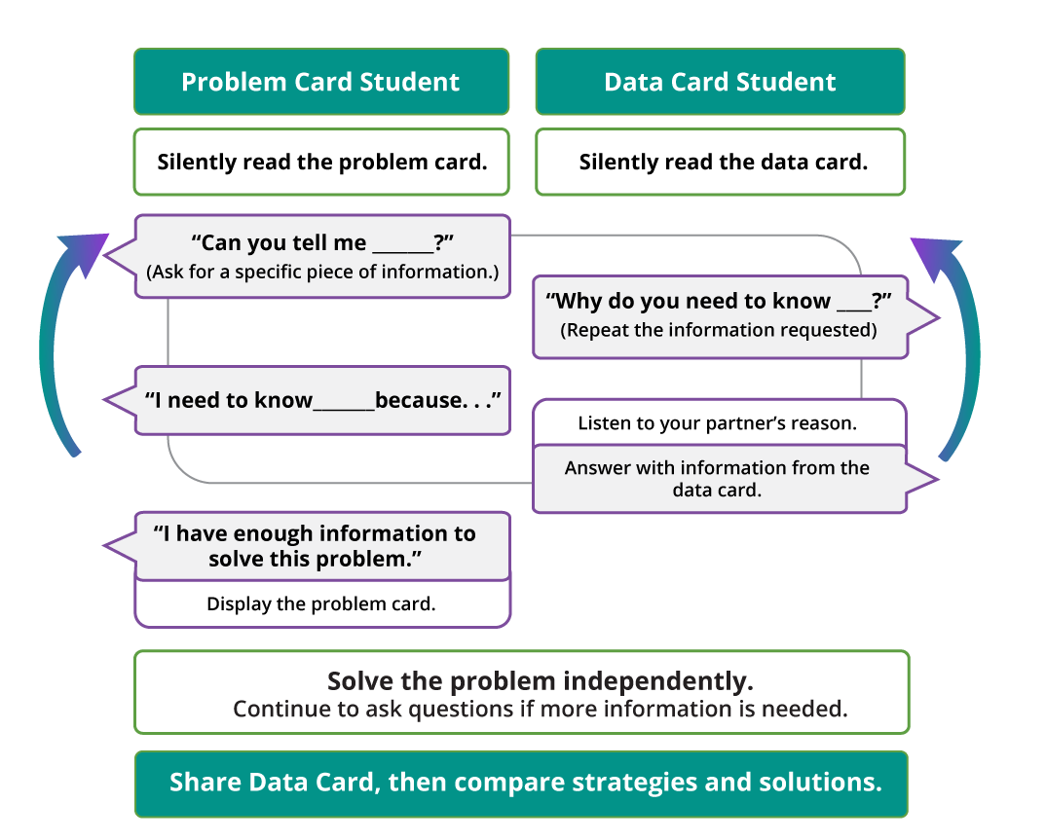
Pause here so your teacher can review your work.
Ask your teacher for a new set of cards and repeat the activity, trading roles with your partner.

2 Info Gap: Pig Weigh-Off

Student Task Statement
Your teacher will give you a new problem card or data card. Do not show or read your card to your partner.
Use the same information gap routine to solve the problem. Then, pause so your teacher can review your work.
Ask your teacher for a new set of cards and repeat the activity, trading roles with your partner.
© CC BY 2021 Illustrative Mathematics®

