Unit 7 Lesson 6: Compare and Describe Angles

WU Which One Doesn’t Belong: Angles (Warm up)

Student Task Statement
Which one doesn’t belong?
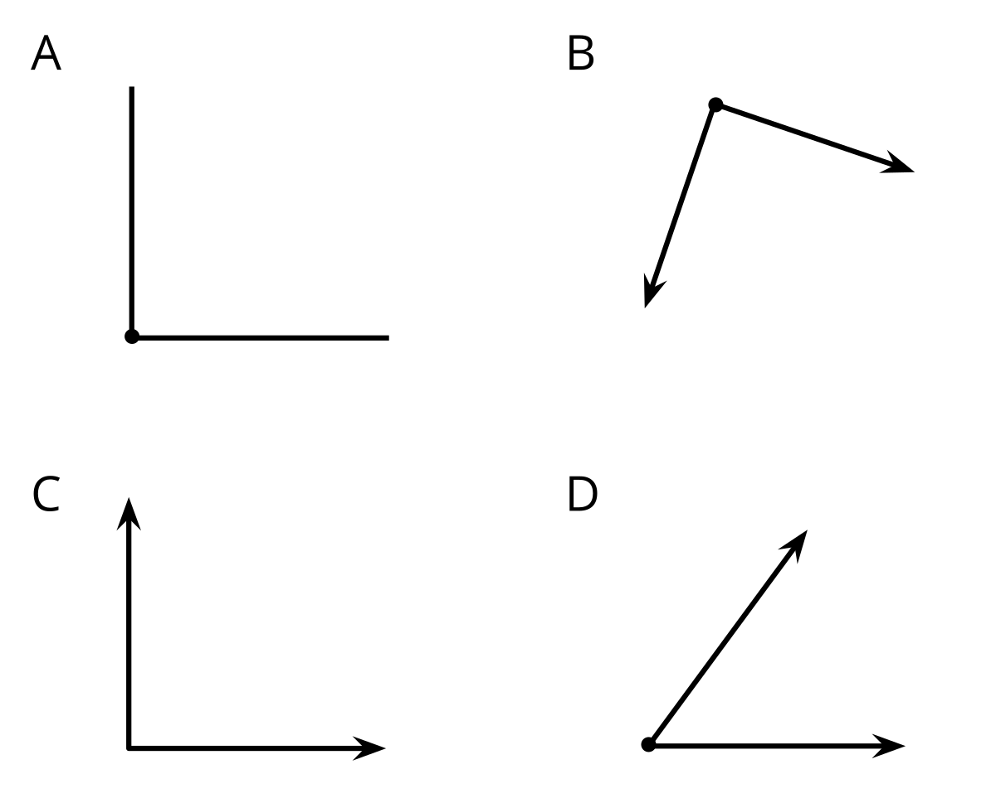

1 Card Sort: Angles

Student Task Statement
Your teacher will give you a set of cards with angles on them.
- Sort the angles into 3 or more categories and in a way that makes sense to you.
- Record your sorted angles here. Write words or phrases to describe each category. Be prepared to explain how you sorted the angles.

2 Order Angles

Student Task Statement
You will need cards A–P from an earlier activity.
Order the angles on the cards from smallest to largest.
Record your ordered angles. Explain or show how you decided which angle was the smallest and which was the largest.
© CC BY 2021 Illustrative Mathematics®

