Lesson 2: Features of a Number Line
- Let’s explore the features of a number line.

2.2: Analyze Number Lines
Jada's number line
Andre’s number line
Elena’s number line
- How should Jada revise her number line?
- How should Andre revise his number line?
- Elena’s number line
- How should Elena revise her number line?
- Fill in the numbers to create your own number line.
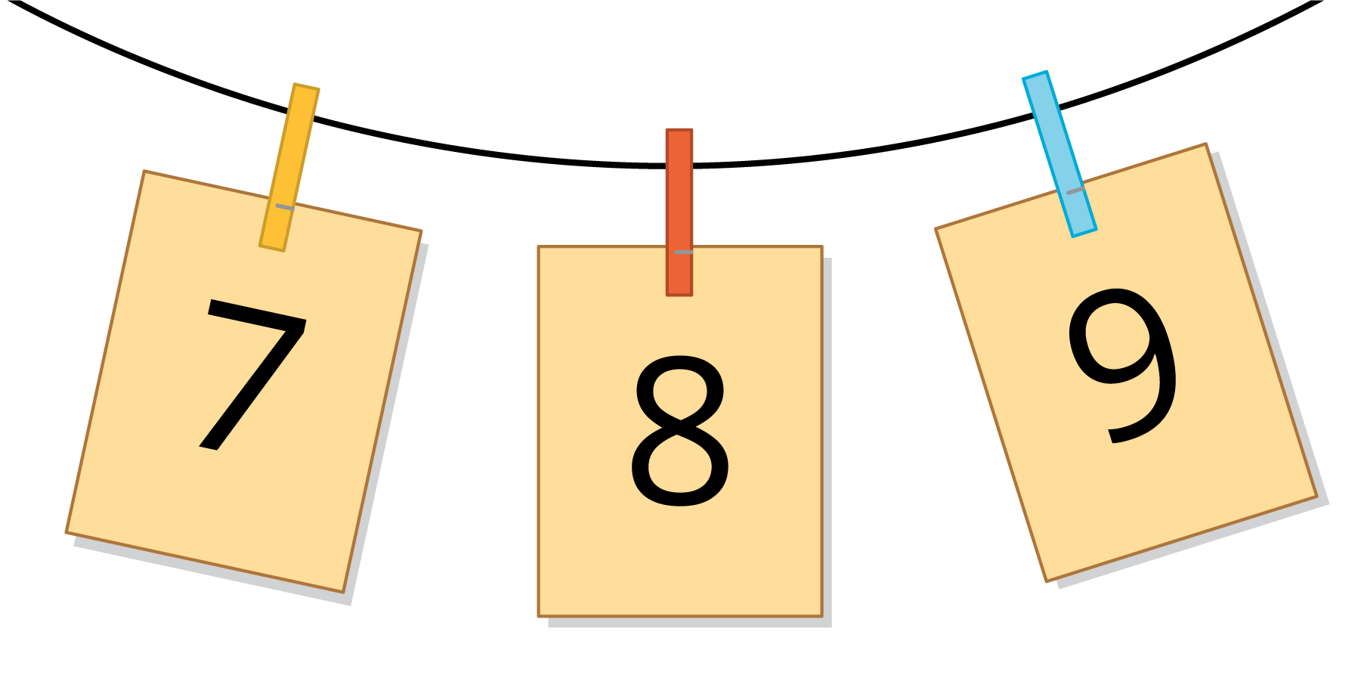
© CC BY 2021 Illustrative Mathematics®

