Lesson 4: Result or Change Unknown
- Let’s solve story problems and write equations to match.

Warm-up: True or False: Equations with 10
Is each statement true or false?
Be prepared to explain your reasoning.
- $10=10$
- $4+6=10$
- $2+7=10$

4.1: Compare the Problems
- Mai has 5 graphic novels.
She checks out 4 more.
How many graphic novels does she have?
Show your thinking using drawings, numbers, or words.
- Equation: ________________________________
- 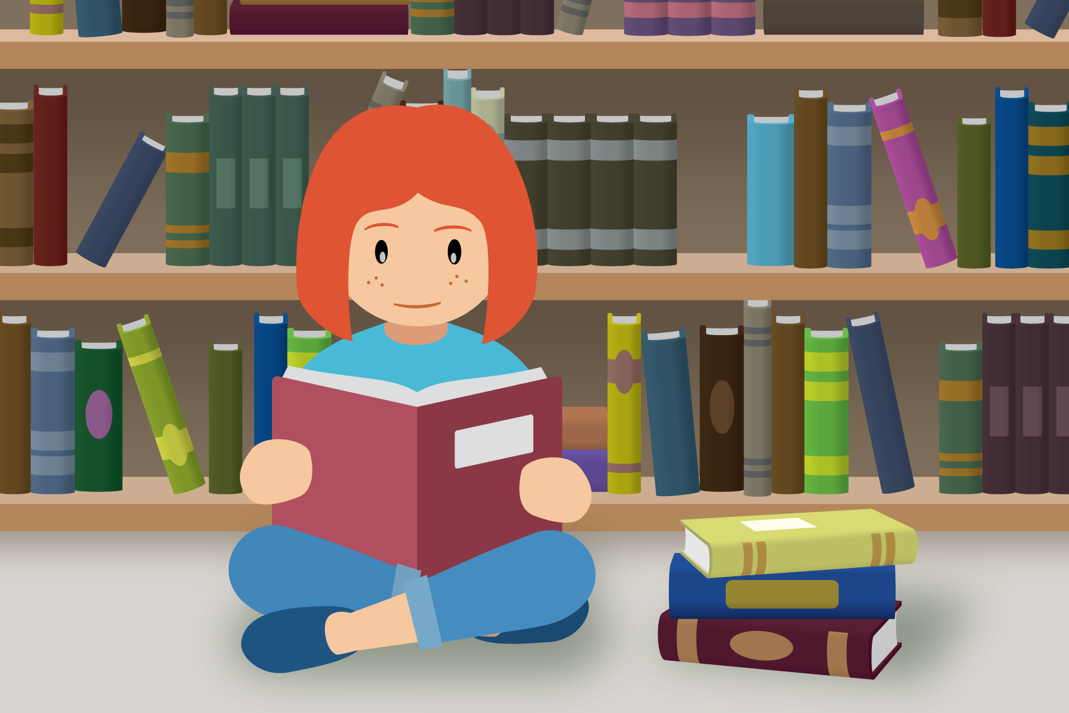
- Mai has 5 graphic novels.
She checks out some more.
Now she has 9 graphic novels.
How many graphic novels did she check out?
Show your thinking using drawings, numbers, or words.
- Equation: ________________________________

4.2: Story Problems about Books
- Mai has read 3 books about dogs.
Diego gives her 4 more books to read.
How many books about dogs will Mai read all together?
Show your thinking using drawings, numbers, or words.
- Equation: ________________________________
- Noah has 4 books of poetry.
His sister gives him some more books.
Now he has 10 books of poetry.
How many books did his sister give him?
Show your thinking using drawings, numbers, or words.
- Equation: ________________________________
- Tyler has 7 books about spiders.
He gives 3 of his books to Kiran.
How many books does Tyler have left?
Show your thinking using drawings, numbers, or words.
- Equation: ________________________________
- Lin has 5 books about outer space.
Her teacher gives her some more books.
Now she has 10 books about outer space.
How many books did Lin's teacher give her?
Show your thinking using drawings, numbers, or words.
- Equation: ________________________________

Section Summary
Section Summary
We solved story problems and represented them with objects, drawings, words, and equations.
- We solved story problems with addition.
- Mai has read 3 books about dogs.
Diego gives her 4 more books to read.
How many books about dogs will Mai read all together?
- 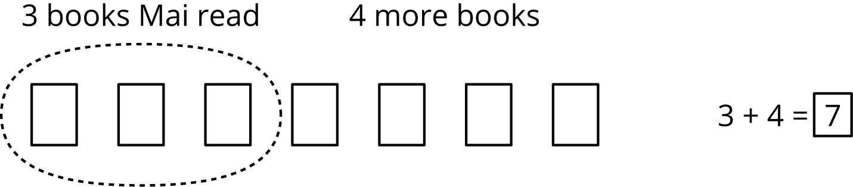
- We solved story problems with subtraction.
- Tyler has 7 books about spiders.
He gives 3 to Kiran to read.
How many books does Tyler have left?
- 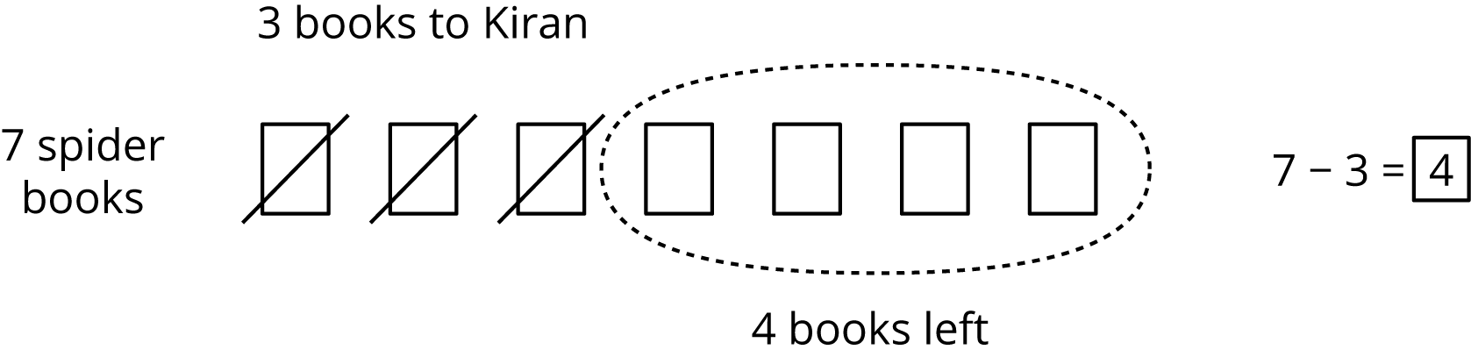
- We solved story problems where the change was unknown.
- Lin has 5 books.
Her teacher gives her some more books.
Now she has 10 books to read.
How many books did her teacher give her?
- 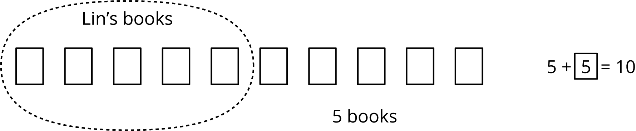
- We learned that the equal sign means “the same amount as” and “equals.”
© CC BY 2021 Illustrative Mathematics®

