Lesson 3: Measure in Halves and Fourths of an Inch

Standards Alignments
Addressing | 3.MD.B.4, 3.NF.A.3.c

Teacher-facing Learning Goals
- Measure lengths using a ruler marked with both halves and fourths of an inch.
- Use equivalent fractions to describe length measurements.

Student-facing Learning Goals
- Let’s measure lengths in halves of an inch and quarters of an inch.

Lesson Purpose
The purpose of this lesson is for students to use what they know about fraction equivalence to measure with a ruler that is marked with halves and fourths of an inch.
Previously, students learned to measure lengths using separate rulers that were marked with halves or fourths of an inch. Here, they use what they know about fraction equivalence to read measurements from a ruler marked with both halves and fourths of an inch. Then, students consider lengths that could be named in more than one way.
In future lessons, this ruler will be used to measure objects and represent measurements in a line plot.

Access for:

Students with Disabilities
- Engagement (Activity 2)

English Learners
- MLR8 (Activity 1)

Instructional Routines
Notice and Wonder (Warm-up)

Materials to Gather
- Materials from a previous activity: Activity 1, Activity 2
- Materials from a previous lesson: Warm-up
- Rulers (inches): Warm-up, Activity 1, Activity 2

Materials to Copy
- Notice and Wonder Rulers (groups of 4): Warm-up

Lesson Timeline
Warm-up | 10 min
Activity 1 | 15 min
Activity 2 | 25 min
Lesson Synthesis | 5 min
Cool-down | 5 min

Teacher Reflection Question
Think about who volunteered to share their thinking with the class today. Are the same students always volunteering, while some students never offer to share? What can you do to help the class understand the value of hearing the ideas of every mathematician?

Cool-down
(to be completed at the end of the lesson) 5min
How Long?

Standards Alignments
Addressing | 3.MD.B.4

Student-facing Task Statement
What is the length of the worm in inches?
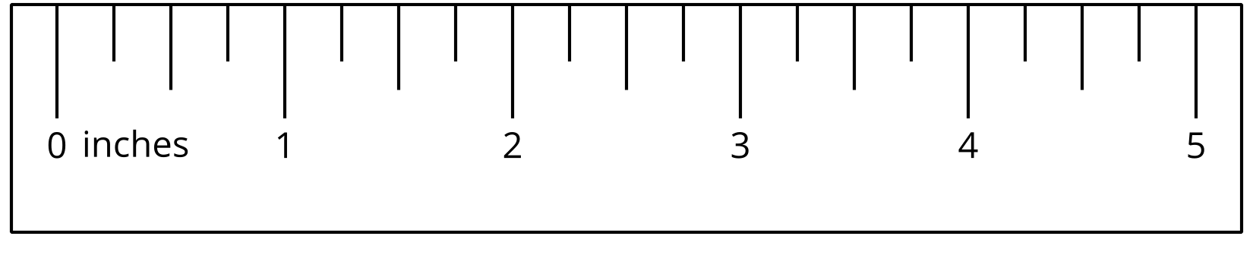

Student Responses
$3\frac{3}{4}$ or $\frac{15}{4}$ inches

