Unit 2 Lesson 6: Side-Angle-Side Triangle Congruence

1 Information Overload? (Warm up)

Student Task Statement
Highlight each piece of given information that is used in the proof, and each line in the proof where that piece of information is used.
Given:
- $\overline{AB}≅\overline{DE}$
- $\overline{AC}≅\overline{DF}$
- $\overline{BC}≅\overline{EF}$
- $∠A≅∠D$
- $∠B≅∠E$
- $∠C≅∠F$
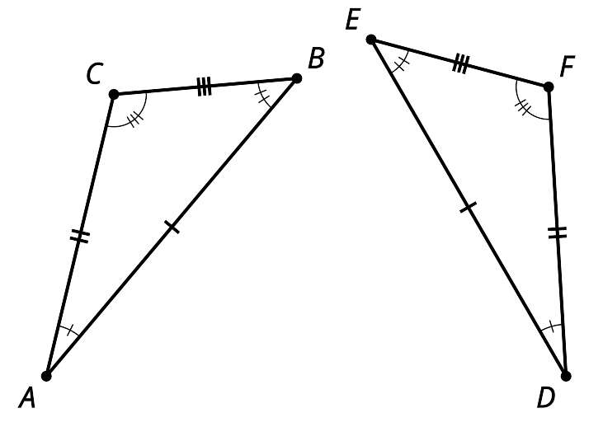
Proof:
- Segments $AB$ and $DE$ are the same length so they are congruent. Therefore, there is a rigid motion that takes $AB$ to $DE$.
- Apply that rigid motion to triangle $ABC$. The image of $A$ will coincide with $D$, and the image of $B$ will coincide with $E$.
- We cannot be sure that the image of $C$ coincides with $F$ yet. If necessary, reflect the image of triangle $ABC$ across $DE$ to be sure the image of $C$, which we will call $C^{′}$, is on the same side of $DE$ as $F$. (This reflection does not change the image of $A$ or $B$.)
- We know the image of angle $A$ is congruent to angle $D$ because rigid motions don’t change the size of angles.
- $C^{′}$ must be on ray $DF$ since both $C^{′}$ and $F$ are on the same side of $DE$, and make the same angle with it at $D$.
- Segment $DC^{′}$ is the image of $AC$ and rigid motions preserve distance, so they must have the same length.
- We also know $AC$ has the same length as $DF$. So $DC^{′}$ and $DF$ must be the same length.
- Since $C^{′}$ and $F$ are the same distance along the same ray from $D$, they have to be in the same place.
- We have shown that a rigid motion takes $A$ to $D$, $B$ to $E$, and $C$ to $F$; therefore, triangle $ABC$ is congruent to triangle $DEF$.

2 Proving the Side-Angle-Side Triangle Congruence Theorem

Student Task Statement
- Two triangles have 2 pairs of corresponding sides congruent, and the corresponding angles between those sides are congruent. Sketch 2 triangles that fit this description and label them $LMN$ and $PQR$, so that:
  - Segment $LM$ is congruent to segment $PQ$
  - Segment $LN$ is congruent to segment $PR$
  - Angle $L$ is congruent to angle $P$
- Use a sequence of rigid motions to take $LMN$ onto $PQR$. For each step, explain how you know that one or more vertices will line up.
- Look back at the congruent triangle proofs you’ve read and written. Do you have enough information here to use a proof that is like one you saw earlier? Use one of those proofs to guide you in writing a proof for this situation.

Activity Synthesis

$\overline{AB}≅\overline{GB},\overline{BC}≅\overline{BC},∠ABC≅∠GBC$ so $△ABC≅△GBC$
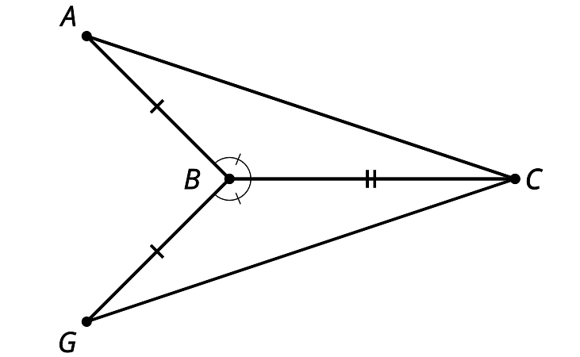

3 What Do We Know For Sure About Isosceles Triangles?

Student Task Statement
Mai and Kiran want to prove that in an isosceles triangle, the 2 base angles are congruent. Finish the proof that they started. Draw the auxiliary line and define it so that you can use the Side-Angle-Side Triangle Congruence Theorem to complete each statement in the proof.
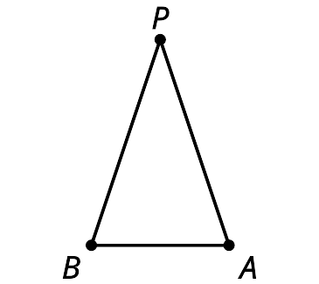
Draw $\underset{_}{}$.
Segment $PA$ is congruent to segment $PB$ because of the definition of isosceles triangle.
Angle $\underset{_}{}$ is congruent to angle $\underset{_}{}$ because $\underset{_}{}$.
Segment $PQ$ is congruent to itself.
Therefore, triangle $APQ$ is congruent to triangle $BPQ$ by the Side-Angle-Side Triangle Congruence Theorem.
Therefore, $\underset{_}{}$.

Activity Synthesis

$\overline{AP}≅\overline{PB}$ so $∠A≅∠B$
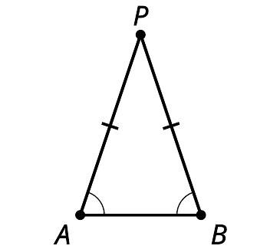

Images for Activity Synthesis
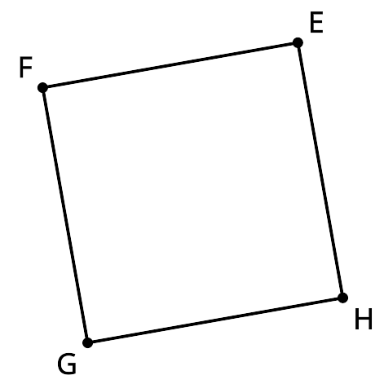
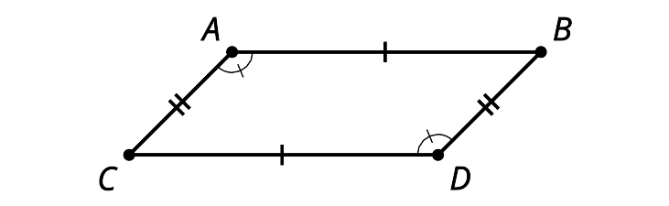
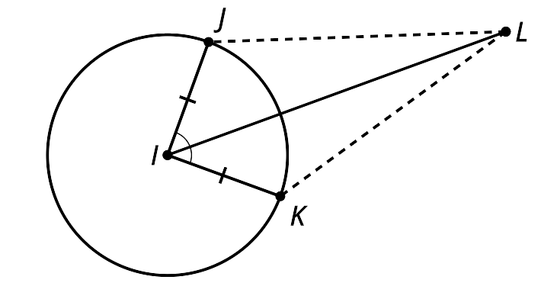
© CC BY 2019 by Illustrative Mathematics

