Lesson 16 Practice Problems
- There are many cylinders with a volume of $144π$ cubic inches. The height $h\left(r\right)$ in inches of one of these cylinders is a function of its radius $r$ in inches where $h\left(r\right)=\frac{144}{r^{2}}$.
  - What is the height of one of these cylinders if its radius is 2 inches?
  - What is the height of one of these cylinders if its radius is 3 inches?
  - What is the height of one of these cylinders if its radius is 6 inches?
- The surface area $S\left(r\right)$ in square units of a cylinder with a volume of 18 cubic units is a function of its radius $r$ in units where $S\left(r\right)=2πr^{2}+\frac{36}{r}$. What is the surface area of a cylinder with a volume of 18 cubic units and a radius of 3 units?
- Han finds an expression for $S\left(r\right)$ that gives the surface area in square inches of any cylindrical can with a specific fixed volume, in terms of its radius $r$ in inches. This is the graph Han gets if he allows $r$ to take on any value between -1 and 5.
  - What would be a more appropriate domain for Han to use instead?
  - What is the approximate minimum surface area for the can?
- 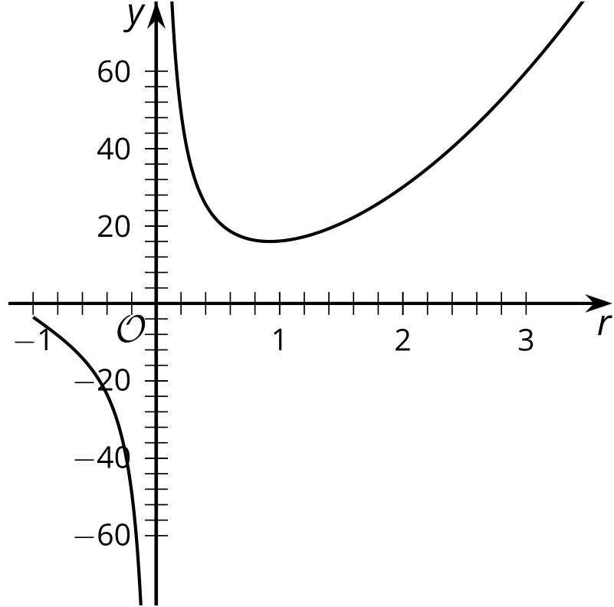
- The graph of a polynomial function $f$ is shown. Is the degree of the polynomial even or odd? Explain your reasoning.

- 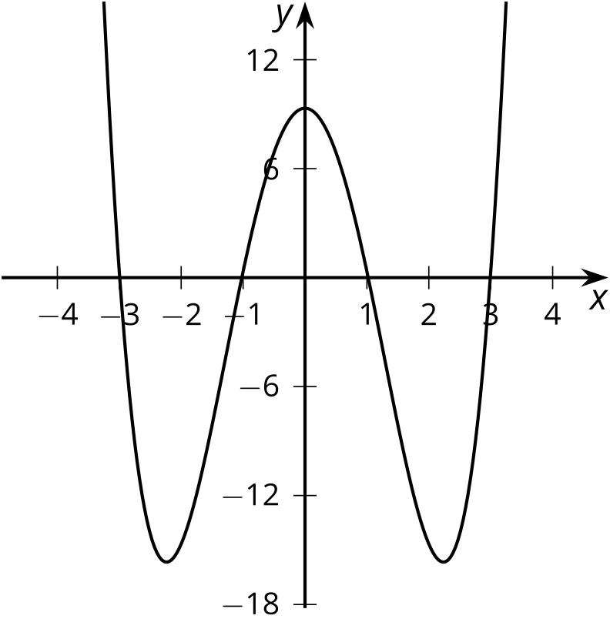
- (From Unit 2, Lesson 8.)
- The polynomial function $p\left(x\right)=x^{4}+4x^{3}−7x^{2}−22x+24$ has known factors of $\left(x+4\right)$ and $\left(x−1\right)$.
  - Rewrite $p\left(x\right)$ as the product of linear factors.
  - Draw a rough sketch of the graph of the function.
- (From Unit 2, Lesson 12.)
- Which polynomial has $\left(x+1\right)$ as a factor?
  - $x^{3}+2x^{2}−19x−20$
  - $x^{3}−21x+20$
  - $x^{3}+8x+11x−20$
  - $x^{3}−3x^{2}+3x−1$
- (From Unit 2, Lesson 15.)
© CC BY 2019 by Illustrative Mathematics®

