Lesson 4: What Fraction of a Group?

4.1: Estimating a Fraction of a Number
- Estimate the quantities:
  - What is $\frac{1}{3}$ of 7?
  - What is $\frac{4}{5}$ of $9\frac{2}{3}$?
  - What is $2\frac{4}{7}$ of $10\frac{1}{9}$?
- Write a multiplication expression for each of the previous questions.

4.2: Fractions of Ropes
Here is a diagram that shows four ropes of different lengths.
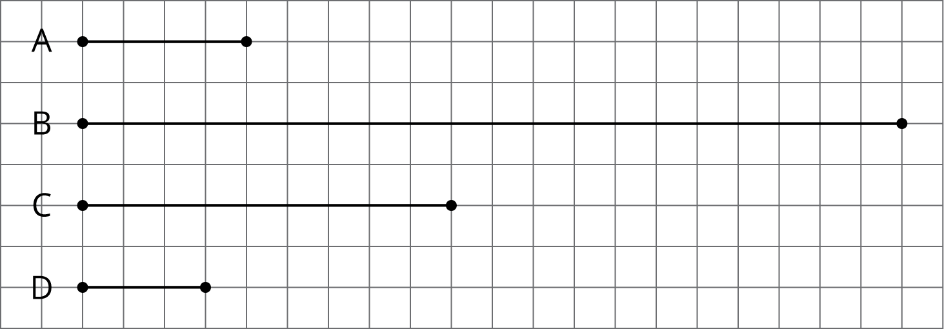
- Complete each sentence comparing the lengths of the ropes. Then, use the measurements shown on the grid to write a multiplication equation and a division equation for each comparison.
  - Rope B is _______ times as long as Rope A.
  - Rope C is _______ times as long as Rope A.
  - Rope D is _______ times as long as Rope A.
- Each equation can be used to answer a question about Ropes C and D. What could each question be?
  - $?⋅3=9$ and $9÷3=?$
  - $?⋅9=3$ and $3÷9=?$

4.3: Fractional Batches of Ice Cream
One batch of an ice cream recipe uses 9 cups of milk. A chef makes different amounts of ice cream on different days. Here are the amounts of milk she used:
- Monday: 12 cups
- Tuesday: $22\frac{1}{2}$ cups
- Thursday: 6 cups
- Friday: $7\frac{1}{2}$ cups
- How many batches of ice cream did she make on these days? For each day, write a division equation, draw a tape diagram, and find the answer.
  - Monday
  - Tuesday
- What fraction of a batch of ice cream did she make on these days? For each day, write a division equation, draw a tape diagram, and find the answer.
  - Thursday
  - Friday
- For each question, write a division equation, draw a tape diagram, and find the answer.
  - What fraction of 9 is 3?
  - What fraction of 5 is $\frac{1}{2}$?

Lesson 4 Summary
It is natural to think about groups when we have more than one group, but we can also have a fraction of a group.
To find the amount in a fraction of a group, we can multiply the fraction by the amount in the whole group. If a bag of rice weighs 5 kg, $\frac{3}{4}$ of a bag would weigh ($\frac{3}{4}⋅5)$ kg.
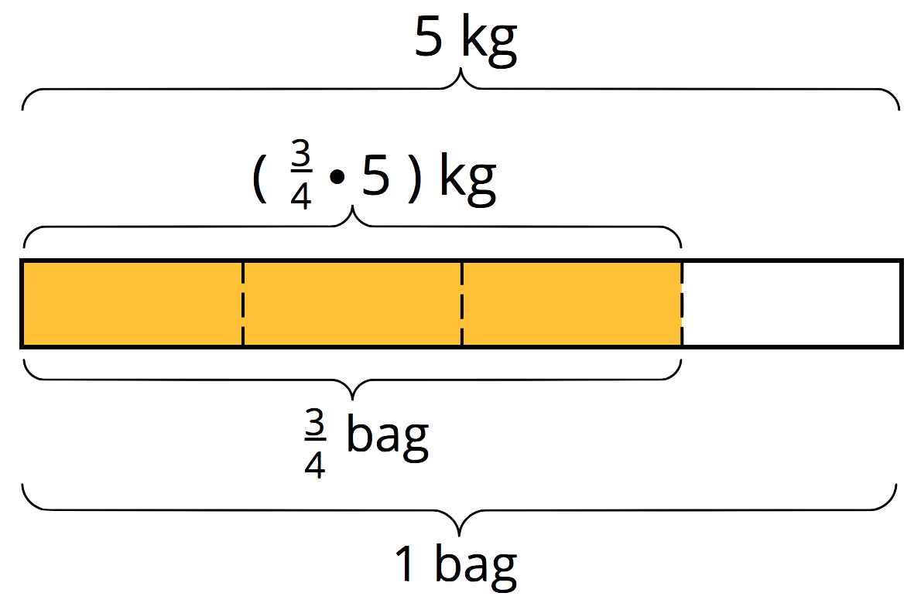
Sometimes we need to find what fraction of a group an amount is. Suppose a full bag of flour weighs 6 kg. A chef used 3 kg of flour. What fraction of a full bag was used? In other words, what fraction of 6 kg is 3 kg?
This question can be represented by a multiplication equation and a division equation, as well as by a diagram.
$?⋅6=3$ $3÷6=?$
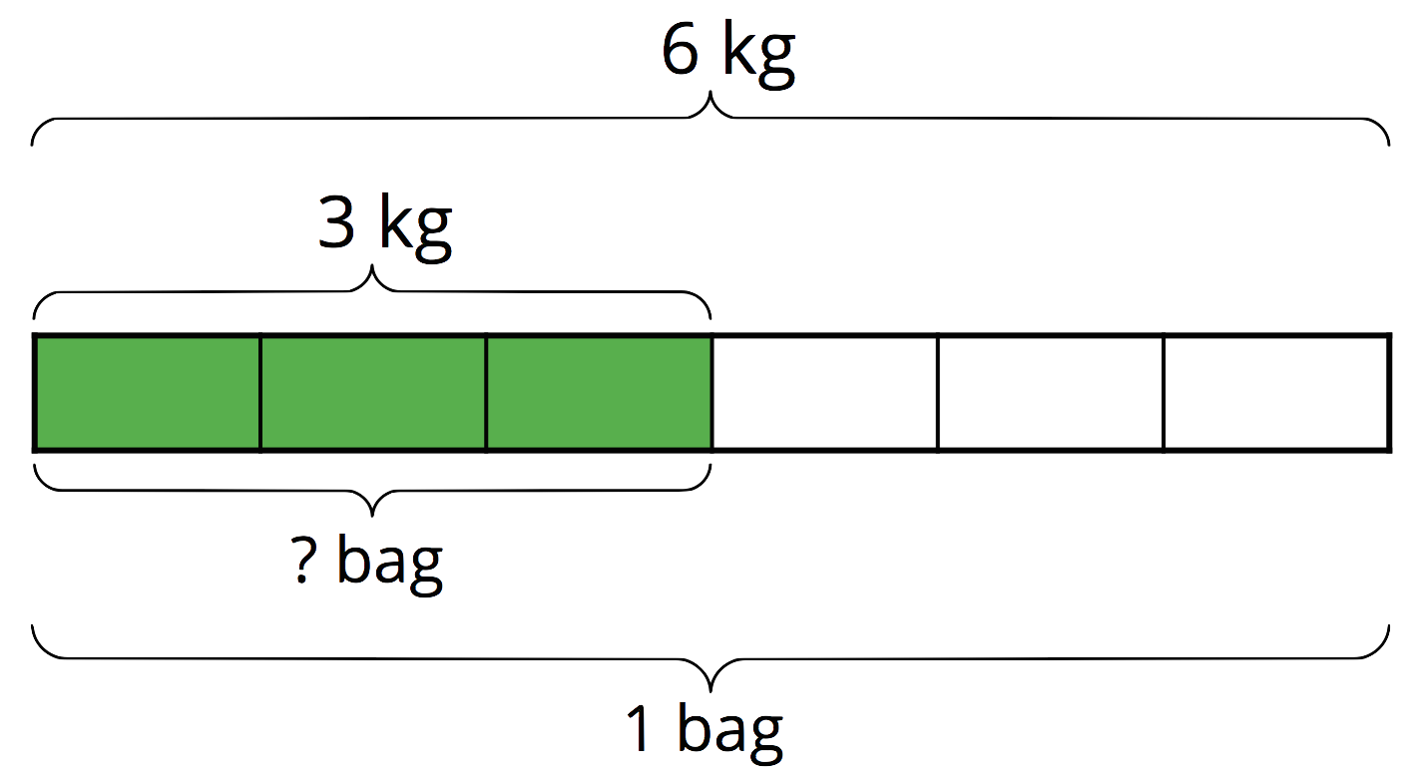
We can see from the diagram that 3 is $\frac{1}{2}$ of 6, and we can check this answer by multiplying: $\frac{1}{2}⋅6=3$.
In any situation where we want to know what fraction one number is of another number, we can write a division equation to help us find the answer.
For example, “What fraction of 3 is $2\frac{1}{4}$?” can be expressed as $?⋅3=2\frac{1}{4}$, which can also be written as $2\frac{1}{4}÷3=?$.
The answer to “What is $2\frac{1}{4}÷3$?” is also the answer to the original question.
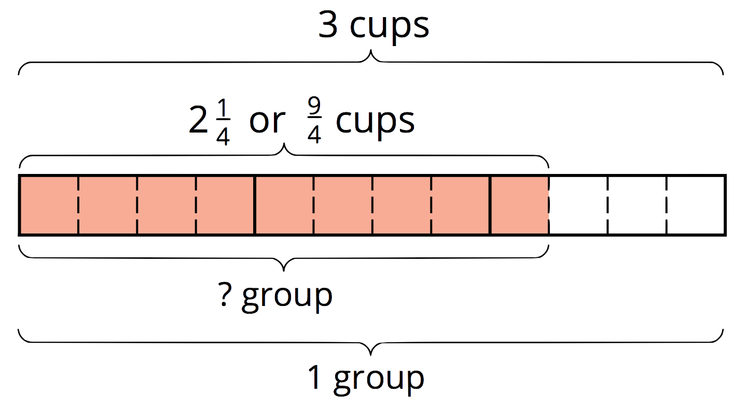
The diagram shows that 3 wholes contain 12 fourths, and $2\frac{1}{4}$ contains 9 fourths, so the answer to this question is $\frac{9}{12}$, which is equivalent to $\frac{3}{4}$.
We can use diagrams to help us solve other division problems that require finding a fraction of a group. For example, here is a diagram to help us answer the question: “What fraction of $\frac{9}{4}$ is $\frac{3}{2}$?,” which can be written as $\frac{3}{2}÷\frac{9}{4}=?$.
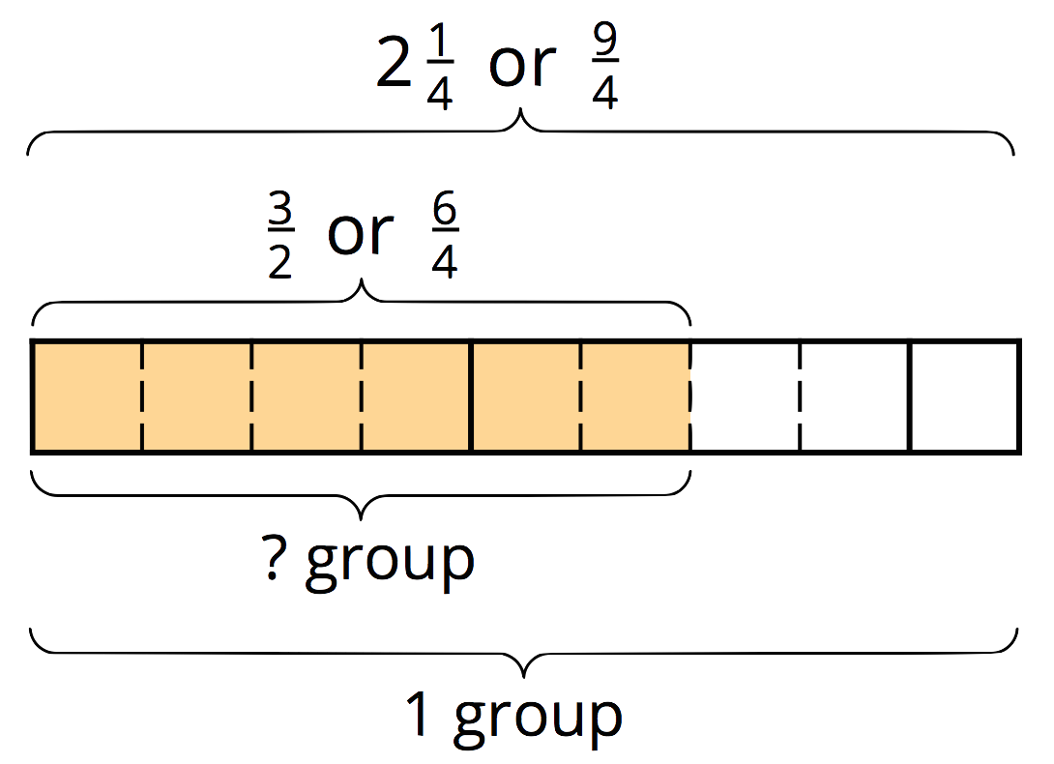
We can see that the quotient is $\frac{6}{9}$, which is equivalent to $\frac{2}{3}$. To check this, let’s multiply. $\frac{2}{3}⋅\frac{9}{4}=\frac{18}{12}$, and $\frac{18}{12}$ is, indeed, equal to $\frac{3}{2}$.
© CC BY Open Up Resources. Adaptations CC BY IM.

