Unit 2 Lesson 14 Cumulative Practice Problems
- The equation $c=2.95g$ shows how much it costs to buy gas at a gas station on a certain day. In the equation, $c$ represents the cost in dollars, and $g$ represents how many gallons of gas were purchased.
  - Write down at least four (gallons of gas, cost) pairs that fit this relationship.
  - Create a graph of the relationship.
  - What does 2.95 represent in this situation?
  - Jada’s mom remarks, “You can get about a third of a gallon of gas for a dollar.” Is she correct? How did she come up with that?
- There is a proportional relationship between a volume measured in cups and the same volume measured in tablespoons. 3 cups is equivalent to 48 tablespoons, as shown in the graph.
  - Plot and label at least two more points that represent the relationship.
  - Use a straightedge to draw a line that represents this proportional relationship.
  - For which value y is ($1,y$) on the line you just drew?
  - What is the constant of proportionality for this relationship?
  - Write an equation representing this relationship. Use $c$ for cups and $t$ for tablespoons.
- 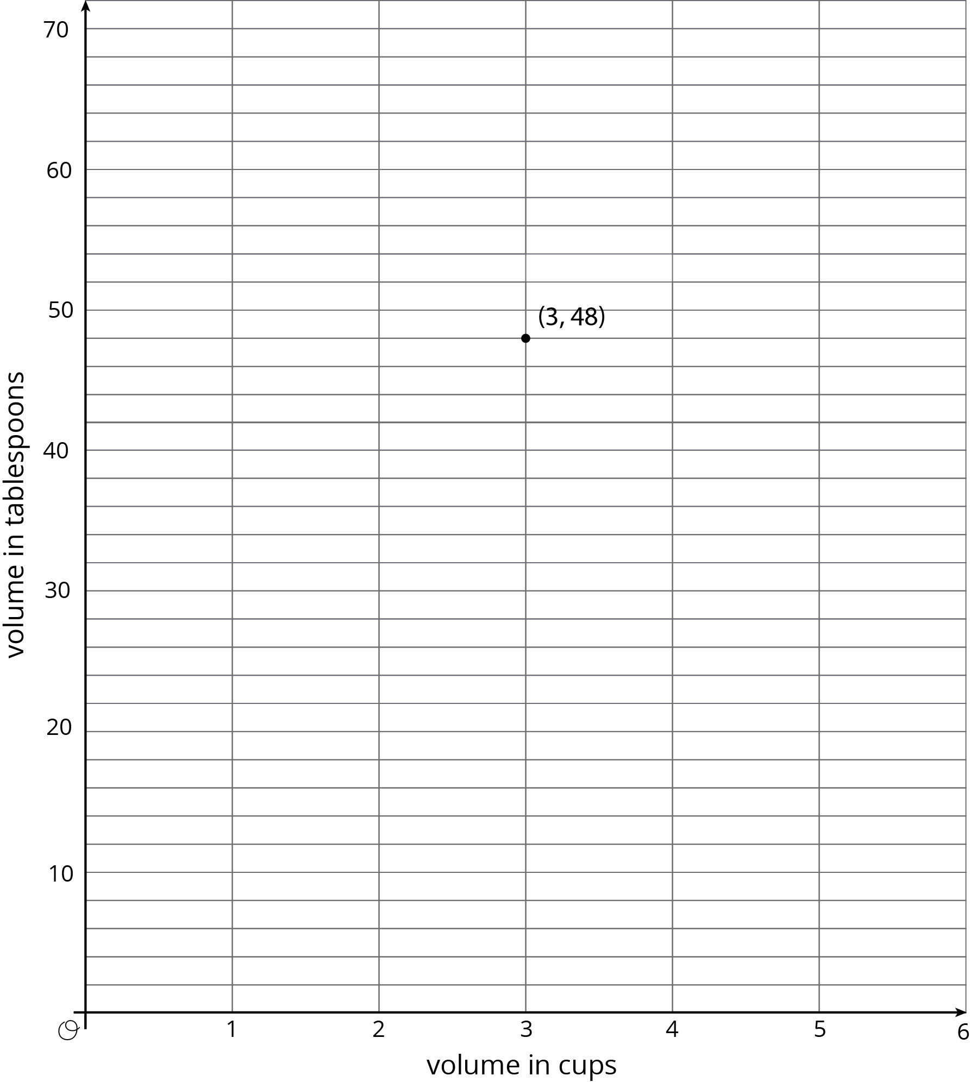
© CC BY Open Up Resources. Adaptations CC BY IM.

