Lesson 16: Interpretemos datos de medidas

Standards Alignments
Addressing | 2.MD.D.9, 2.NBT.B.5

Teacher-facing Learning Goals
- Interpret data presented in a line plot.
- Represent numerical data in a line plot using an appropriate scale.

Student-facing Learning Goals
- Representemos y entendamos datos en diagramas de puntos.

Lesson Purpose
The purpose of this lesson is for students to create and interpret a line plot.
The purpose of this lesson is for students to continue to consider what numbers to use to label the tick marks as they create line plots. Students will use data presented in a table to determine the longest and shortest length and then create a line plot and interpret the data to answer questions. When working with measurements with larger numbers, students learn to set up their number line to start with the shortest length. Students also answer questions that require calculations.
This lesson has a Student Section Summary.

Access for:

Students with Disabilities
- Representation (Activity 1)

English Learners
- MLR8 (Activity 2)

Instructional Routines
Number Talk (Warm-up)

Materials to Copy
- Line Plot Template (groups of 1): Activity 1

Lesson Timeline
Warm-up | 10 min
Activity 1 | 20 min
Activity 2 | 15 min
Lesson Synthesis | 10 min
Cool-down | 5 min

Teacher Reflection Question
In another unit, students are introduced to the number line. They learn how to represent numbers and equations on the number line. How will their work with line plots support that learning?

Cool-down
(to be completed at the end of the lesson) 5min
El proyecto de arte de Diego

Standards Alignments
Addressing | 2.MD.D.9

Student-facing Task Statement
Diego recolectó palitos para un proyecto de arte y los midió. Sus datos se muestran en este diagrama de puntos.
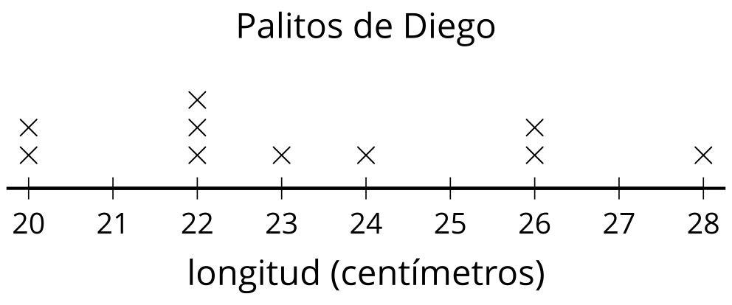
Responde las preguntas basándote en el diagrama de puntos de Diego.
- ¿Cuántos palitos recolectados medían 22 cm?
- ¿Cuántos palitos recolectó Diego?
- ¿Qué tan largo era el palito más largo?
- ¿Cuántos palitos medían 21 cm?

Student Responses
- 3 sticks were 22 cm long.
- Diego collected 10 sticks.
- 28 cm
- 0. There are no Xs at 21, so none of the sticks measured 21 cm.

