Lesson 2: Story Problems and Equations
- Let’s solve story problems and write equations.

Warm-up: Number Talk: Adding 1 More
Find the value of each expression mentally.
- $5+1$
- $5+2$
- $6+2$
- $7+3$

2.1: Write Equations
- 7 people were working on the computers.
3 more people came to the computers.
Now 10 people are working on the computers.
- Equation: ________________________________
- A group of kids was using 10 puppets to act out a story.
They put 5 of the puppets away.
Now they have 5 puppets left.
- Equation: ________________________________
- 5 people came to story time.
Then 4 more people joined.
Now there are 9 people at story time.
- Equation: ________________________________
- 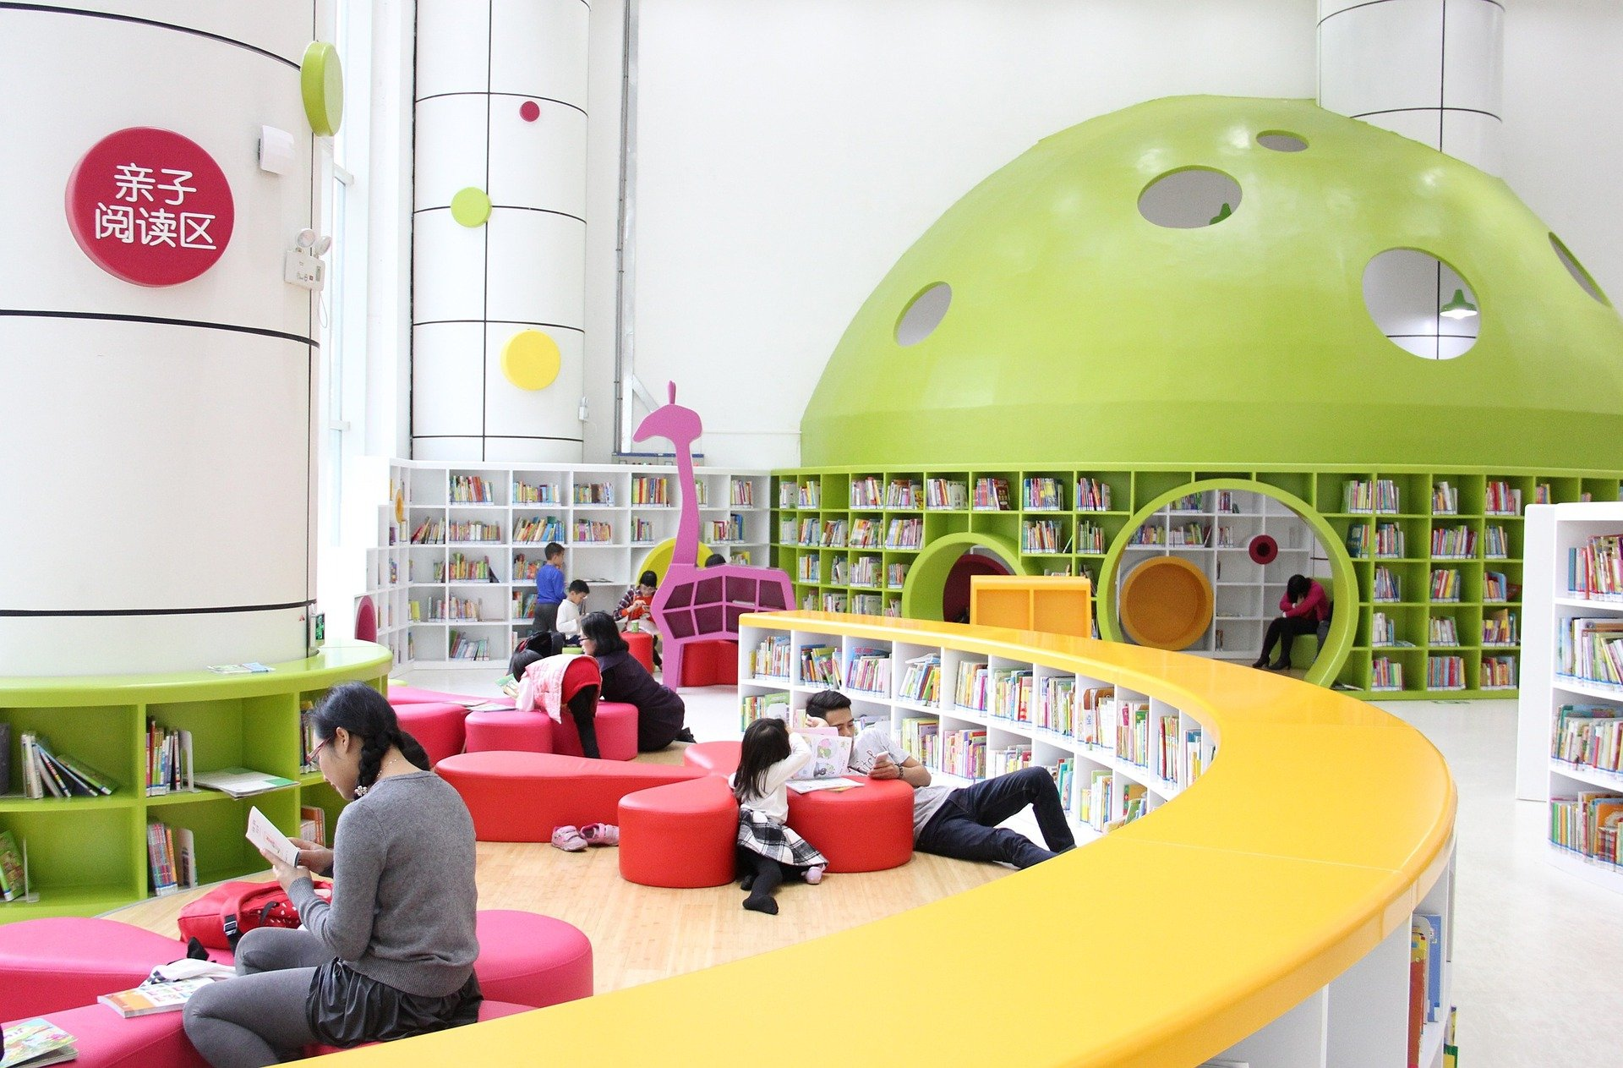
- 8 students were doing homework at a table.
3 of the students finished their homework and left the table.
Now there are 5 students at the table.
- Equation: ________________________________

2.2: Solve and Write Equations
- There was a stack of 6 books on the table.
Someone put 4 more books in the stack.
How many books are in the stack now?
Show your thinking using drawings, numbers, or words.
- Equation: ________________________________
- 9 books were on a cart.
The librarian took 2 of the books and put them on the shelf.
How many books are still on the cart?
Show your thinking using drawings, numbers, or words.
- Equation: ________________________________
- 2 kids were working on an art project.
7 kids join them.
How many kids are working on the art project now?
Show your thinking using drawings, numbers, or words.
- Equation: ________________________________
- The librarian had 8 bookmarks.
He gave 5 bookmarks to kids at the library.
How many bookmarks does he have now?
Show your thinking using drawings, numbers, or words.
- Equation: ________________________________
© CC BY 2021 Illustrative Mathematics®

