Lesson 9: Interpreting Functions
- Let’s describe the domain of a function based on the context it models.

9.1: Notice and Wonder: What Do You See?
Here is a table of values of data that was collected.
$x$ | 0 | 1 | 2 | 3 | 4 | 5 | 6
$y$ | 6 | 5 | 4 | 3 | 2 | 1 | 0
Here are two graphs of the data. What do you notice? What do you wonder?

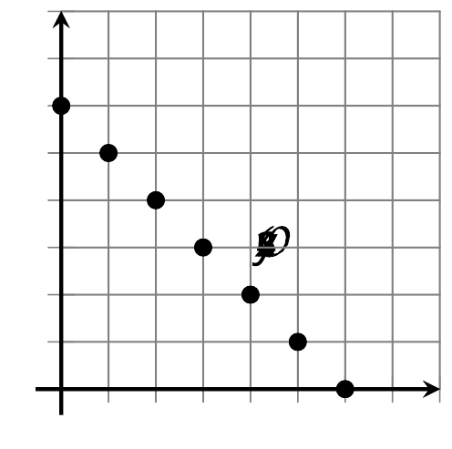

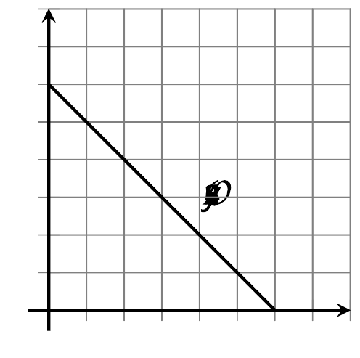

9.2: Connect . . . or Not
Here are descriptions of relationships between quantities.
- Make a table of at least 5 pairs of values that represent the relationship.
- Plot the points. Label the axes of the graph.
- Should the points be connected? Are there any input or output values that don’t make sense? Explain.
- A cab charges $1.50 per mile plus $3.50 for entering the cab. The cost of the ride is a function of the miles, $m$, ridden and is defined by $c(m)=1.50m+3.50$.
- 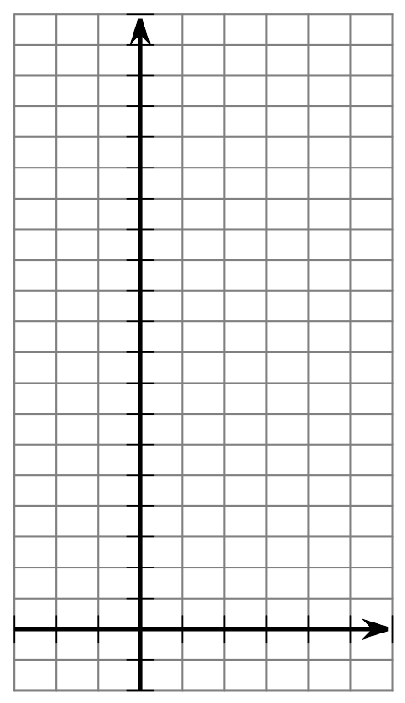
- $m$
- The admission to the state park is $5.00 per vehicle plus $1.50 per passenger. The total admission for one vehicle is a function of the number of passengers, $p$, defined by the equation $a(p)=5+1.50p$.
- $p$
- A new species of mice is introduced to an island, and the number of mice is a function of the time in months, $t$, since they were introduced. The number of mice is represented by the model $b(t)=16⋅(1.5)^{t}$.
- $t$
- When you fold a piece of paper in half, the visible area of the paper gets halved. The area is a function of number of folds, $n$, and is defined by $A(n)=93.5{\left(\frac{1}{2}\right)}^{n}$.
- 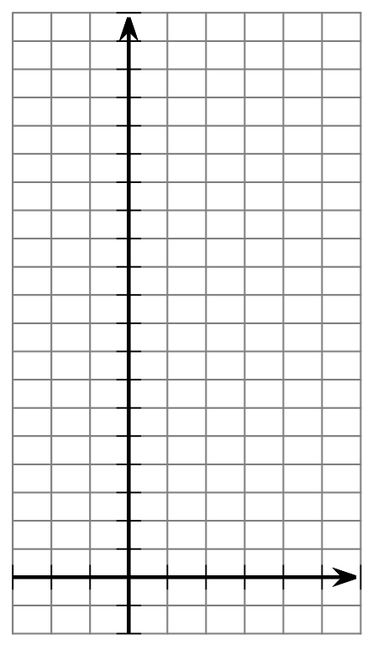
- $n$

9.3: Thinking Like a Modeler
To make sense in a given context, many functions need restrictions on the domain and range. For each description of a function
- describe the domain and range
- describe what its graph would look like (separate dots, or connected?)
- weight of a puppy as a function of time
- number of winter coats sold in a store as a function of temperature outside
- number of books in a library as a function of number of people who live in the community the library serves
- height of water in a tank as a function of volume of water in the tank
- amount of oxygen in the atmosphere as a function of elevation above or below sea level
- thickness of a folded piece of paper as a function of number of folds
© CC BY 2019 by Illustrative Mathematics®

