Lesson 13: Fractional Measurements on Line Plots

Standards Alignments
Building On | 3.MD.B.4
Addressing | 4.MD.B.4, 4.NF.B.3.d
Building Towards | 4.MD.B.4

Teacher-facing Learning Goals
- Analyze and interpret fractional measurement data on line plots.
- Organize measurement data in fractions of a unit ($\frac{1}{8}$, $\frac{1}{4}$, $\frac{1}{2}$) onto line plots.

Student-facing Learning Goals
- Let’s create line plots and analyze the data.

Lesson Purpose
The purpose of this lesson is for students to display a set of measurements in fractions of a unit ($\frac{1}{8}$, $\frac{1}{4}$, and $\frac{1}{2}$) on a line plot and interpret the data. Students also add and subtract fractions to answer questions about data presented in line plots.
In grade 3, students generated measurement data in nearest $\frac{1}{2}$ inch or $\frac{1}{4}$ inch and represented such data on line plots. Earlier in the course, students learned about equivalent fractions and about sums and differences of fractions with the same denominator. In this lesson, students plot data involving lengths measured in $\frac{1}{8}$ inch and analyze the data. They use the line plots and their knowledge of equivalence and fraction operations to answer questions about situations.
An optional measuring activity is included in the lesson. While grade 4 standards do not require students to measure lengths or generate measurement data, measuring reinforces student understanding of the relative size of fractions and gives meaning to the context used in subsequent activities.
The activities in this lesson call for used colored pencils. If colored pencils are unavailable, substitute with regular pencils.

Access for:

Students with Disabilities
- Representation (Activity 2)

English Learners
- MLR7 (Activity 3)

Instructional Routines
Notice and Wonder (Warm-up)

Materials to Gather
- Colored pencils: Activity 1

Lesson Timeline
Warm-up | 10 min
Activity 1 | 25 min
Activity 2 | 20 min
Activity 3 | 15 min
Lesson Synthesis | 10 min
Cool-down | 5 min

Teacher Reflection Question
Today’s lesson encouraged small-group collaboration. How did students interact with each other’s ideas today in the work? How can you ensure in future small-group collaborations that all students’ voices are heard?

Cool-down
(to be completed at the end of the lesson) 5min
Jada’s Pencil Data

Standards Alignments
Addressing | 4.MD.B.4, 4.NF.B.3.d

Student-facing Task Statement
Jada measured the lengths of her pencils and displayed her data on a line plot.
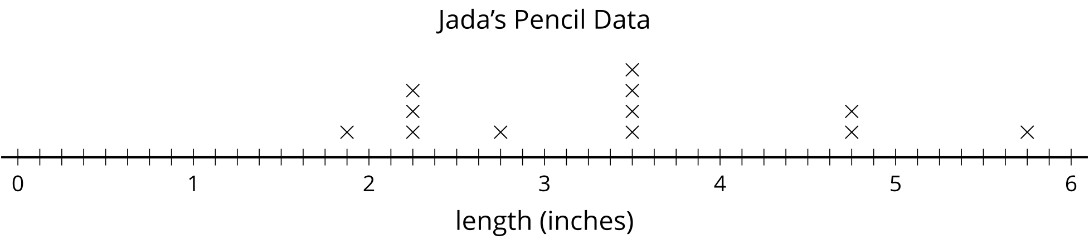
- The last three pencils in her collection are not yet plotted. Their lengths are: $3\frac{1}{4}$, $4\frac{3}{8}$, and $5\frac{1}{4}$. Plot them on the line plot.
- What is the difference in the length of the shortest and the longest pencil in her collection? Show your reasoning.

Student Responses

- 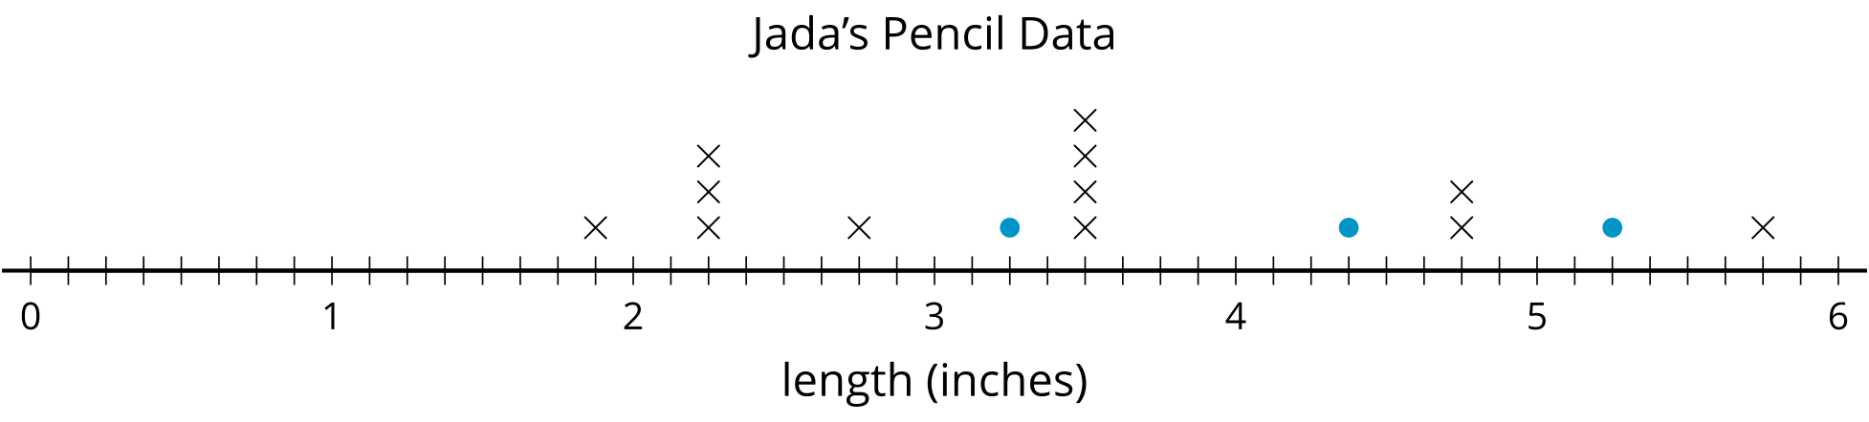
- $3\frac{7}{8}$ inches. Sample response: $5\frac{6}{8}−1\frac{7}{8}=4\frac{14}{8}–1\frac{7}{8}=3\frac{7}{8}$

