Lesson 8: Formemos números con 10 y algunos más (parte 2)

Standards Alignments
Addressing | K.CC.B.5, K.NBT.A.1

Teacher-facing Learning Goals
- Compose and decompose numbers 11–19 using 10 ones and some more ones.

Student-facing Learning Goals
- Mostremos números con tableros de 10 y puntos o fichas.

Lesson Purpose
The purpose of this lesson is for students to compose numbers 11–19 using 10 ones and some more ones.
In previous lessons, students saw numbers 11–19 as ten ones and some more ones as they counted, composed, and represented these numbers. The purpose of this lesson is for students to use the understanding that a full 10-frame contains 10 ones to compose numbers 11–19. Using a 10-frame encourages students to count on from 10. While this lesson highlights counting on as a strategy, students need significant practice working with 10-frames before they are able to count on to determine the total with understanding. Students can complete the activities by counting all. Counting on to determine the total is not an expectation in kindergarten.

Access for:

Students with Disabilities
- Engagement (Activity 2)

English Learners
- MLR8 (Activity 1)

Instructional Routines
How Many Do You See? (Warm-up)

Materials to Gather
- Glue or tape: Activity 1
- Scissors: Activity 1
- Two-color counters: Activity 2, Activity 3

Materials to Copy
- 10-frame and More Dots Cards (groups of 2): Activity 1
- Make Number Cards (groups of 1): Activity 1
- Bingo Stage 4 Gameboard (groups of 4): Activity 3
- Number Cards 11-19 (groups of 2): Activity 3

Lesson Timeline
Warm-up | 10 min
Activity 1 | 15 min
Activity 2 | 10 min
Activity 3 | 15 min
Lesson Synthesis | 5 min
Cool-down | 5 min

Teacher Reflection Question
How did the work of the previous lesson lay the foundation for students to be successful in the activities of this lesson?

Cool-down
(to be completed at the end of the lesson) 5min
Forma 14

Standards Alignments
Addressing | K.CC.B.5, K.NBT.A.1

Student-facing Task Statement
Dibuja más puntos para mostrar 14.
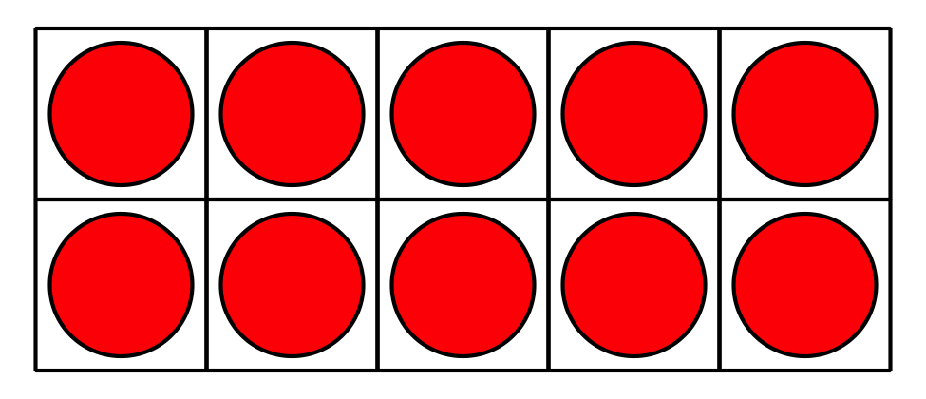

Student Responses
Students draw 4 dots.

