Lesson 5: How Much in Each Group? (Part 1)

5.1: Inventing a Situation
- Think of a situation with a question that can be represented by the equation $12÷\frac{2}{3}= ?$ Describe the situation and the question.
- Trade descriptions with your partner, and answer your partner’s question.

5.2: How Much in One Batch?
To make 5 batches of cookies, 10 cups of flour are required. Consider the question: How many cups of flour does each batch require?
We can write equations and draw a diagram to represent this situation.
$5 ⋅?=10$ $10÷5=?$
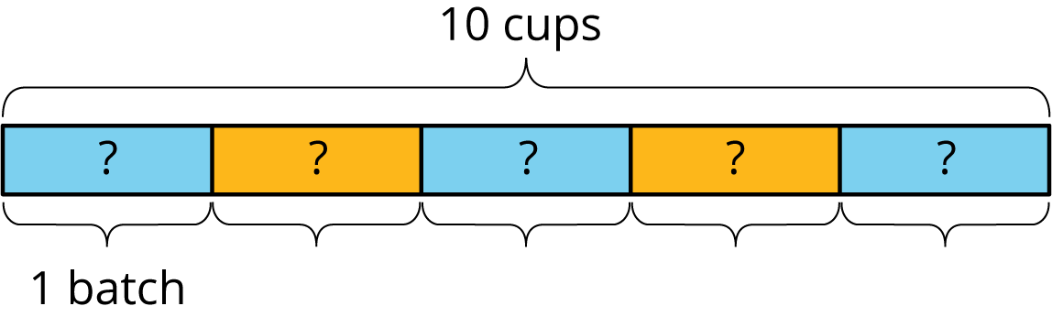
This helps us see that each batch requires 2 cups of flour.
For each question, write a multiplication equation and a division equation, draw a diagram, and find the answer.
- To make 4 batches of cupcakes, it takes 6 cups of flour. How many cups of flour are needed for 1 batch?
- To make $\frac{1}{2}$ batch of rolls, it takes $\frac{5}{4}$ cups of flour. How many cups of flour are needed for 1 batch?
- Two cups of flour make $\frac{2}{3}$ batch of bread. How many cups of flour make 1 batch?

5.3: One Container and One Section of Highway
Here are three tape diagrams that represent situations about filling containers of water.
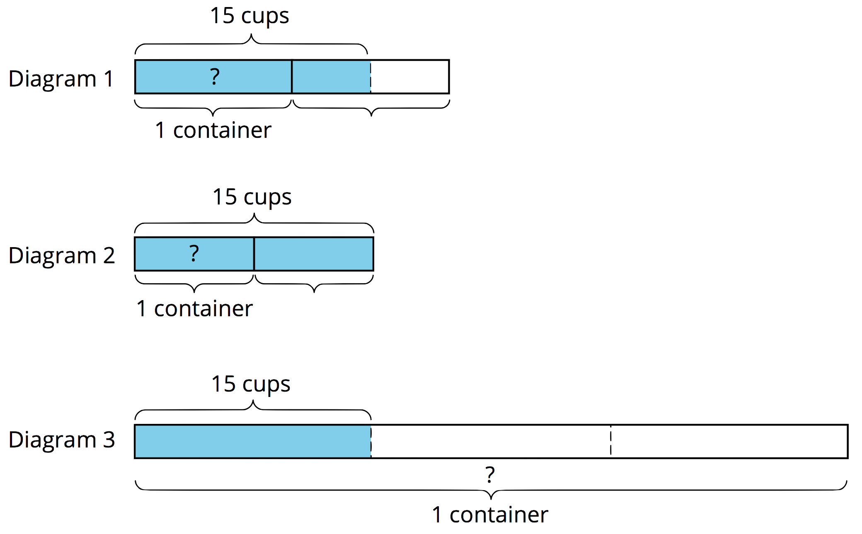
Match each situation to a diagram and use the diagram to help you answer the question. Then, write a multiplication equation and a division equation to represent the situation.
- Tyler poured a total of 15 cups of water into 2 equal-sized bottles and filled each bottle. How much water was in each bottle?
- Kiran poured a total of 15 cups of water into equal-sized pitchers and filled $1\frac{1}{2}$ pitchers. How much water was in the full pitcher?
- It takes 15 cups of water to fill $\frac{1}{3}$ pail. How much water is needed to fill 1 pail?
- Here are tape diagrams that represent situations about cleaning sections of highway.
- 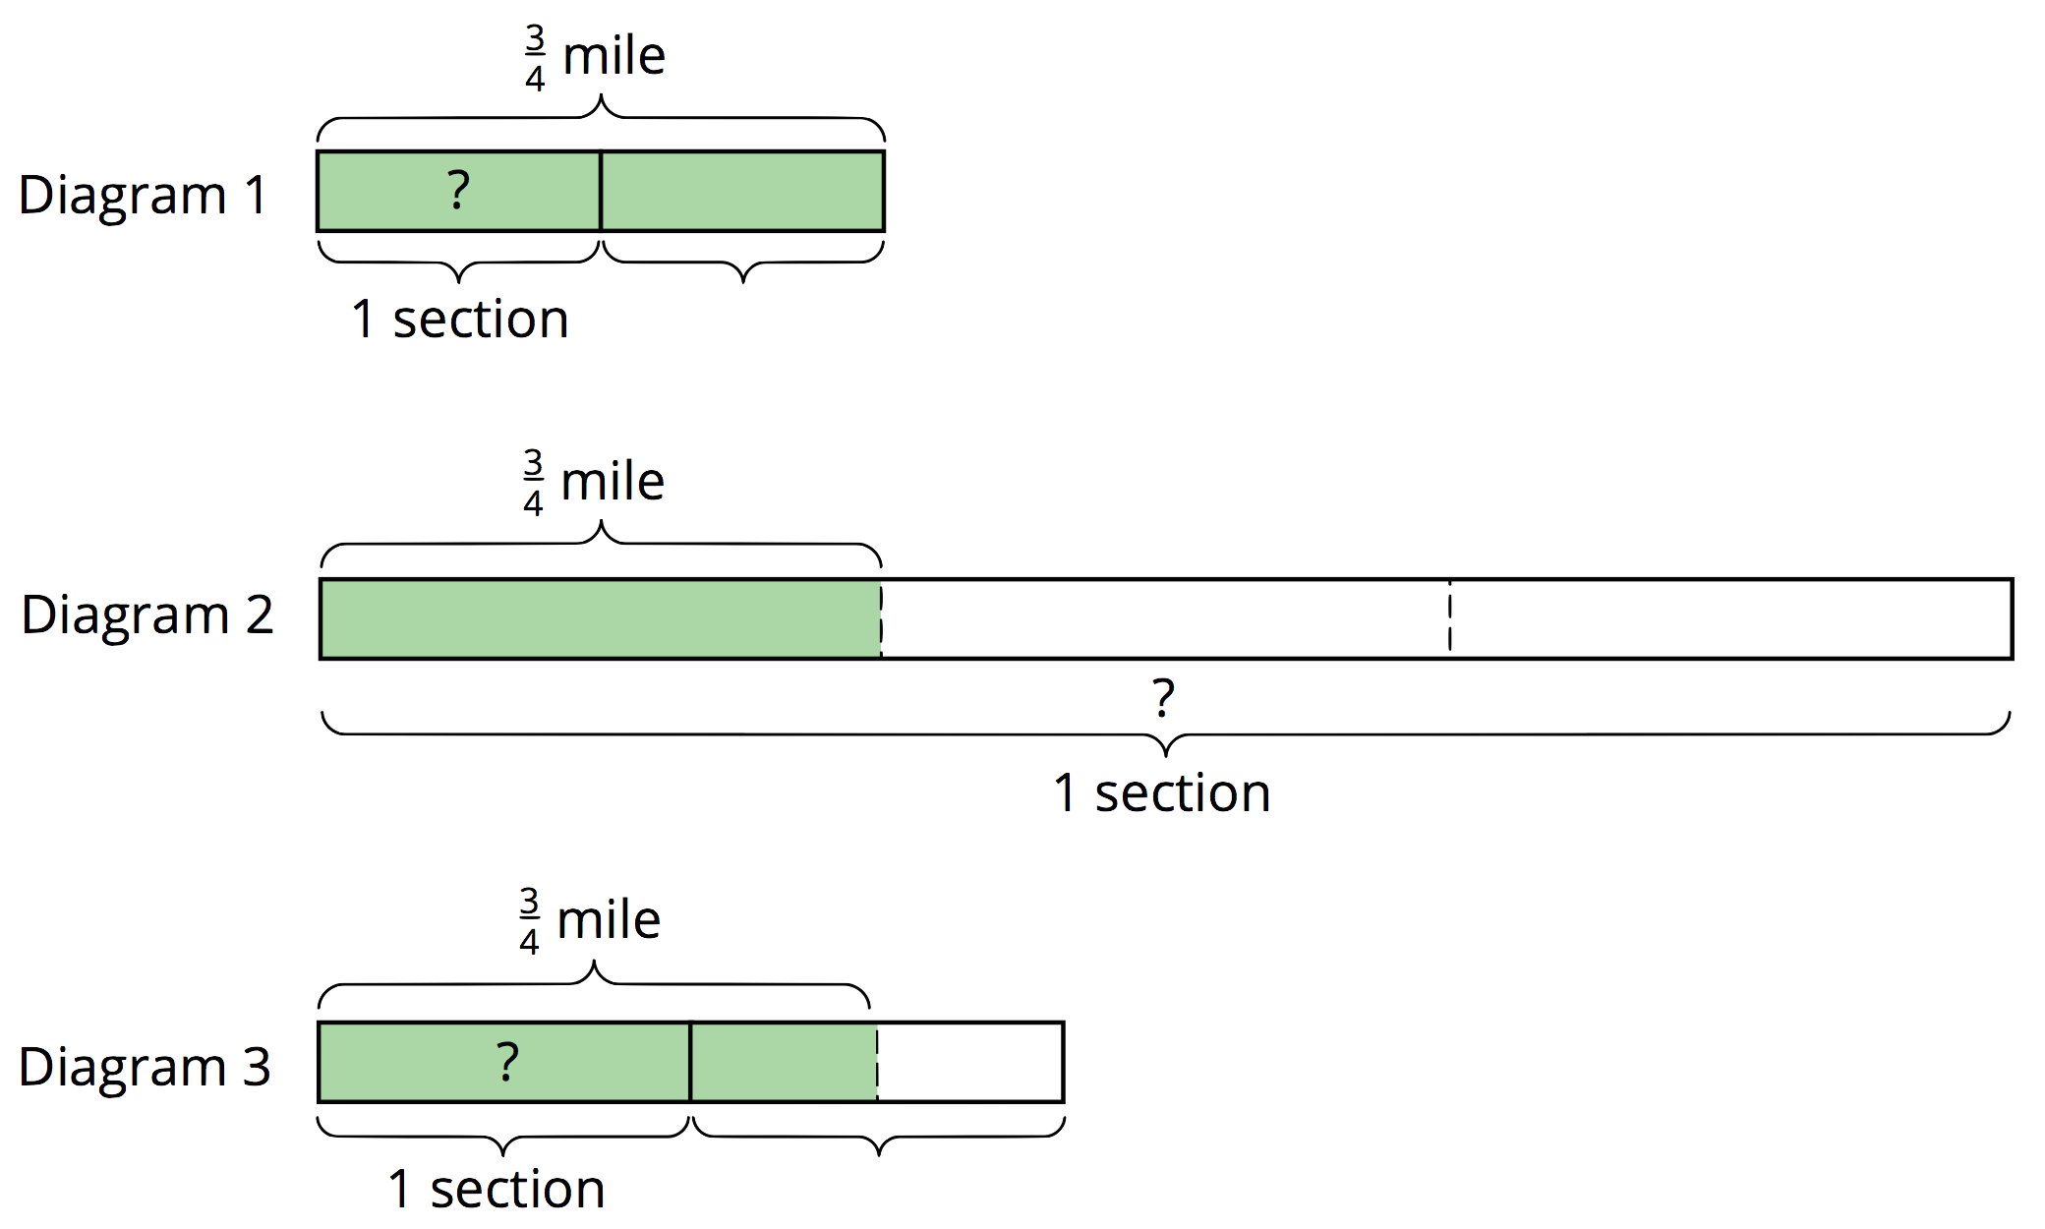
- Match each situation to a diagram and use the diagram to help you answer the question. Then, write a multiplication equation and a division equation to represent the situation.
- Priya’s class has adopted two equal sections of a highway to keep clean. The combined length is $\frac{3}{4}$ of a mile. How long is each section?
- Lin’s class has also adopted some sections of highway to keep clean. If $1\frac{1}{2}$ sections are $\frac{3}{4}$ mile long, how long is each section?
- A school has adopted a section of highway to keep clean. If $\frac{1}{3}$ of the section is $\frac{3}{4}$ mile long, how long is the section?

Are you ready for more?
To make a Cantor ternary set:
- Start with a tape diagram of length 1 unit. This is step 1.
- Color in the middle third of the tape diagram. This is step 2.
- Do the same to each remaining segment that is not colored in. This is step 3.
- Keep repeating this process.
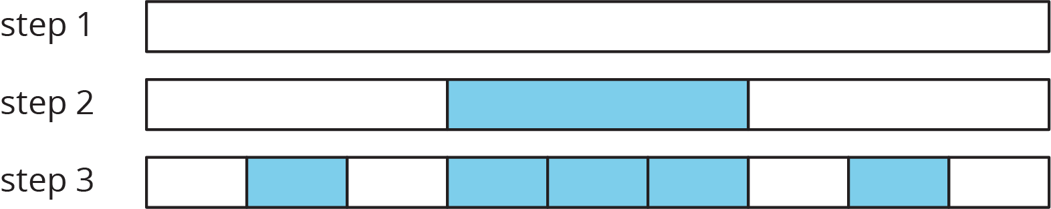
- How much of the diagram is colored in after step 2? Step 3? Step 10?
- If you continue this process, how much of the tape diagram will you color?
- Can you think of a different process that will give you a similar result? For example, color the first fifth instead of the middle third of each strip.

Lesson 5 Summary
Sometimes we know the amount for multiple groups, but we don’t know how much is in one group. We can use division to find out.
For example, if 5 people share $8\frac{1}{2}$ pounds of cherries equally, how many pounds of cherries does each person get?
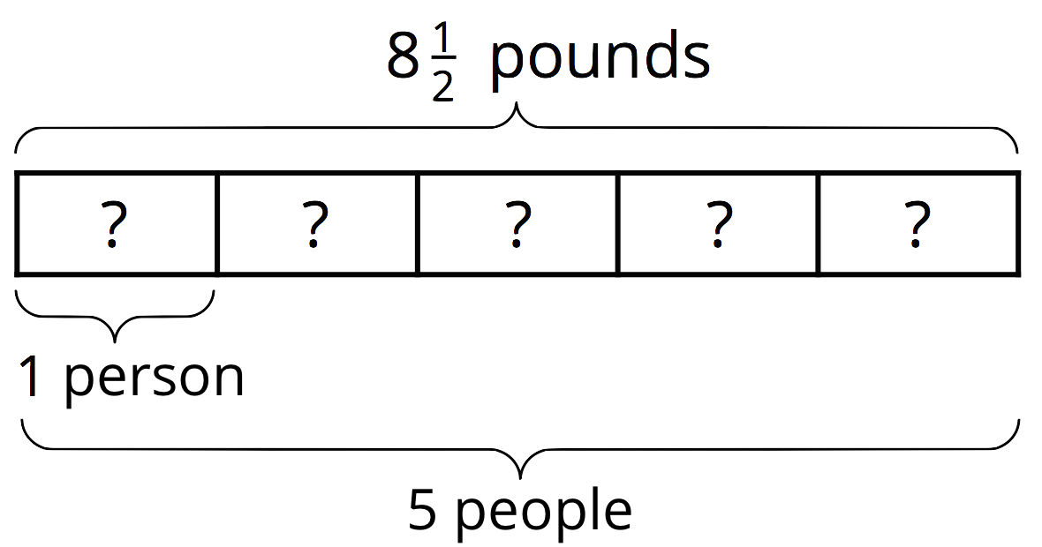
We can represent this situation with a multiplication equation and a division equation: $5 ⋅?=8\frac{1}{2}$ $8\frac{1}{2}÷5=?$
$8\frac{1}{2}÷5$ can be written as $\frac{17}{2}÷5$. Dividing by 5 is equivalent to multiplying by $\frac{1}{5}$, and $\frac{17}{2}⋅\frac{1}{5}=\frac{17}{10}$. This means each person gets $1\frac{7}{10}$ pounds.
Other times, we know the amount for a fraction of a group, but we don’t know the size of one whole group. We can also use division to find out.
For example, Jada poured 5 cups of iced tea in a pitcher and filled $\frac{2}{3}$ of the pitcher. How many cups of iced tea fill the entire pitcher?
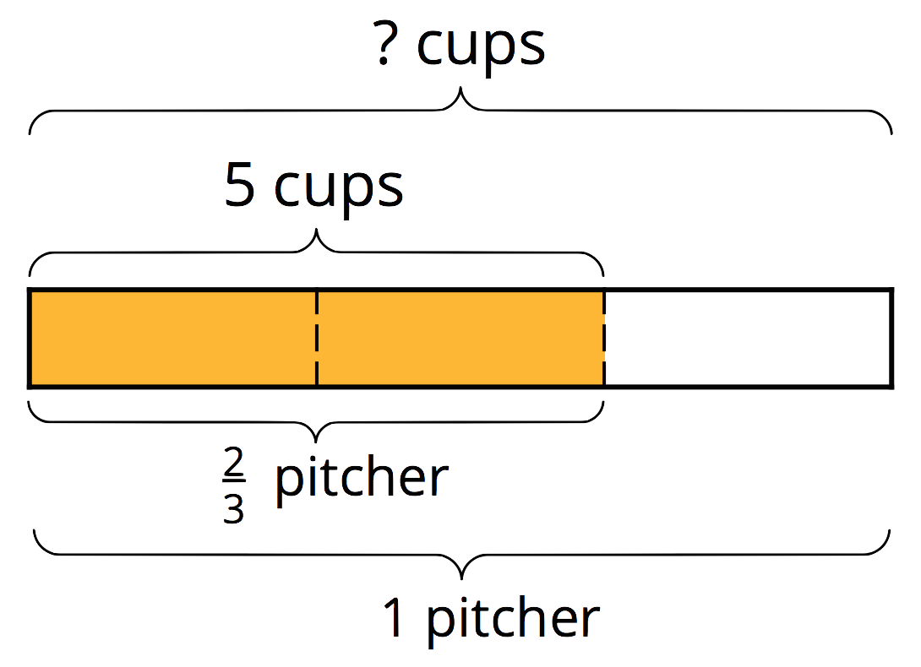
We can represent this situation with a multiplication equation and a division equation: $\frac{2}{3}⋅?=5$ $5÷\frac{2}{3}=?$
The diagram can help us reason about the answer. If $\frac{2}{3}$ of a pitcher is 5 cups, then $\frac{1}{3}$ of a pitcher is half of 5, which is $\frac{5}{2}$. Because there are 3 thirds in 1 whole, there would be $(3⋅\frac{5}{2})$ or $\frac{15}{2}$ cups in one whole pitcher. We can check our answer by multiplying: $\frac{2}{3}⋅\frac{15}{2}=\frac{30}{6}$, and $\frac{30}{6}=5$.
Notice that in the first example, the number of groups is greater than 1 (5 people) and in the second, the number of groups is less than 1 ($\frac{2}{3}$ of a pitcher), but the division and multiplication equations for both situations have the same structures.
© CC BY Open Up Resources. Adaptations CC BY IM.

