Lesson 9: What’s the Correlation?
- Let’s reason about correlation of two variables in a situation.

9.1: Which One Doesn’t Belong: Correlations
Which one doesn’t belong?
A. the number of pictures painted and the amount of paint left in the paint can
B. amount of ice cream eaten the previous summer and number of movies seen this summer
C. distance run and number of water breaks during the run
D. number of people who contracted a genetic disease and presence of the gene that raises risk for the disease

9.2: Correlation Relationships
For each pair of graphs, the linear model fits the data about the same. What do you notice about the variables? How might the variables be related?
1a. the number of cows in some states and the number of chickens in those same states
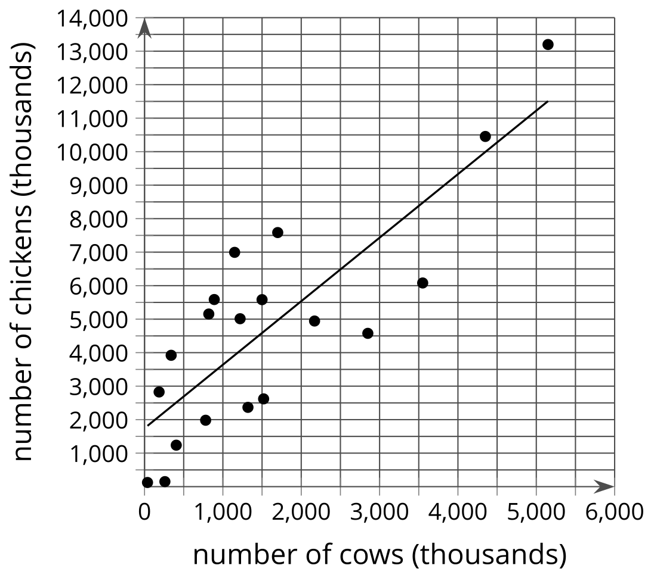
1b. the number of cows in some states and the number of farms in those same states
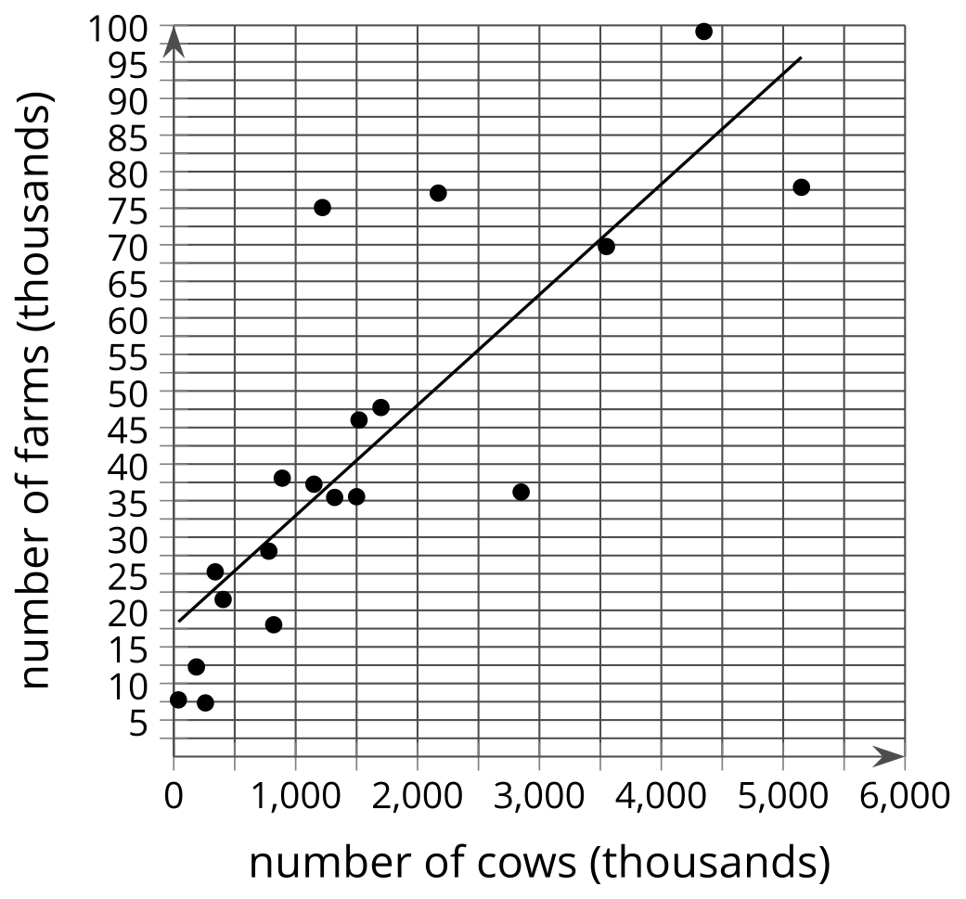
2a. the worth of a person’s house and the worth of that same person’s car
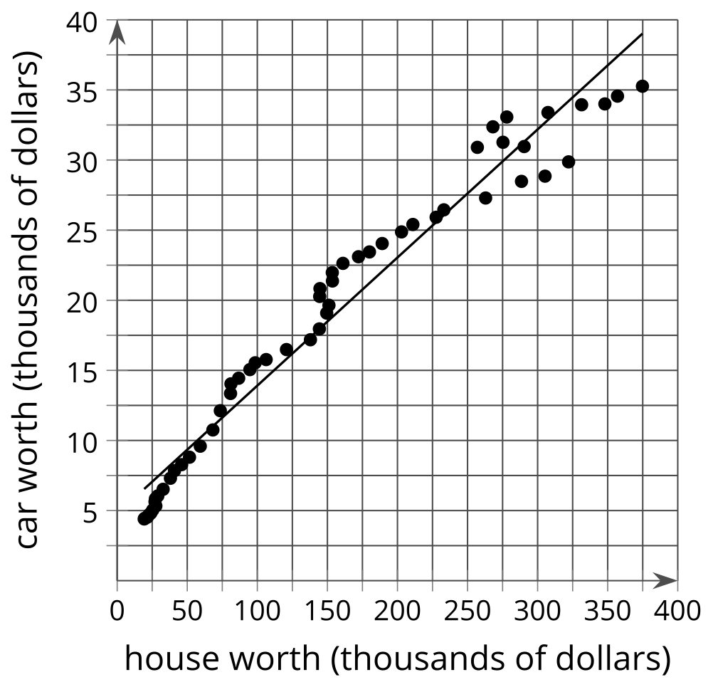
2b. the worth of a person's car and their income
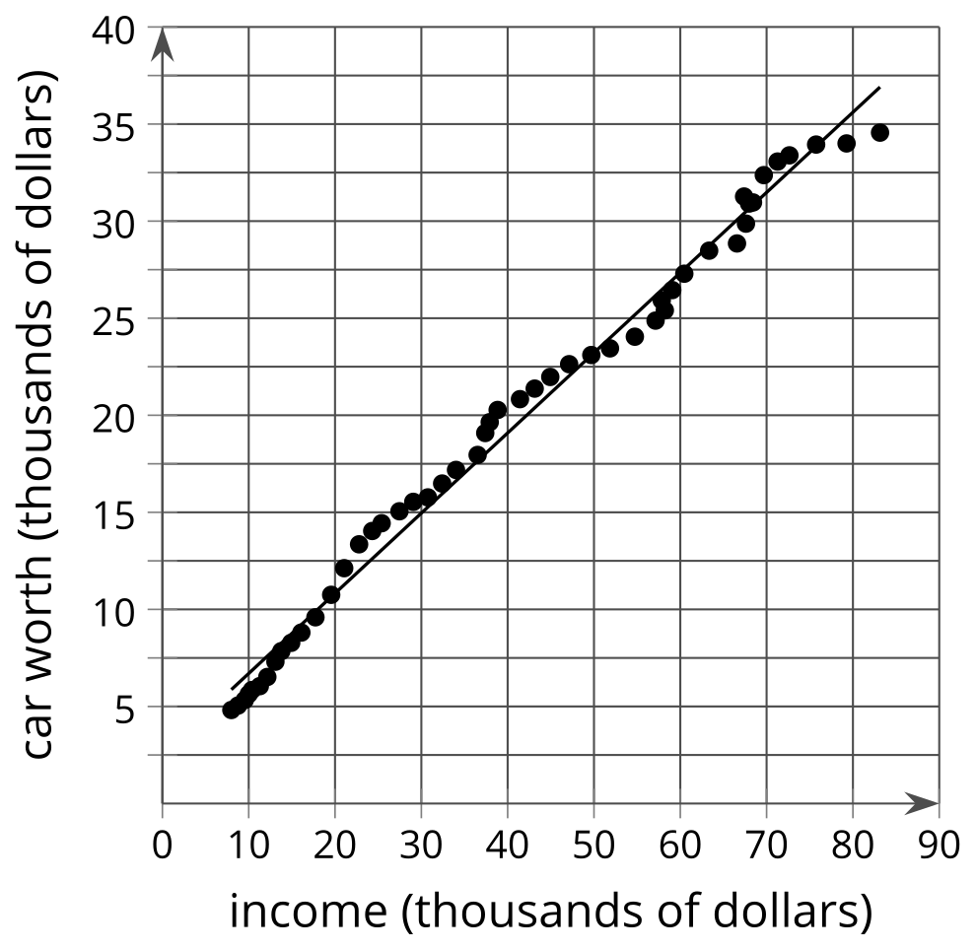
​​​​​​

9.3: It Takes Two
Mai is training for the upcoming track season by running 8 laps around the school track each morning before school. She records her time to complete the 8 laps and notices that she is finishing faster and faster as time goes on. She also notices that she feels better in the morning and her grades in her first class are improving as her times improve.
- In addition to the 2 listed, what other variables are changing in this situation?
  - time to complete 8 laps
  - number of mornings Mai has run 8 laps

- Select 3 pairs of variables from the list. For each pair determine if they are related, then decide whether you think one variable causes the other to change. Explain your reasoning.

© CC BY 2019 by Illustrative Mathematics®

