Unit 6 Lesson 16: Graphing from the Vertex Form

1 Which Form to Use? (Warm up)

Student Task Statement
Expressions in different forms can be used to define the same function. Here are three ways to define a function $f$.
$f\left(x\right)=x^{2}−4x+3$
(standard form)
$f\left(x\right)=\left(x−3\right)\left(x−1\right)$
(factored form)
$f\left(x\right)={\left(x−2\right)}^{2}−1$
(vertex form)
Which form would you use if you want to find the following features of the graph of $f$? Be prepared to explain your reasoning.
- the $x$-intercepts
- the vertex
- the $y$-intercept

2 Sharing a Vertex

Student Task Statement
Here are two equations that define quadratic functions.
$p\left(x\right)=\text{-}{\left(x−4\right)}^{2}+10q\left(x\right)=\frac{1}{2}{\left(x−4\right)}^{2}+10$
- The graph of $p$ passes through $\left(0,\text{-}6\right)$ and $\left(4,10\right)$, as shown on the coordinate plane.
- Find the coordinates of another point on the graph of $p$. Explain or show your reasoning. Then, use the points to sketch and label the graph.
- 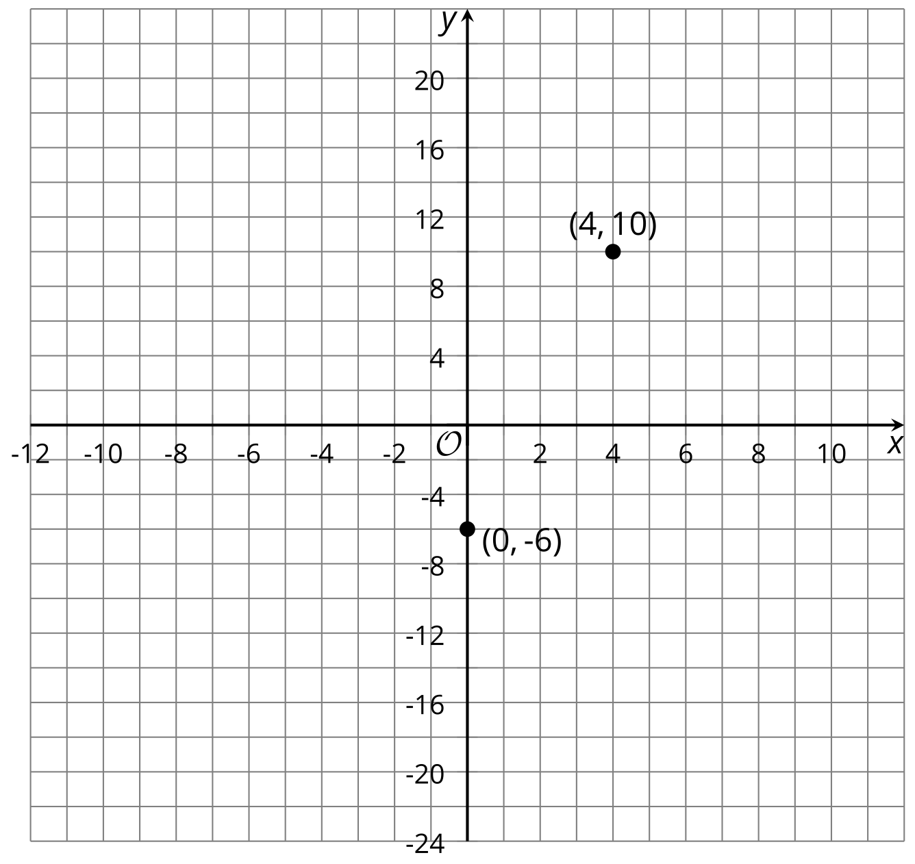
- On the same coordinate plane, identify the vertex and two other points that are on the graph of $q$. Explain or show your reasoning. Sketch and label the graph of $q$.
- Priya says, "Once I know the vertex is $\left(4,10\right)$, I can find out, without graphing, whether the vertex is the maximum or the minimum of function $p$. I would just compare the coordinates of the vertex with the coordinates of a point on either side of it."
- Complete the table and then explain how Priya might have reasoned about whether the vertex is the minimum or maximum.
- $x$ | - 3 | - 4 | - 5
- $p\left(x\right)$ |  | - 10

3 Card Sort: Matching Equations with Graphs

Student Task Statement
Your teacher will give you a set of cards. Each card contains an equation or a graph that represents a quadratic function. Take turns matching each equation to a graph that represents the same function.
- For each pair of cards that you match, explain to your partner how you know they belong together.
- For each pair of cards that your partner matches, listen carefully to their explanation. If you disagree, discuss your thinking and work to reach an agreement.
- Once all the cards are matched, record the equation, the label and a sketch of the corresponding graph, and write a brief note or explanation about how you knew they were a match.
Equation:
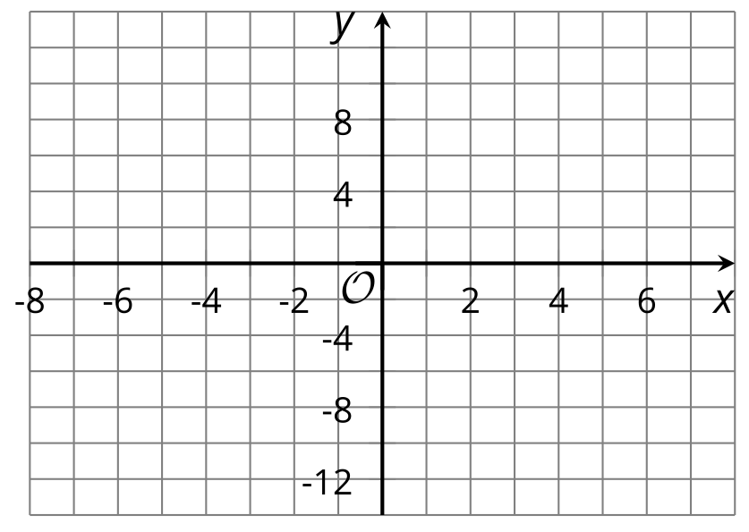
Explanation:
Equation:
Explanation:
Equation:
Explanation:
Equation:
Explanation:
Equation:
Explanation:
Equation:
Explanation:
© CC BY 2019 by Illustrative Mathematics®

