Unit 1 Lesson 22: Now What Can You Build?

1 Notice and Wonder: Dramatic Designs (Warm up)

Student Task Statement
What do you notice? What do you wonder?
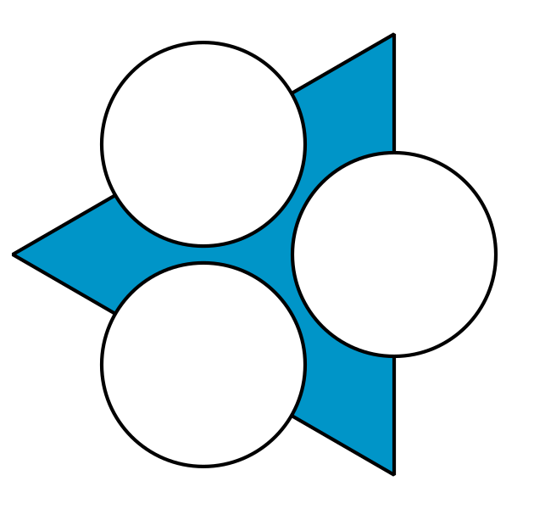
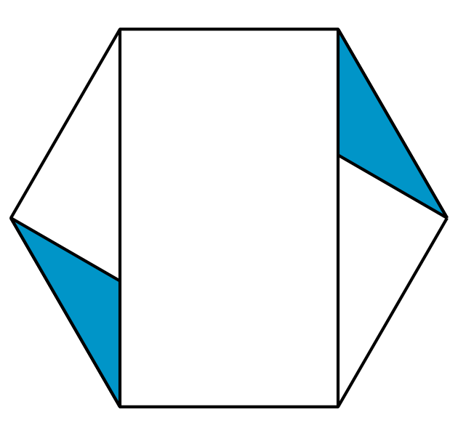

2 Duplicate a Design (Optional)

Student Task Statement
Your teacher will give you a collection of designs that all began from the construction of a regular hexagon. Choose one to use.
- Record any rigid motions (rotation, reflection, or translation) you see in your design.
- Use straightedge and compass moves to recreate the design.
- Write down instructions for how to construct it.

3 Make Your Own Design (Optional)

Student Task Statement
Use straightedge and compass moves to create a new design.
Write down the moves you followed on that same sheet of paper so someone else can recreate your design.

4 Make Their Design (Optional)

Student Task Statement
- Follow the instructions to make a design.
- List everything in the design that is congruent. Explain how you know.
© CC BY 2019 by Illustrative Mathematics®

