Lesson 15 Practice Problems
- For the polynomial function $f\left(x\right)=x^{3}−2x^{2}−5x+6$, we have $f\left(0\right)=6,f\left(2\right)=\text{-}4,f\left(\text{-}2\right)=0,f\left(3\right)=0,f\left(\text{-}1\right)=8,f\left(1\right)=0$. Rewrite $f\left(x\right)$ as a product of linear factors.
- Select all the polynomials that have $\left(x−4\right)$ as a factor.
  - $x^{3}−13x−12$
  - $x^{3}+8x^{2}+19x+12$
  - $x^{3}+6x+5x−12$
  - $x^{3}−x^{2}−10x−8$
  - $x^{2}−4$
- Write a polynomial function, $p\left(x\right)$, with degree 3 that has $p\left(7\right)=0$.
- Long division was used here to divide the polynomial function $p\left(x\right)=x^{3}+7x^{2}−20x−110$ by $\left(x−5\right)$ and to divide it by $\left(x+5\right)$.
- x2+12x+40x−5x3+7x2−20x−110−x3+5x2_−20x−11012x2−20x−110−12x2+60x_−11040x−110−40x+200_90
- x2+2x−30x+5x3+7x2−20x−110−x3−5x2_−20x−1102x2−20x−110−2x2−10x_−110-30x−11030x+150_40
  - What is $p\left(\text{-}5\right)$?
  - What is $p\left(5\right)$?
- Which polynomial function has zeros when $x=5,\frac{2}{3},\text{-}7$?
  - $f\left(x\right)=\left(x+5\right)\left(2x+3\right)\left(x−7\right)$
  - $f\left(x\right)=\left(x+5\right)\left(3x+2\right)\left(x−7\right)$
  - $f\left(x\right)=\left(x−5\right)\left(2x−3\right)\left(x+7\right)$
  - $f\left(x\right)=\left(x−5\right)\left(3x−2\right)\left(x+7\right)$
- (From Unit 2, Lesson 5.)
- The polynomial function $q\left(x\right)=3x^{4}+8x^{3}−13x^{2}−22x+24$ has known factors $\left(x+3\right)$ and $\left(x+2\right)$. Rewrite $q\left(x\right)$ as the product of linear factors.
- (From Unit 2, Lesson 12.)
- We know these things about a polynomial function $f\left(x\right)$: it has degree 3, the leading coefficient is negative, and it has zeros at $x=\text{-}5,\text{-}1,3$. Sketch a graph of $f\left(x\right)$ given this information.
- 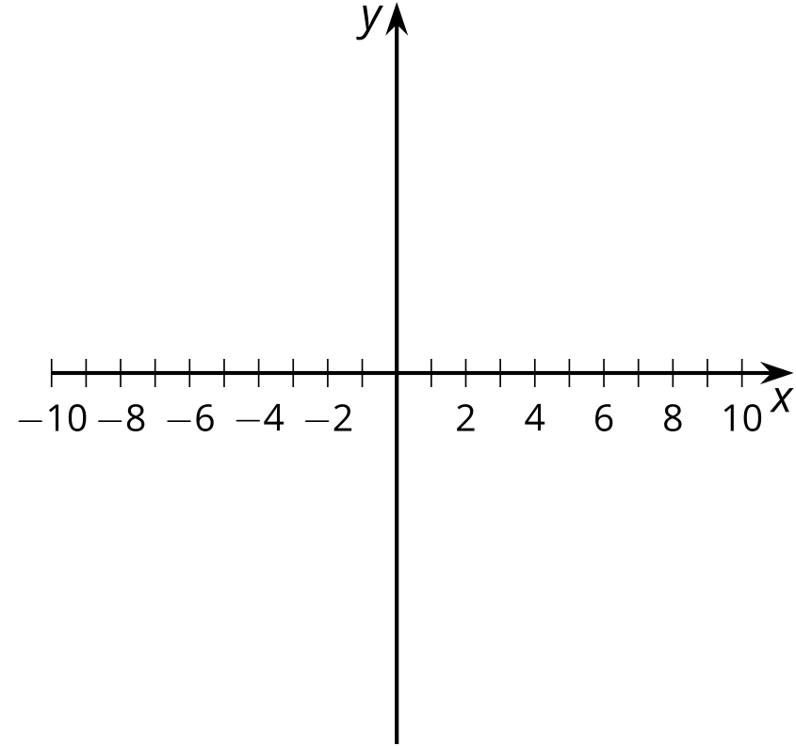
- (From Unit 2, Lesson 14.)
© CC BY 2019 by Illustrative Mathematics®

