Lesson 1: Whole Numbers on the Number Line
- Let’s represent numbers on a number line.

Warm-up: Notice and Wonder: Rulers and Number Lines
What do you notice? What do you wonder?
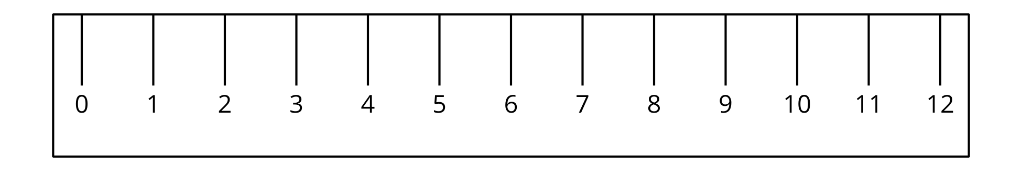

1.1: What is a Number Line?
- Label each tick mark with the number it represents.
- 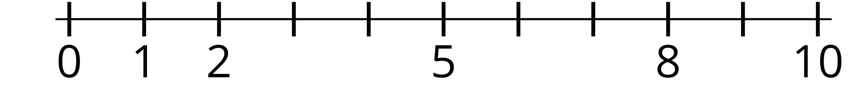
- Locate 6 on the number line. Mark it with a point.
- Locate a number on the number line that is greater than 6. Mark it with a point.
- Label each tick mark with the number it represents.
- Locate 9 on the number line. Mark it with a point.
- Locate a number on the number line that is less than 9. Mark it with a point.

1.2: Make Your Own Number Line
- Make a number line that goes from 0 to 20.
- Locate 13 on your number line. Mark it with a point.
- Locate 3 on your number line. Mark it with a point.
- Compare your number line with your partner’s.
© CC BY 2021 Illustrative Mathematics®

