Lesson 3: A Change is Coming
- Let's solve story problems and find the answer in equations.

Warm-up: Notice and Wonder: Kiran’s Books
What do you notice?
What do you wonder?
Kiran has some books.
His friend gives him some more books.
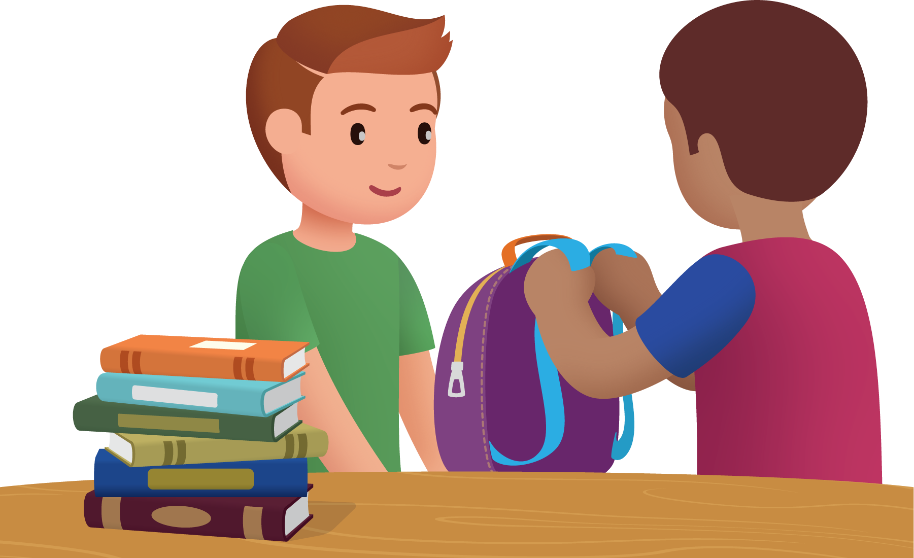

3.1: Kiran’s Books
Kiran has 6 books.
His friend gives him some more books.
Now he has 8 books.
How many books did Kiran get from his friend?
Show your thinking using drawings, numbers, or words.

3.2: Lin Represents a Story Problem
- Andre checked out some books from the library.
Mai gives him more books.
Now he has 9 books.
- What do you notice?
What do you wonder?
- Andre checked out 3 books from the library.
Mai gives him some more books.
Now he has 9 books.
How many books did Mai give him?
- Lin made this drawing.
- 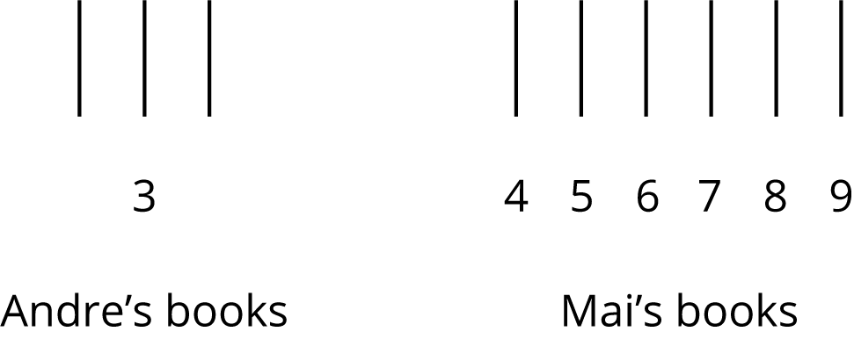
- She wrote the equation
- $3+6=\boxed{9}$
- Is her equation correct?
Show your thinking using drawings, number, or words.

3.3: Centers: Choice Time
Choose a center.
Sort and Display
Check it Off
What’s Behind My Back
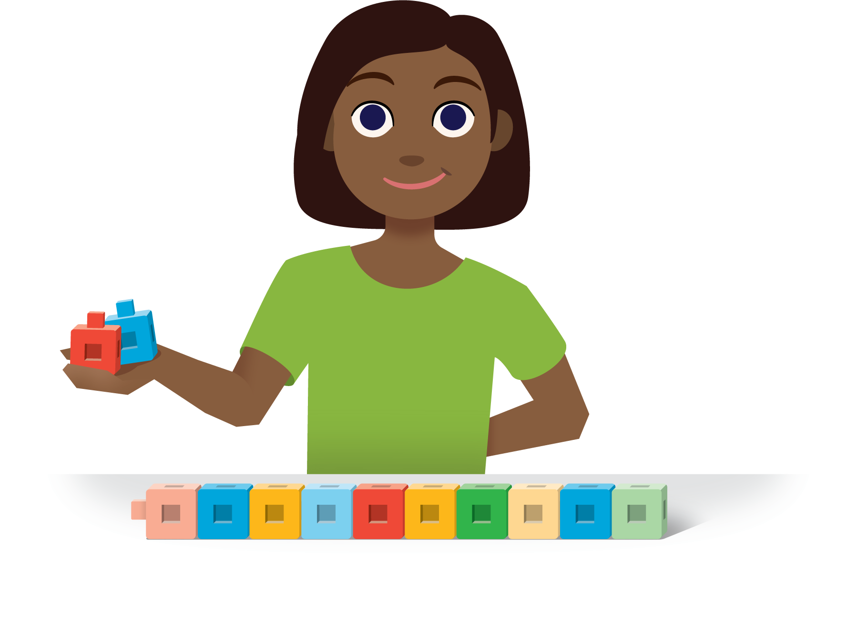
© CC BY 2021 Illustrative Mathematics®

