Lesson 14: Problems about Fractional Measurement Data

Standards Alignments
Addressing | 4.MD.B.4, 4.NF.B.3.c
Building Towards | 4.MD.B.4

Teacher-facing Learning Goals
- Use information on line plots to solve problems involving addition and subtraction of fractions and mixed numbers.

Student-facing Learning Goals
- Let’s solve problems involving measurement data on line plots.

Lesson Purpose
The purpose of this lesson is for students to solve problems using information presented in line plots.
Previously, students organized and analyzed measurement data on a line plot. They also learned to express equivalent fractions (for example, they expressed 3 fourths as 6 eighths). In this lesson, they continue to use these skills, along with their knowledge of addition and subtraction of fractions with the same denominator, to solve problems involving fractional measurements.
This lesson has a Student Section Summary.

Access for:

Students with Disabilities
- Representation (Activity 1)

English Learners
- MLR8 (Activity 2)

Instructional Routines
Notice and Wonder (Warm-up)

Lesson Timeline
Warm-up | 10 min
Activity 1 | 20 min
Activity 2 | 15 min
Lesson Synthesis | 10 min
Cool-down | 5 min

Teacher Reflection Question
Which question asked during this lesson generated the most discourse? What was it about this question to motivate student thinking? How might you use the structure of this question moving forward in upcoming lessons?

Cool-down
(to be completed at the end of the lesson) 5min
Fourth-grade Height Data

Standards Alignments
Addressing | 4.MD.B.4

Student-facing Task Statement
The students in a fourth-grade class keep track of their height all year long. The line plot shows the number of inches each student in the class has grown this year.
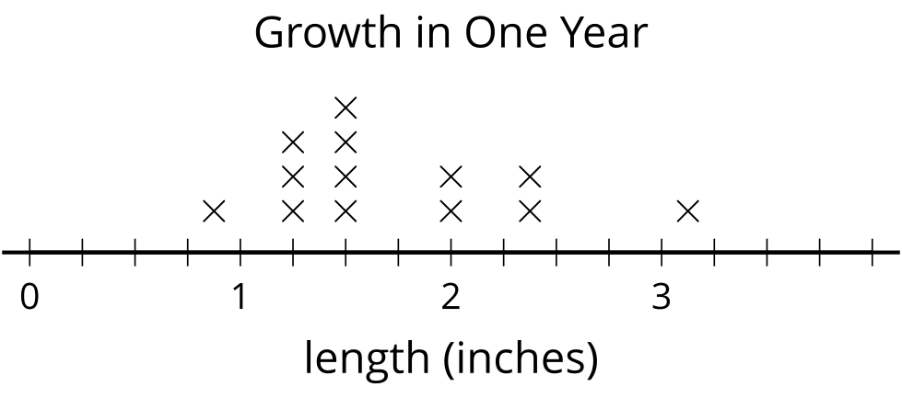
- How many students grew more than $1\frac{3}{8}$ inches? Explain your reasoning.
- What is the difference between the greatest amount of growth and the least amount of growth in inches?

Student Responses
- Nine students grew more than $1\frac{3}{8}$ inches. Sample response: $\frac{3}{8}$ is located between $1\frac{1}{4}$ and $1\frac{2}{4}$ and there are 9 points to the right of $1\frac{3}{8}$.
- $2\frac{2}{8}$ inches. Sample response: $3\frac{1}{8}−\frac{7}{8}=2\frac{9}{8}−\frac{7}{8}=2\frac{2}{8}$.

