Lesson 10: Longitudes de lado fraccionarias y menores que 1

Standards Alignments
Addressing | 5.NF.B.3, 5.NF.B.4.a, 5.NF.B.4.b
Building Towards | 5.NF.B.4

Teacher-facing Learning Goals
- Find the area of a rectangle with one non-unit fractional side length.
- Represent the area of a rectangle with a multiplication expression.

Student-facing Learning Goals
- Encontremos el área de rectángulos que tienen un lado de longitud fraccionaria.

Lesson Purpose
The purpose of this lesson is for students to find the area of rectangles with one non-unit fractional side length and one whole number side length.
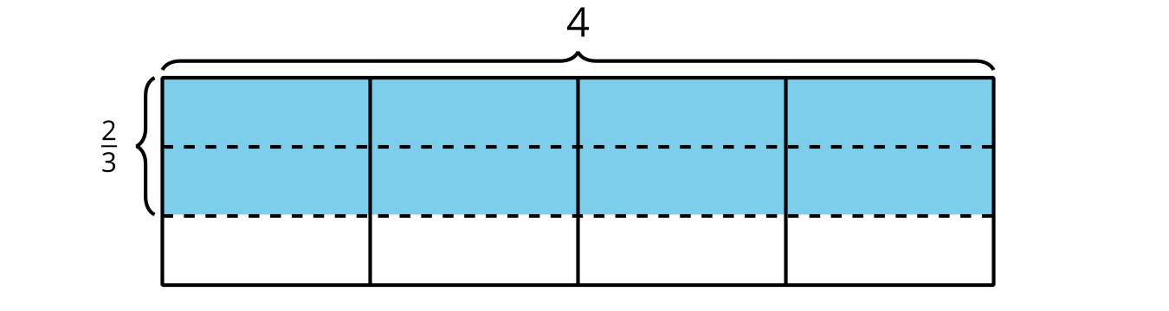
In the previous lesson, students extended their understanding of multiplication to find the area of rectangles with a side length that is a unit fraction. In this lesson, students will find the area of rectangles with a whole number side length and a non-unit fraction side length. Students will apply what they learned in earlier lessons to area representations and recognize that a side length of $\frac{a}{b}$ is equivalent to a side length of $a×\frac{1}{b}$. This allows them to find areas by counting the number of pieces covering the area and then multiplying this by the unit fractional area of each piece. For example, in the image below, there are 8 shaded pieces and each piece has an area of $\frac{1}{3}$ square unit.

Access for:

Students with Disabilities
- Representation (Activity 1)

English Learners
- MLR2 (Activity 2)

Instructional Routines
5 Practices (Activity 1), Estimation Exploration (Warm-up)

Lesson Timeline
Warm-up | 10 min
Activity 1 | 20 min
Activity 2 | 15 min
Lesson Synthesis | 10 min
Cool-down | 5 min

Teacher Reflection Question
In the next lesson, students will find the area of a rectangle where one of the side lengths is a fraction greater than 1. Try finding the area of a rectangle that is $\frac{5}{4}$ by 6. How do the understandings in today’s lesson support how you found the area of that rectangle?

Cool-down
(to be completed at the end of the lesson) 5min
Un lado de longitud fraccionaria

Standards Alignments
Addressing | 5.NF.B.4.b

Student-facing Task Statement
- Escribe una expresión de multiplicación que represente el área de la región sombreada.
- 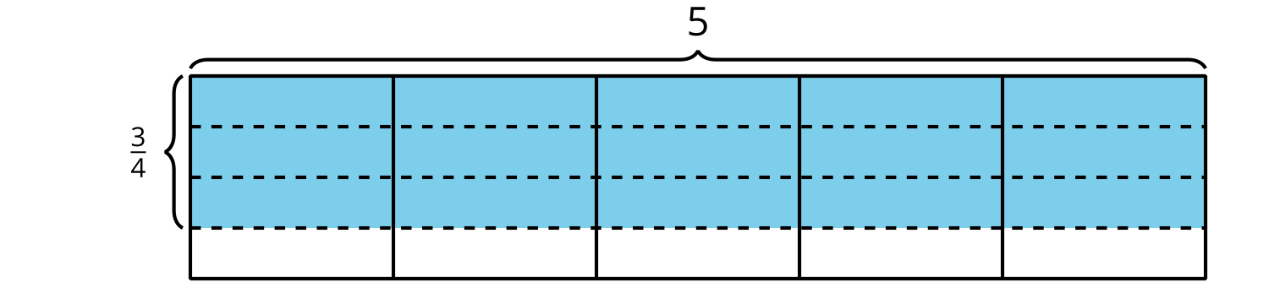
- Encuentra el área de la región sombreada.

Student Responses
- $\frac{3}{4}×5$ or $5×\frac{3}{4}$
- $\frac{15}{4}$ or $3\frac{3}{4}$ square units

