Lesson 6: Methods for Multiplying Decimals
Let’s look at some ways we can represent multiplication of decimals.

6.1: Equivalent Expressions
Write as many expressions as you can think of that are equal to 0.6. Do not use addition or subtraction.

6.2: Using Properties of Numbers to Reason about Multiplication
Elena and Noah used different methods to compute $\left(0.23\right)⋅\left(1.5\right)$. Both calculations were correct.
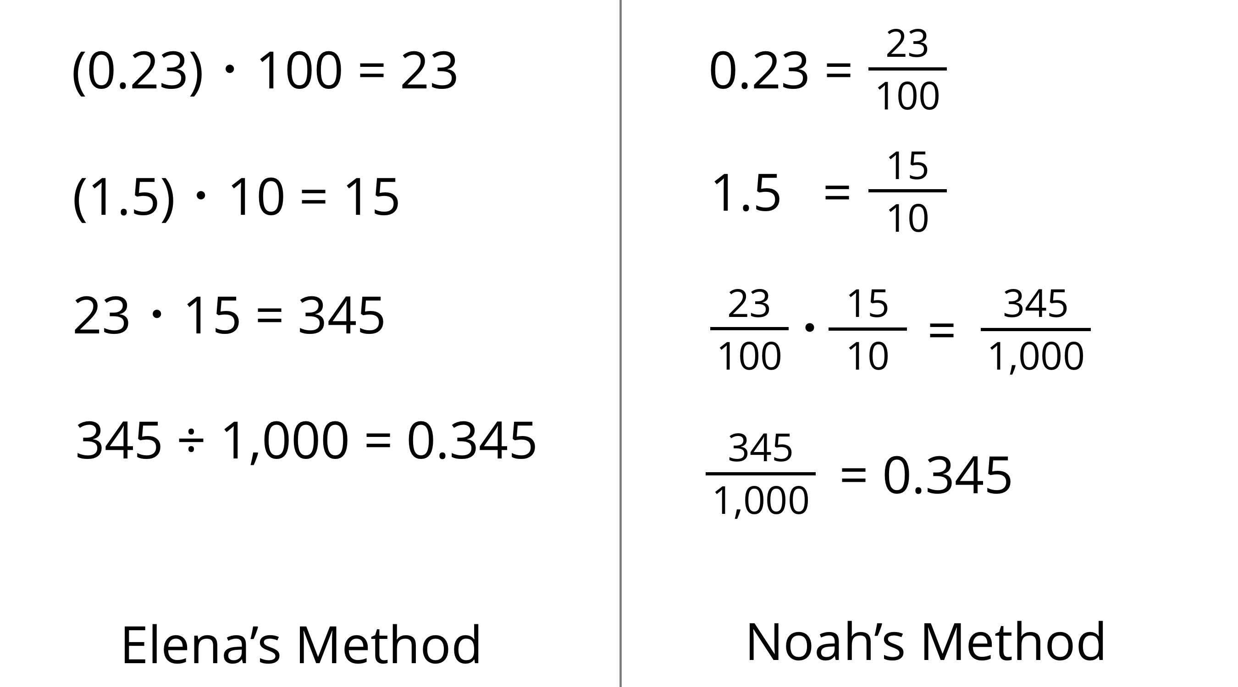
- Analyze the two methods, then discuss these questions with your partner.
  - Which method makes more sense to you? Why?
  - What might Elena do to compute $\left(0.16\right)⋅\left(0.03\right)$? What might Noah do to compute $\left(0.16\right)⋅\left(0.03\right)$? Will the two methods result in the same value?
- Compute each product using the equation $21⋅47=987$ and what you know about fractions, decimals, and place value. Explain or show your reasoning.
  - $\left(2.1\right)⋅\left(4.7\right)$
  - $21⋅\left(0.047\right)$
  - $\left(0.021\right)⋅\left(4.7\right)$

6.3: Using Area Diagrams to Reason about Multiplication
- In the diagram, the side length of each square is 0.1 unit.
  - Explain why the area of each square is not 0.1 square unit.
  - 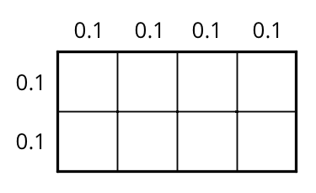
  - How can you use the area of each square to find the area of the rectangle? Explain or show your reasoning.
  - Explain how the diagram shows that the equation $\left(0.4\right)⋅\left(0.2\right)=0.08$ is true.
- Label the squares with their side lengths so the area of this rectangle represents $40⋅20$.
  - What is the area of each square?
  - Use the squares to help you find $40⋅20$. Explain or show your reasoning.
- 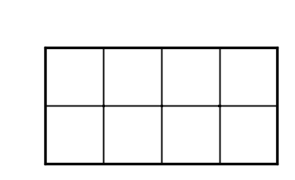
- Label the squares with their side lengths so the area of this rectangle represents $\left(0.04\right)⋅\left(0.02\right)$.
- Next, use the diagram to help you find $\left(0.04\right)⋅\left(0.02\right)$. Explain or show your reasoning.

Lesson 6 Summary
Here are three other ways to calculate a product of two decimals such as $\left(0.04\right)⋅\left(0.07\right)$.
- First, we can multiply each decimal by the same power of 10 to obtain whole-number factors.
- Because we multiplied both 0.04 and 0.07 by 100 to get 4 and 7, the product 28 is $\left(100⋅100\right)$ times the original product, so we need to divide 28 by 10,000.
- $\left(0.04\right)⋅100=4$
- $\left(0.07\right)⋅100=7$
- $4⋅7=28$
- $28÷10,​000=0.0028$
- Second, we can write each decimal as a fraction, $0.04=\frac{4}{100}$ and $0.07=\frac{7}{100}$, and multiply them. $\frac{4}{100}⋅\frac{7}{100}=\frac{28}{10,​000}=0.0028$
- Third, we can use an area model. The product $\left(0.04\right)⋅\left(0.07\right)$ can be thought of as the area of a rectangle with side lengths of 0.04 unit and 0.07 unit.
- 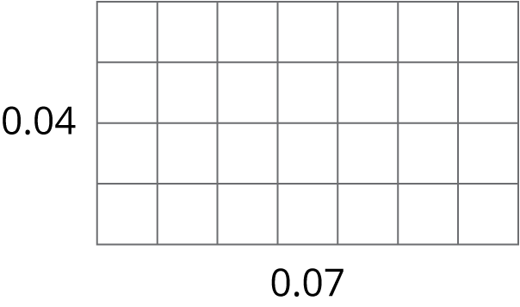
- In this diagram, each small square is 0.01 unit by 0.01 unit. The area of each square, in square units, is therefore $\left(\frac{1}{100}⋅\frac{1}{100}\right)$, which is $\frac{1}{10,000}$.
- Because the rectangle is composed of 28 small squares, the area of the rectangle, in square units, must be: $28⋅\frac{1}{10,000}=\frac{28}{10,000}=0.0028$
All three calculations show that $\left(0.04\right)⋅\left(0.07\right)=0.0028$.
© CC BY Open Up Resources. Adaptations CC BY IM.

