Lesson 7: Observing More Patterns in Scatter Plots

7.1: Notice and Wonder: Nonlinear Scatter Plot
What do you notice? What do you wonder?
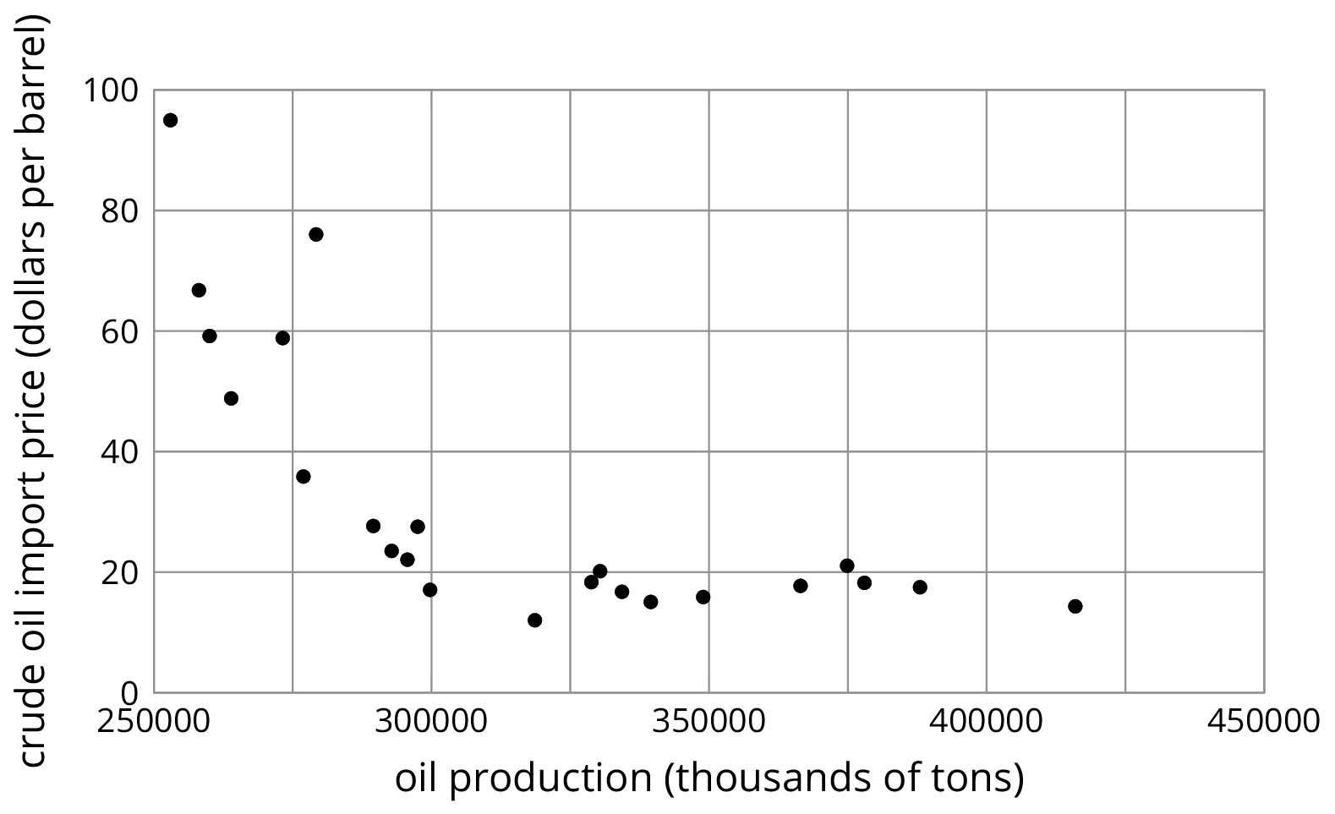

7.2: Scatter Plot City
Your teacher will give you a set of cards. Each card shows a scatter plot.
- Sort the cards into categories and describe each category.
- Explain the reasoning behind your categories to your partner. Listen to your partner’s reasoning for their categories.
- Sort the cards into two categories: positive associations and negative associations. Compare your sorting with your partner’s and discuss any disagreements.
- Sort the cards into two categories: linear associations and non-linear associations. Compare your sorting with your partner’s and discuss any disagreements.

7.3: Clustering
How are these scatter plots alike? How are they different?
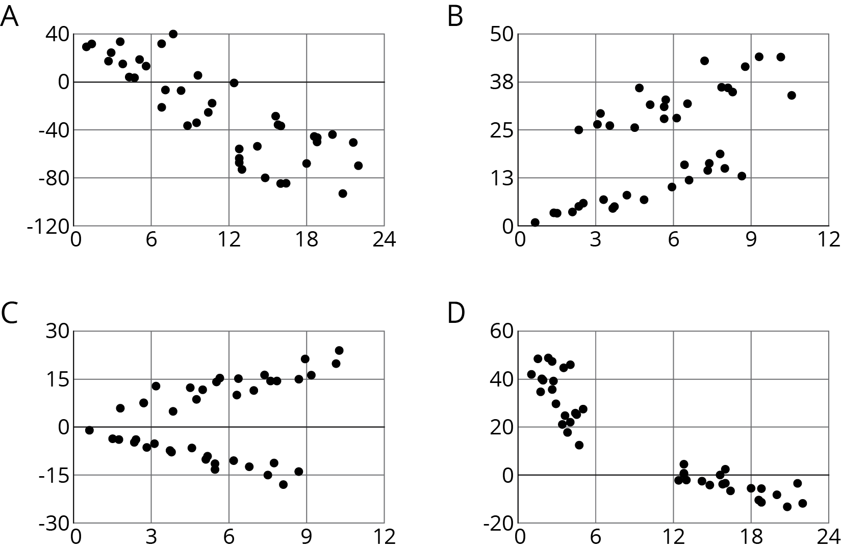

Lesson 7 Summary
Sometimes a scatter plot shows an association that is not linear:
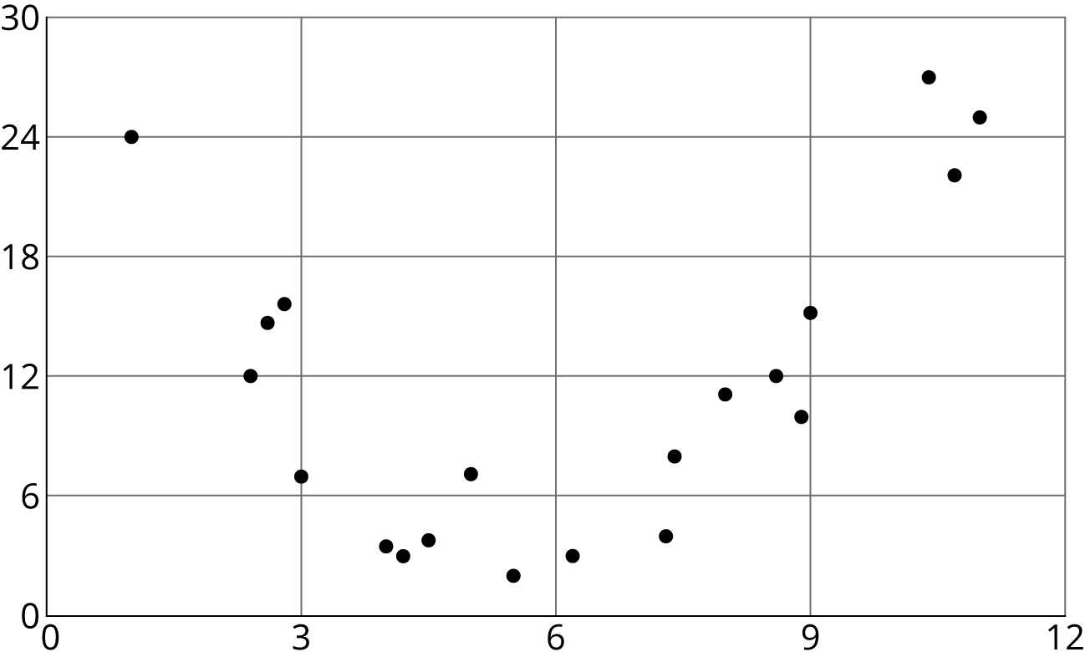
We call such an association a non-linear association. In later grades, you will study functions that can be models for non-linear associations.
Sometimes in a scatter plot we can see separate groups of points.
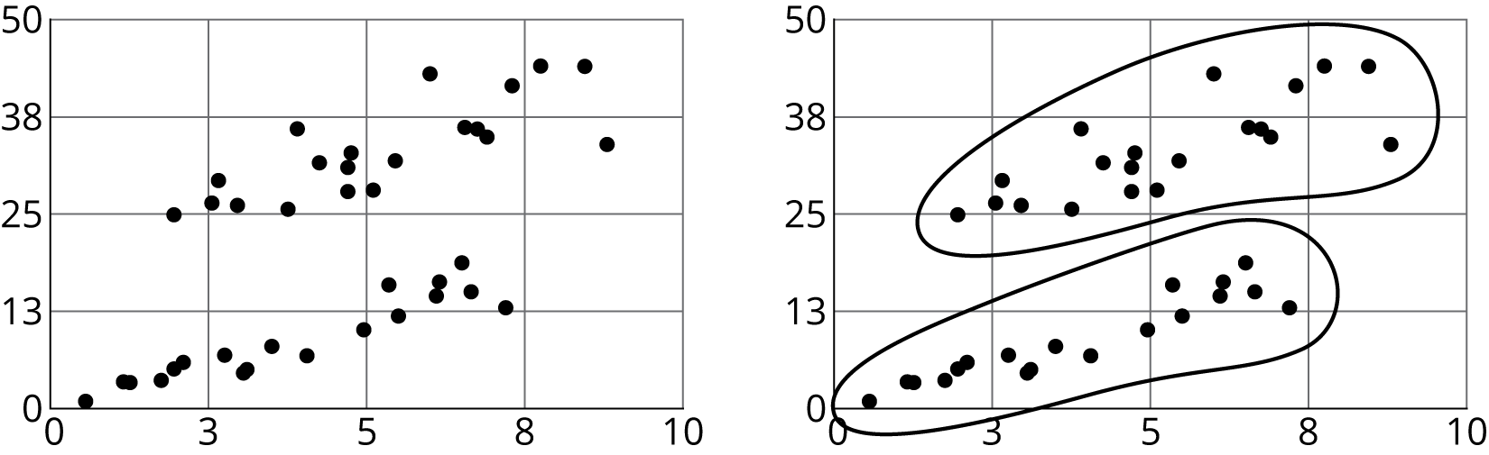
We call these groups clusters.
© CC BY Open Up Resources. Adaptations CC BY IM.

