Unit 6 Lesson 10: Parallel Lines in the Plane

1 Translating Lines (Warm up)

Student Task Statement
- Draw any non-vertical line in the plane. Draw 2 possible translations of the line.
- 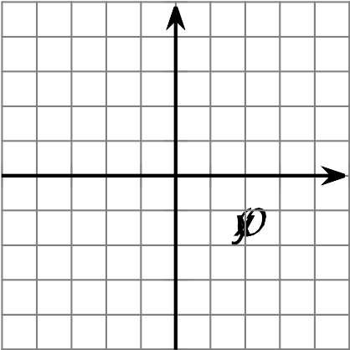
- Find the slope of your original line and the slopes of the images.

2 Priya’s Proof

Images for Launch

Student Task Statement
Priya writes a proof saying:
Consider any 2 parallel lines. Assume they are not horizontal or vertical. Therefore they must pass through the $x$-axis as well as the $y$-axis. This forms 2 right triangles with a second congruent angle. Call the angle $θ$. The tangent of $θ$ is equal for both triangles. Therefore the lines have the same slope.
- How does Priya know the right triangles have a second congruent angle?
- Show or explain what it means that the tangent of $θ$ is equal for both triangles.
- How does this prove the slopes of parallel lines are equal?

Activity Synthesis

3 Prove Your Parallelogram

Student Task Statement
- Write the equation of a line parallel to $y=2x+3$, passing through $(\text{-}4,1)$.
- Graph both lines described in the previous question.
- Draw a parallelogram using the 2 lines you graphed and using $(\text{-}4,1)$ as one of the vertices.
- Prove that your figure is a parallelogram.

Images for Activity Synthesis
© CC BY 2019 by Illustrative Mathematics®

