Lesson 6: Comparemos longitudes de reptiles en problemas-historia

Standards Alignments
Addressing | 2.MD.B.5, 2.NBT.B.5, 2.OA.A.1, 2.OA.B.2

Teacher-facing Learning Goals
- Solve addition and subtraction story problems about length.

Student-facing Learning Goals
- Resolvamos problemas-historia sobre longitudes de reptiles.

Lesson Purpose
The purpose of this lesson is for students to solve Compare story problems within 100 involving length.
In previous lessons, students measured lengths and determined how much longer one object is than another using centimeters. They have also developed strategies for adding and subtracting numbers within 100.
This lesson combines these skills. Students interpret story problems about length measurements whose solution requires addition and subtraction within 100. In each activity, students solve Compare problems in situations where the language of the problem may direct students to use an incorrect operation. Throughout the lesson, they are encouraged to make sense of and use tape diagrams to visualize the measurement contexts and make sense of the lengths and their relationships (MP1, MP2).
This lesson has a Student Section Summary.

Access for:

Students with Disabilities
- Action and Expression (Activity 1)

English Learners
- MLR8 (Activity 2)

Instructional Routines
MLR6 Three Reads (Activity 1), Number Talk (Warm-up)

Materials to Gather
- Base-ten blocks: Activity 1, Activity 2

Lesson Timeline
Warm-up | 10 min
Activity 1 | 20 min
Activity 2 | 15 min
Lesson Synthesis | 10 min
Cool-down | 5 min

Teacher Reflection Question
What representations have been most helpful for the students as they solve story problems? What do you notice in their work from today’s lesson that you might leverage in a future lesson?

Cool-down
(to be completed at the end of the lesson) 5min
Kiran y Han comparan mascotas

Standards Alignments
Addressing | 2.MD.B.5, 2.OA.A.1

Student-facing Task Statement
La serpiente mascota de Kiran mide 47 cm de largo. Esta es 26 cm más corta que la serpiente mascota de Han.
¿Cuál es la longitud de la serpiente mascota de Han?
- Marca el diagrama que corresponde a la historia.
- 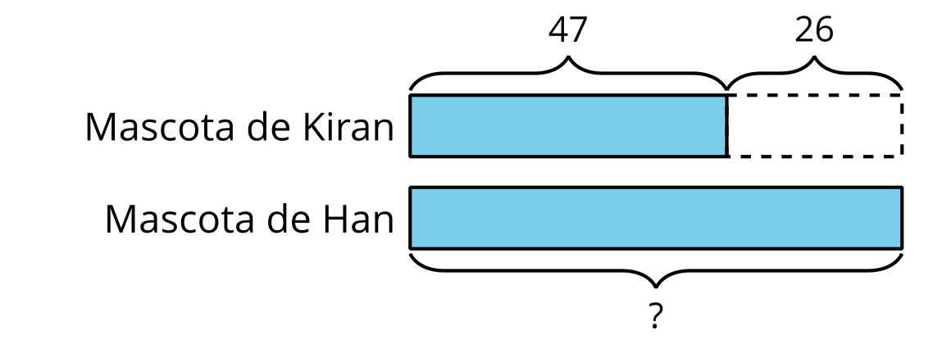
- 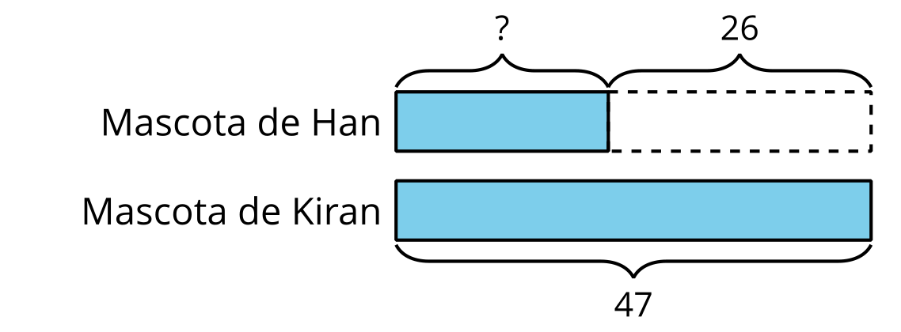
- Resuelve. Muestra cómo pensaste.
- La serpiente de Han mide _______________ cm de largo.

Student Responses
- Students circle the tape diagram showing Han's pet as the larger unknown.
- Han’s snake is 73 cm long. Sample response: $40+20=607+6=1360+10+3=7347+26=73$

