Lesson 8 Practice Problems
- Jada rolls one standard number cube, then she rolls another standard number cube.
  - What is the probability that she rolls a 5 on both number cubes?
  - What is the probability that the second roll is a 5 under the condition that the first roll is a 6?
  - What is the probability that the second roll is a 5 under the condition that the first roll is a 5?
  - What is the probability that the second roll is not a 5?
  - What is the probability that the first roll is a 5 and the second roll is not a 5?
- There are four slices of pizza left to choose from. Each slice of pizza has one topping. Three of the slices have sausage as a topping and the fourth slice has pepperoni as a topping. Kiran randomly selects one slice then Mai randomly selects one slice. What is the probability that Mai selects a slice of pepperoni pizza under the condition that Kiran selects a slice of sausage pizza?
  - $\frac{1}{3}$
  - $\frac{1}{4}$
  - $\frac{2}{3}$
  - $\frac{2}{4}$
- Han's soccer team plays a soccer game in the morning. Lin's soccer team plays a soccer game in the afternoon against a different team than Han's soccer team played in the morning. Let A represent the event “Han's soccer team wins the morning game” and B represent the event “Lin's soccer team wins the afternoon game.”
  - Describe the meaning of $P\left(\text{B | A}\right)$.
  - Do you think A and B are independent events? Explain your reasoning.
  - If the events are independent, how are $P\left(\text{B | A}\right)$ and $P\left(\text{B}\right)$ related?
- Each of the letters A through F are written on slips of paper and placed in a hat. Priya selects a slip of paper at random and then replaces it. Noah then selects a slip of paper at random.
  - What is the probability that Priya selects a slip of paper labeled A?
  - What is the probability that Noah selects a slip of paper labeled A?
  - What is the probability that both Priya and Noah select a paper labeled A?
  - Are the events of Priya selecting a paper and Noah selecting a paper dependent or independent? Explain your reasoning.
- (From Unit 8, Lesson 7.)
- The Wildcats have won approximately 80% of their 20 basketball games this season. The Wildcats won 5 of the 8 games they played when Elena started the game. Are the events “the Wildcats win the game” and “the Wildcats win the game when Elena started the game” dependent or independent events? Explain your reasoning.
- (From Unit 8, Lesson 7.)
- In a genetics experiment on plants, 17% of the plants exhibit trait A and 22% of the plants exhibit trait B. 36% of the plants exhibit trait A or trait B. What percentage of the plants exhibit both trait A and trait B?
- (From Unit 8, Lesson 6.)
- 70 students were asked two survey questions:
  - Do you play a school sport?
  - Are you a member of the school choir?
- Their responses are summarized in the Venn diagram.
- 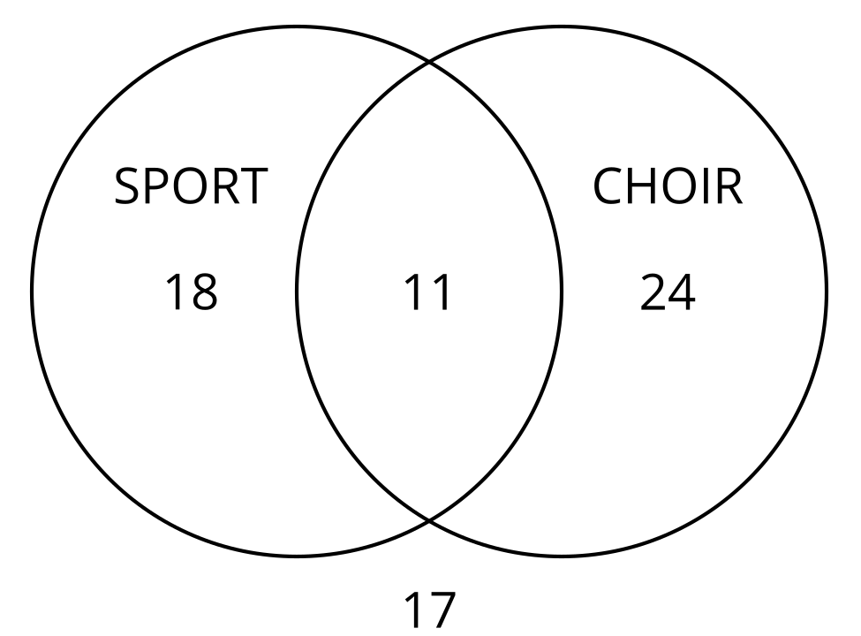

  - How many students play a school sport?
  - How many students play a school sport or are a member of the school choir?
  - How many students play a school sport and are a member of the school choir?
  - How many students are not a member of the school choir?
  - Name two ways to determine how many students play a sport.
- (From Unit 8, Lesson 5.)
© CC BY 2019 by Illustrative Mathematics®

