Lesson 4 Practice Problems
- Here are two expressions whose product is a new expression, $A$.
- 5x4+33x34x3−6=A
- Andre says that any real number can go in either of the boxes and $A$ will be a polynomial. Is he correct? Explain your reasoning.
- Lin divides the polynomial $2x^{2}−4x+1$ by 4 and gets $0.5x^{2}−x+0.25$. Is $0.5x^{2}−x+0.25$ a polynomial? Explain your thinking.
- What is the result when any 2 integers are multiplied?
  - a positive integer
  - a negative integer
  - an integer
  - an even number
- Clare wants to make an open-top box by cutting out corners of a 30 inch by 25 inch piece of poster board and then folding up the sides. The volume $V\left(x\right)$ in cubic inches of the open-top box is a function of the side length $x$ in inches of the square cutouts.
  - Write an expression for $V\left(x\right)$.
  - What is a reasonable domain for $V$ in this context?
- (From Unit 2, Lesson 1.)
- Identify the degree, leading coefficient, and constant value of each of the following polynomials.
  - $f\left(x\right)=2x^{5}−8x^{2}−x−6$
  - $h\left(x\right)=x^{3}−7x^{2}−x+2$
  - $g\left(x\right)=5x^{2}−4x^{3}+2x+5.4$
- (From Unit 2, Lesson 3.)
- Which point is a relative minimum?
- 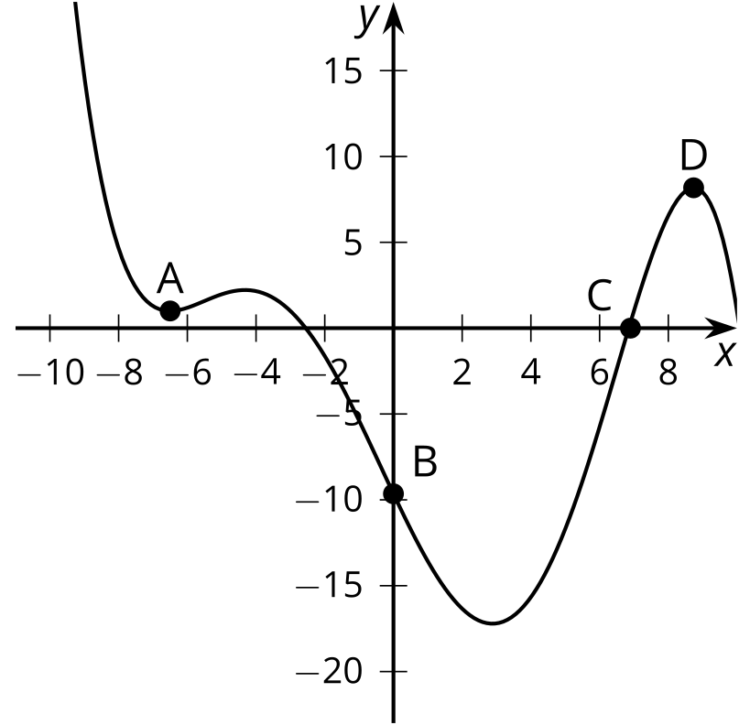
  - A
  - B
  - C
  - D
- (From Unit 2, Lesson 3.)
© CC BY 2019 by Illustrative Mathematics®

