## Unit 7 Lesson 12: Constructing the Coordinate Plane

### 1 English Winter (Warm up)

#### Student Task Statement

The following data were collected over one December afternoon in England.

|  |  |
| --- | --- |
| time after noon (hours) | temperature () |
| 0 | 5 |
| 1 | 3 |
| 2 | 4 |
| 3 | 2 |
| 4 | 1 |
| 5 | -2 |
| 6 | -3 |
| 7 | -4 |
| 8 | -4 |

1. Which set of axes would you choose to represent these data? Explain your reasoning.
2. Explain why the other two sets of axes did not seem as appropriate as the one you chose.

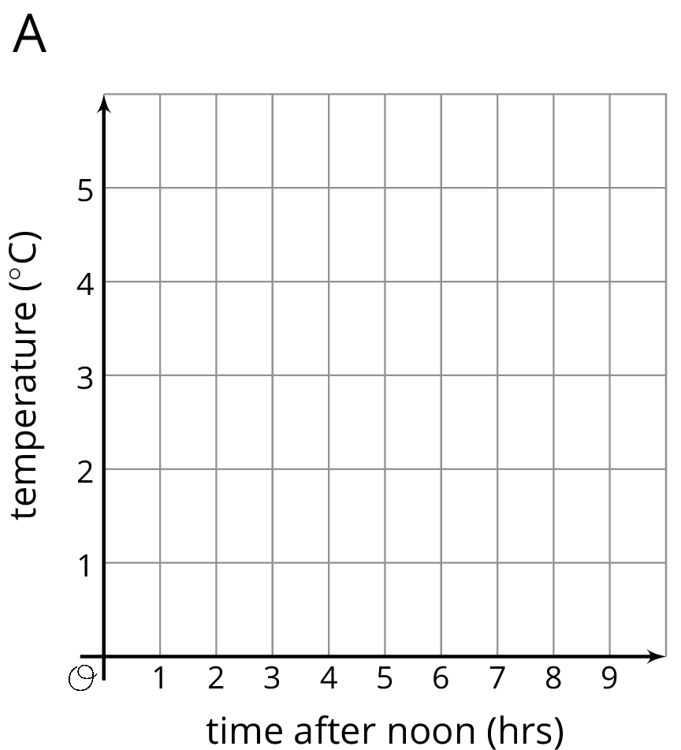

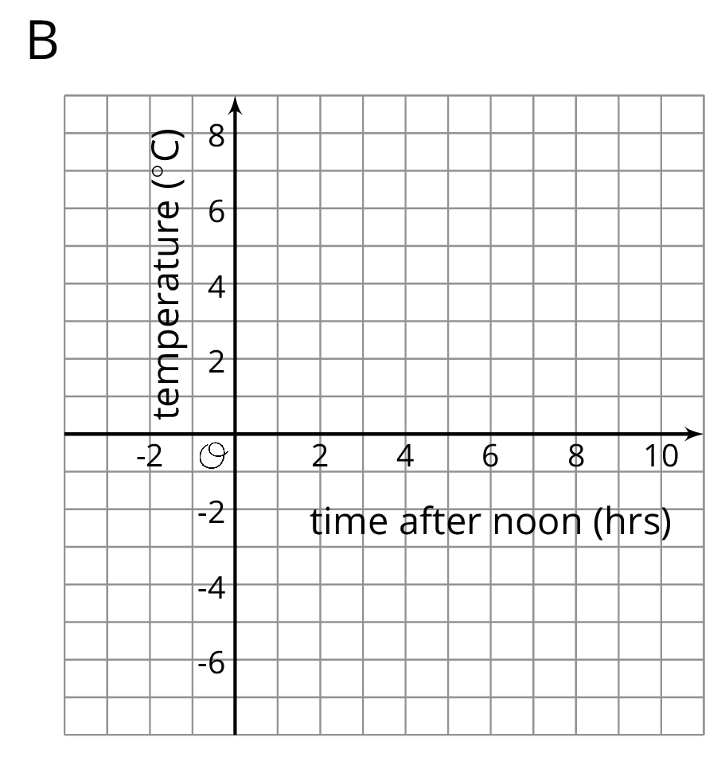

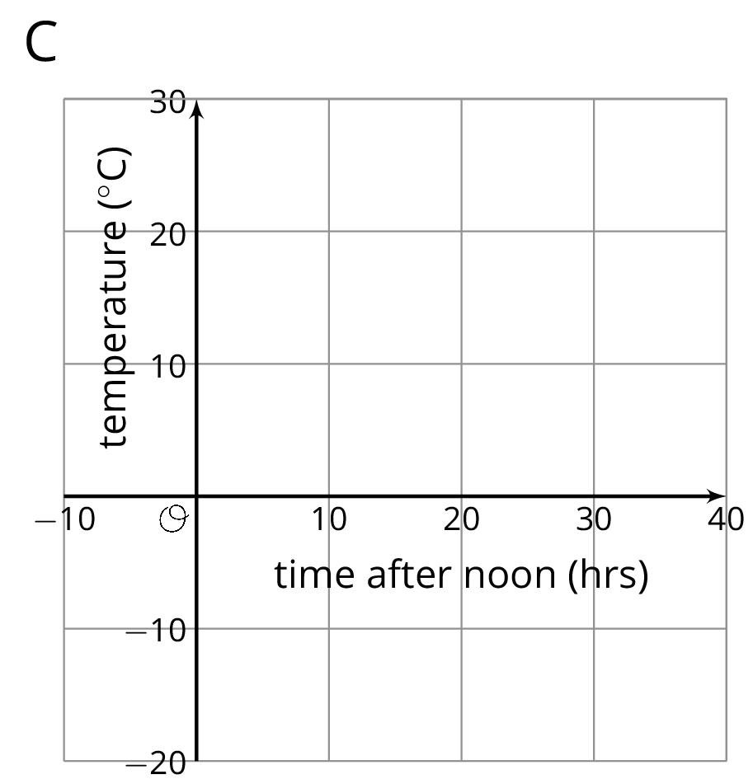

### 2 Axes Drawing Decisions

#### Student Task Statement

1. Here are three sets of coordinates. For each set, draw and label an appropriate pair of axes and plot the points.
   * 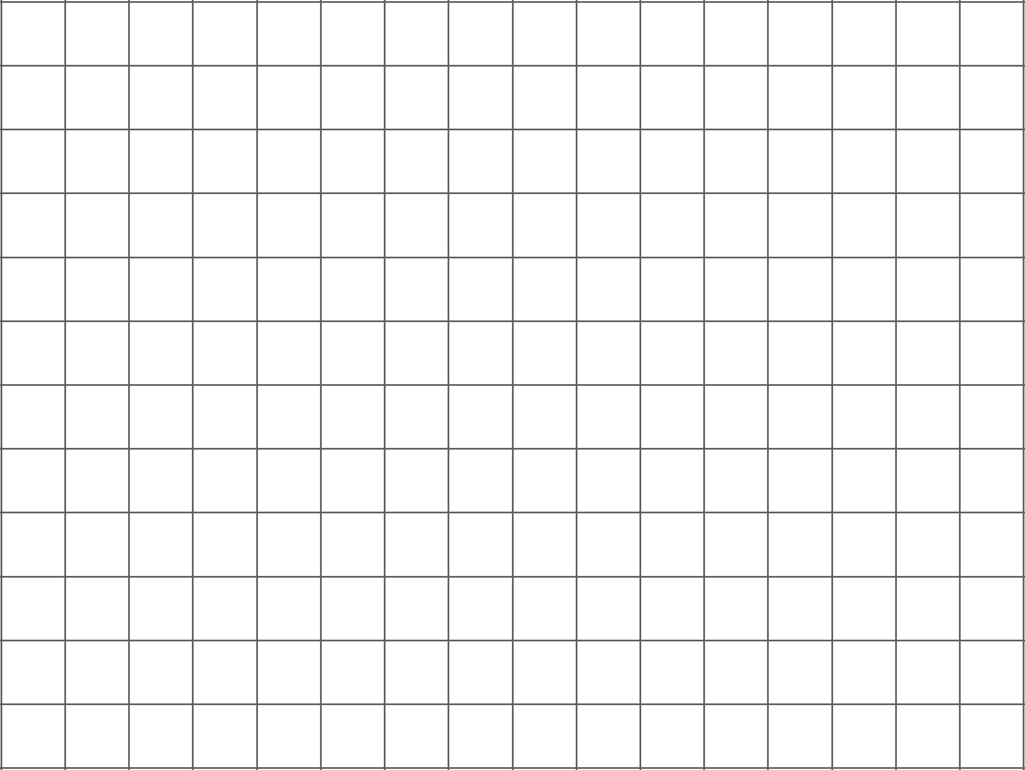
   * 
   * 
2. Discuss with a partner:
   * How are the axes and labels of your three drawings different?
   * How did the coordinates affect the way you drew the axes and label the numbers?

### 3 Positively A-maze-ing (Optional)

#### Student Task Statement

Here is a maze on a coordinate plane. The black point in the center is (0, 0). The side of each grid square is 2 units long.

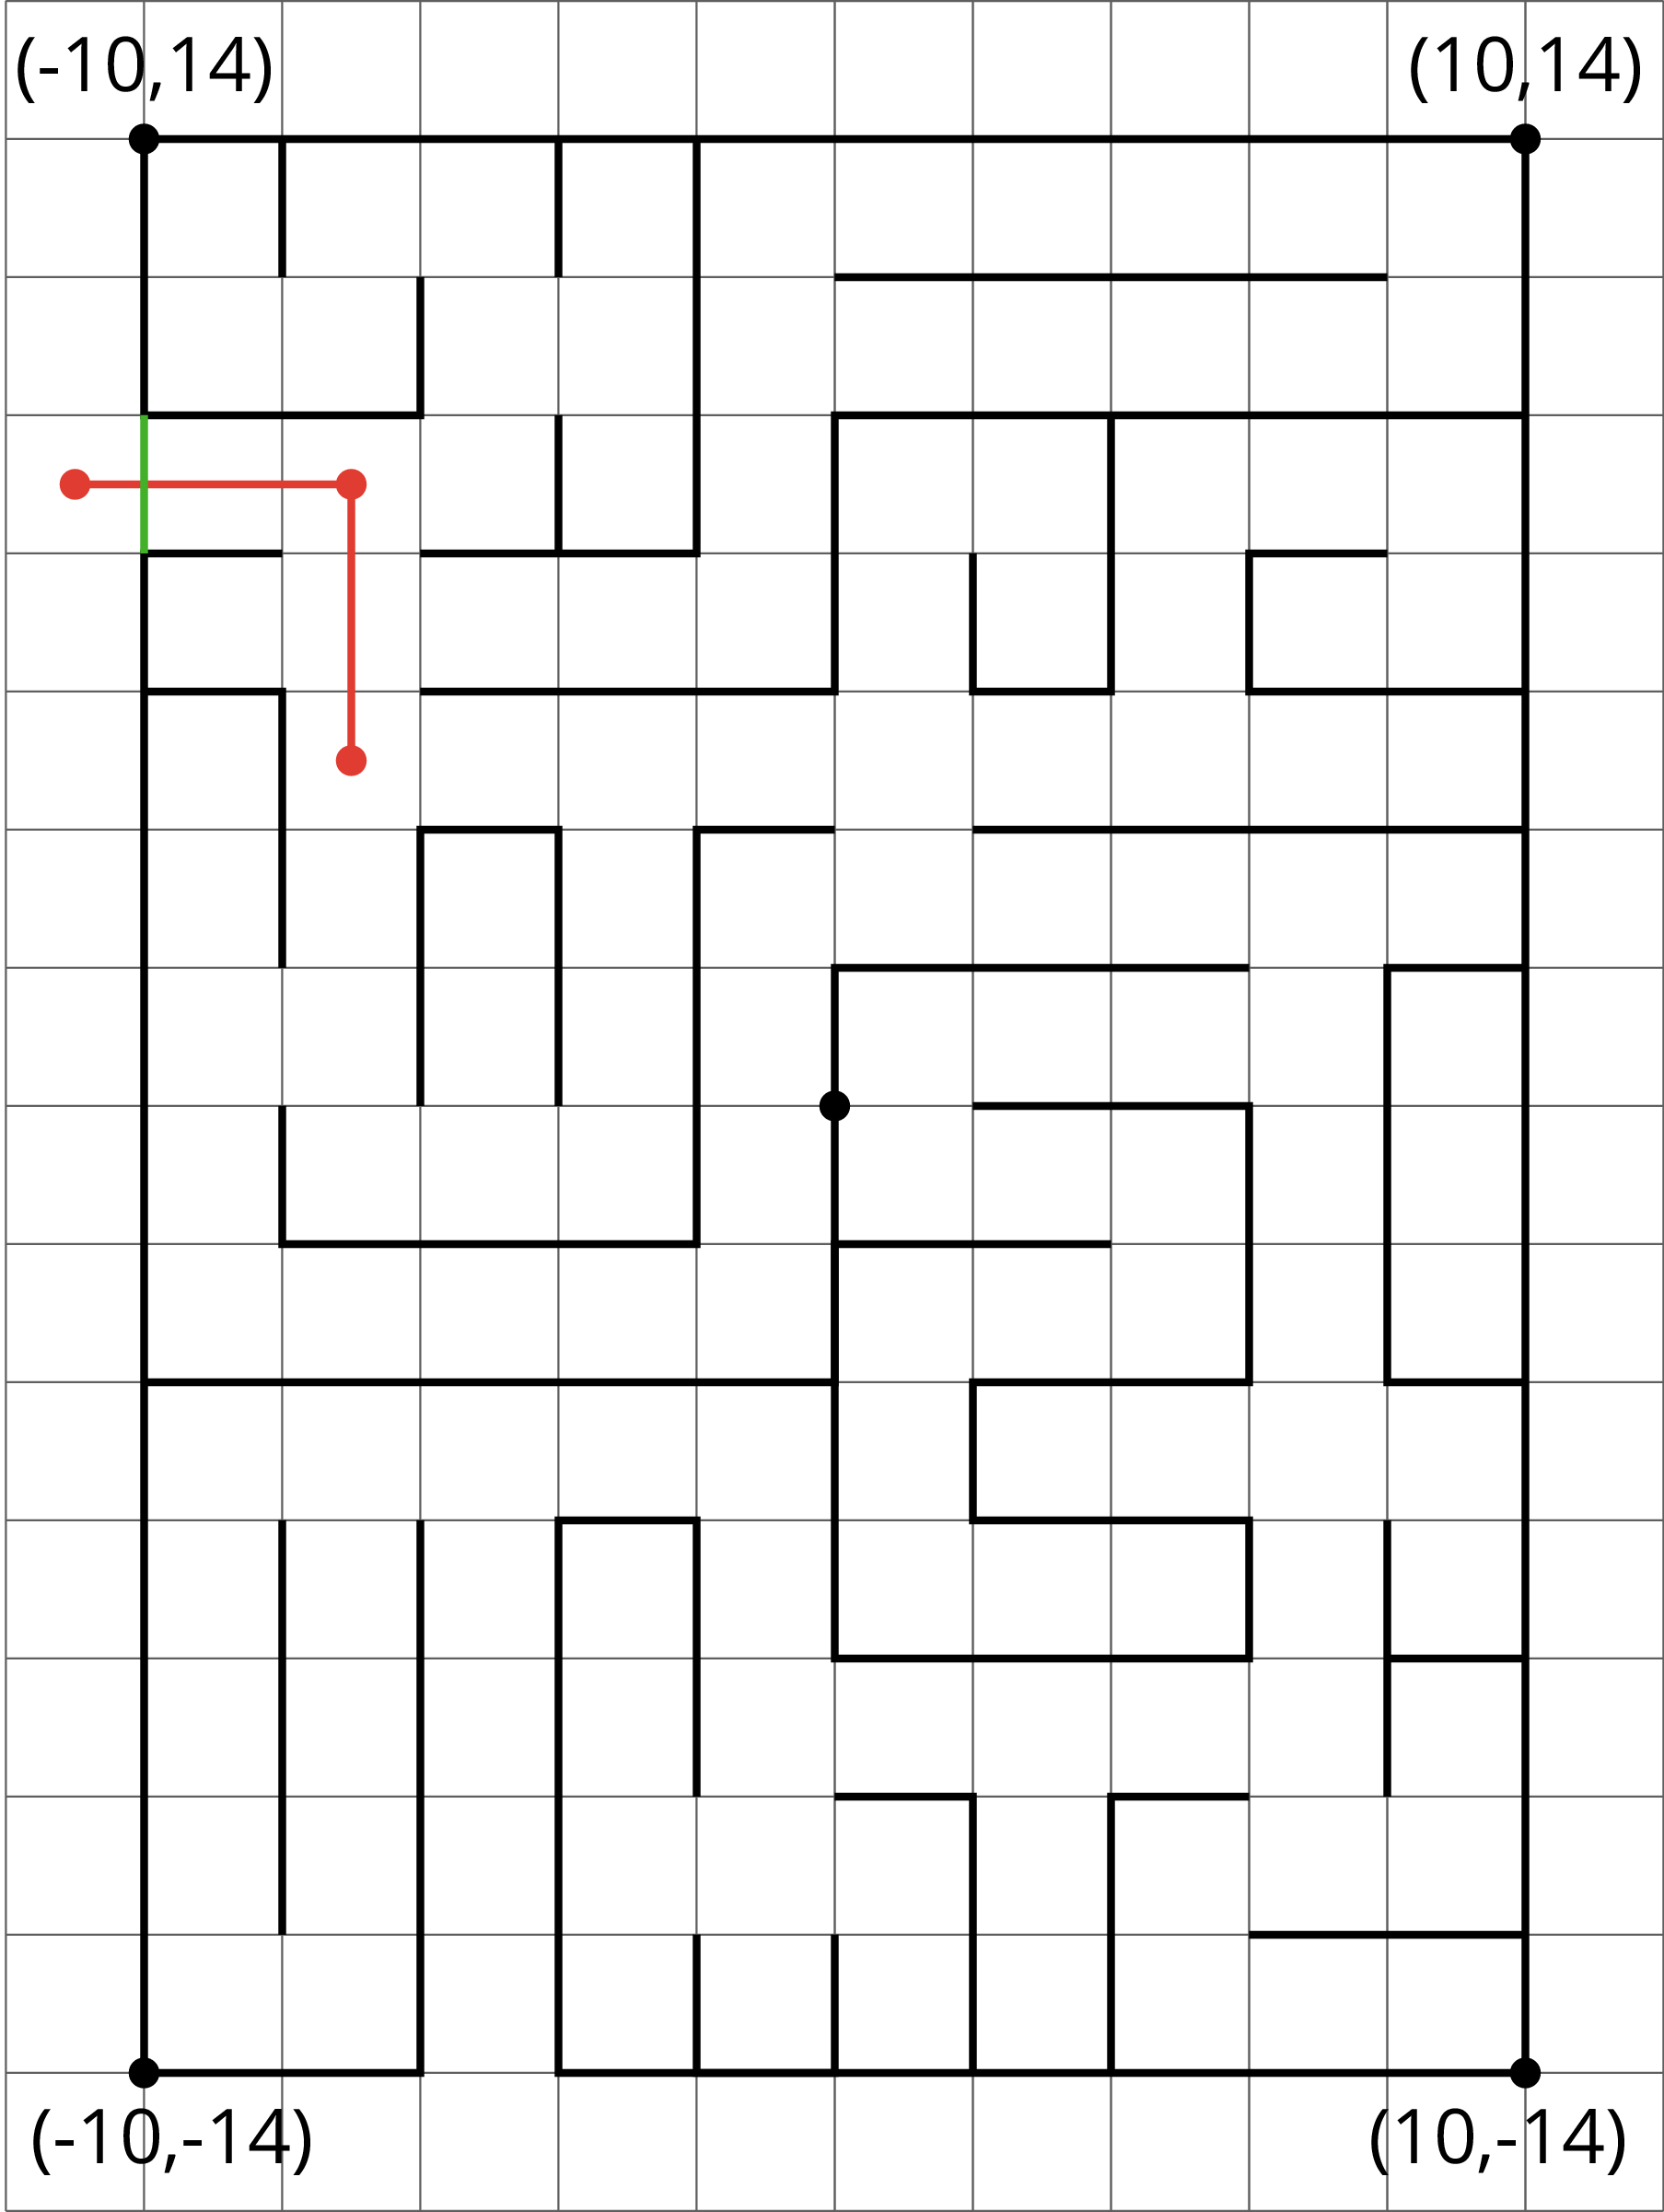

​

1. Enter the above maze at the location marked with a green segment. Draw line segments to show your way through and out of the maze. Label each turning point with a letter. Then, list all the letters and write their coordinates.
2. Choose any 2 turning points that share the same line segment. What is the same about their coordinates? Explain why they share that feature.



© CC BY Open Up Resources. Adaptations CC BY IM.