Unit 7 Lesson 12: Applications of Arithmetic with Powers of 10

1 What Information Do You Need? (Warm up)

Student Task Statement
What information would you need to answer these questions?
- How many meter sticks does it take to equal the mass of the Moon?
- If all of these meter sticks were lined up end to end, would they reach the Moon?

2 Meter Sticks to the Moon

Student Task Statement
- How many meter sticks does it take to equal the mass of the Moon? Explain or show your reasoning.
- Label the number line and plot your answer for the number of meter sticks.
- If you took all the meter sticks from the last question and lined them up end to end, will they reach the Moon? Will they reach beyond the Moon? If yes, how many times farther will they reach? Explain your reasoning.
- One light year is approximately ${10}^{16}$ meters. How many light years away would the meter sticks reach? Label the number line and plot your answer.

3 The “Science” of Scientific Notation

Images for Launch
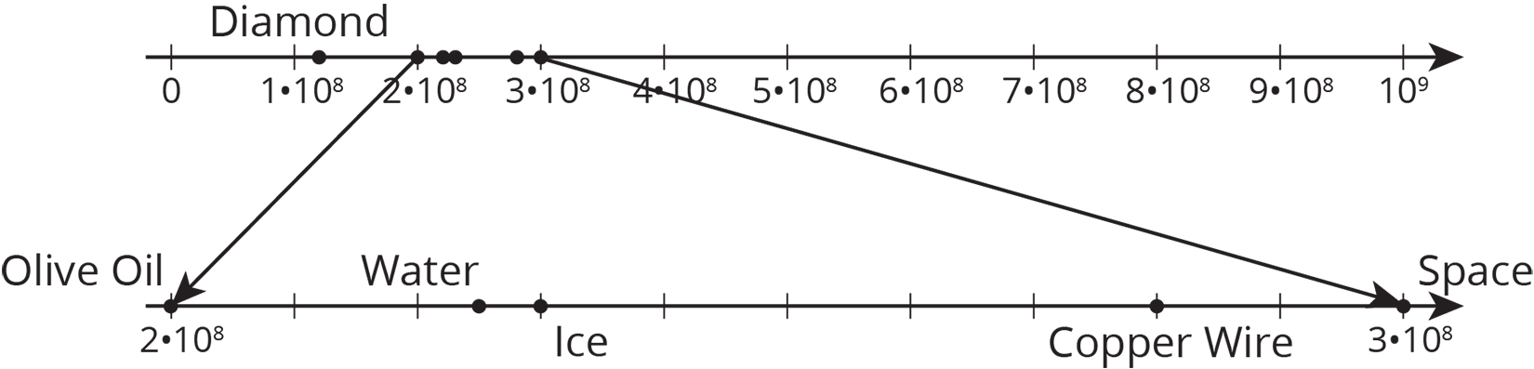

Student Task Statement
The table shows the speed of light or electricity through different materials.
material | speed (meters per second)
space | 300,000,000
water | $2.25×{10}^{8}$
copper (electricity) | 280,000,000
diamond | $124×{10}^{6}$
ice | $2.3×{10}^{8}$
olive oil | $0.2×{10}^{9}$
Circle the speeds that are written in scientific notation. Write the others using scientific notation.

4 Scientific Notation Matching

Student Task Statement
Your teacher will give you and your partner a set of cards. Some of the cards show numbers in scientific notation, and other cards show numbers that are not in scientific notation.
- Shuffle the cards and lay them facedown.
- Players take turns trying to match cards with the same value.
- On your turn, choose two cards to turn faceup for everyone to see. Then:
  - If the two cards have the same value and one of them is written in scientific notation, whoever says “Science!” first gets to keep the cards, and it becomes that player’s turn. If it’s already your turn when you call “Science!”, that means you get to go again. If you say “Science!” when the cards do not match or one is not in scientific notation, then your opponent gets a point.
  - If both partners agree the two cards have the same value, then remove them from the board and keep them. You get a point for each card you keep.
  - If the two cards do not have the same value, then set them facedown in the same position and end your turn.
- If it is not your turn:
  - If the two cards have the same value and one of them is written in scientific notation, then whoever says “Science!” first gets to keep the cards, and it becomes that player’s turn. If you call “Science!” when the cards do not match or one is not in scientific notation, then your opponent gets a point.
  - Make sure both of you agree the cards have the same value.
If you disagree, work to reach an agreement.
- Whoever has the most points at the end wins.
© CC BY Open Up Resources. Adaptations CC BY IM.

