Lesson 14 Practice Problems
- The number of letters received in the mail over the past week is recorded.
- 2 | - 3 | - 5 | - 5 | - 5 | - 15

- Which value appears to be an outlier?
  - 2
  - 3
  - 5
  - 15
- Elena collects 112 specimens of beetle and records their lengths for an ecology research project. When she returns to the laboratory, Elena finds that she incorrectly recorded one of lengths of the beetles as 122 centimeters (about 4 feet). What should she do with the outlier, 122 centimeters, when she analyzes her data?
- Mai took a survey of students in her class to find out how many hours they spend reading each week. Here are some summary statistics for the data that Mai gathered:
- mean: 8.5 hours
- standard deviation: 5.3 hours
- median: 7 hours
- Q1: 5 hours
- Q3: 11 hours
  - Give an example of a number of hours larger than the median which would be an outlier. Explain your reasoning.
  - Are there any outliers below the median? Explain your reasoning.
- The box plot shows the statistics for the weight, in pounds, of some dogs.
- 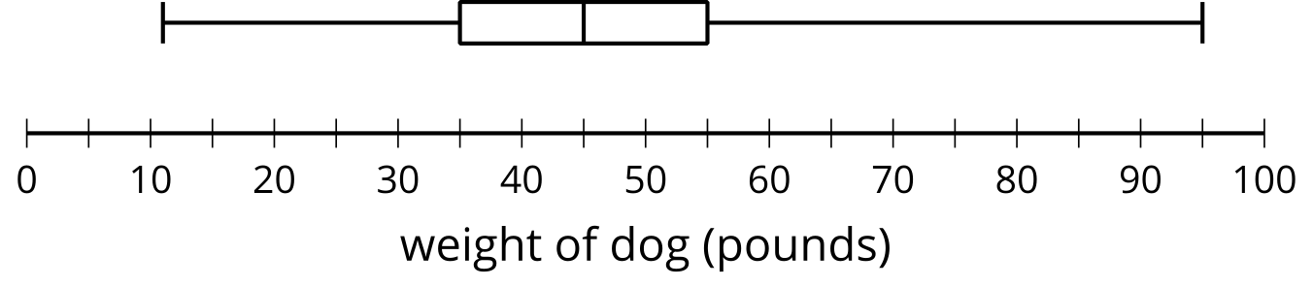
- Are there any outliers? Explain how you know.
- The mean exam score for the first group of twenty examinees applying for a security job is 35.3 with a standard deviation of 3.6.
- The mean exam score for the second group of twenty examinees is 34.1 with a standard deviation of 0.5. Both distributions are close to symmetric in shape.
  - Use the mean and standard deviation to compare the scores of the two groups.
  - The minimum score required to get an in-person interview is 33. Which group do you think has more people get in-person interviews?
- (From Unit 1, Lesson 13.)
- A group of pennies made in 2018 are weighed. The mean is approximately 2.5 grams with a standard deviation of 0.02 grams.
- Interpret the mean and standard deviation in terms of the context.
- (From Unit 1, Lesson 13.)
- These values represent the expected number of paintings a person will produce over the next 10 days.
- 0, 0, 0, 1, 1, 1, 2, 2, 3, 5
  - What are the mean and standard deviation of the data?
  - The artist is not pleased with these statistics. If the 5 is increased to a larger value, how does this impact the median, mean, and standard deviation?
- (From Unit 1, Lesson 12.)
- List the four dot plots in order of variability from least to greatest.
  - 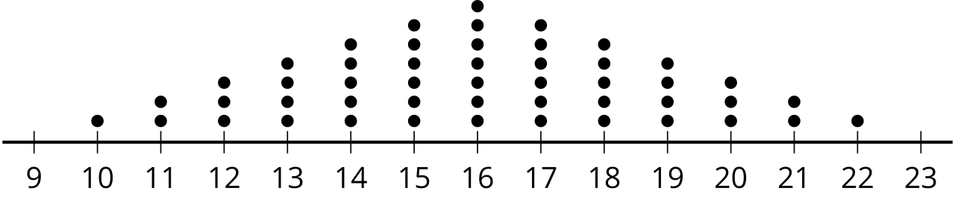
  - 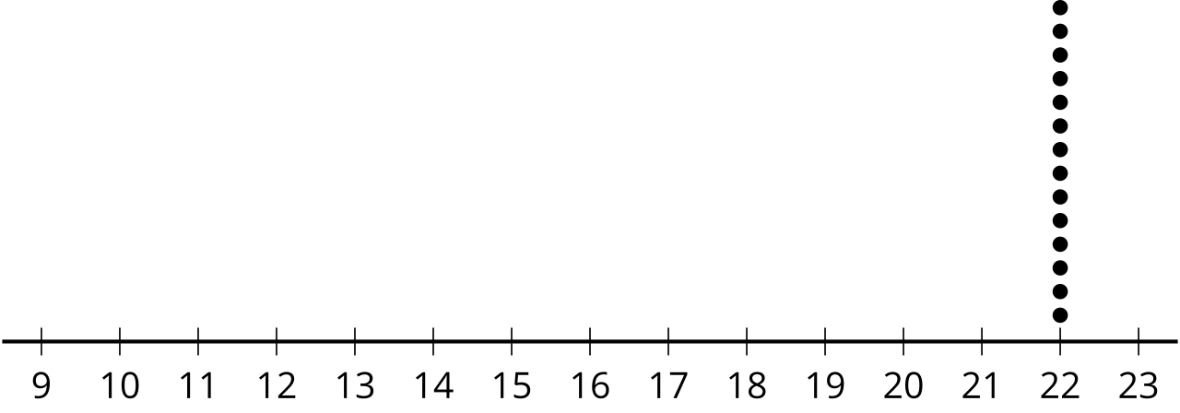
  - 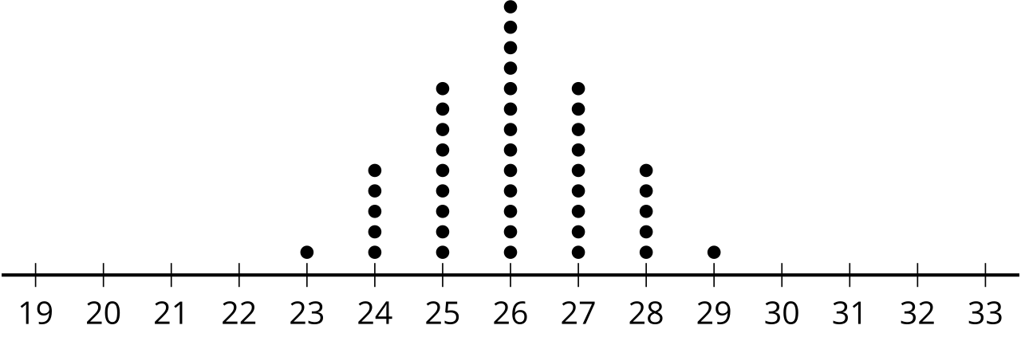
  - 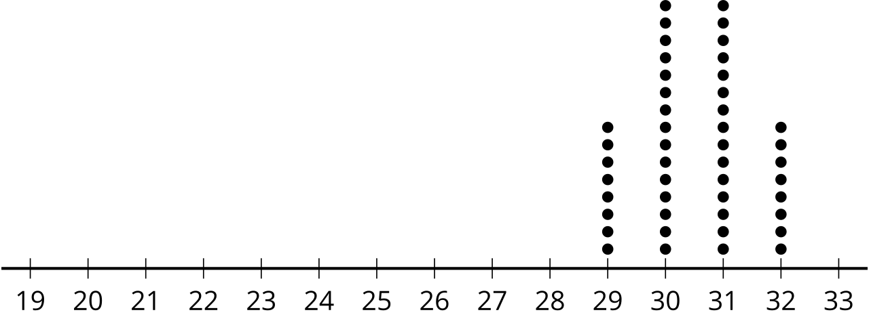
- (From Unit 1, Lesson 11.)
© CC BY 2019 by Illustrative Mathematics®

