Unit 6 Lesson 3: Building Quadratic Functions from Geometric Patterns

1 Quadratic Expressions and Area (Warm up)

Student Task Statement
Figure A is a large square. Figure B is a large square with a smaller square removed. Figure C is composed of two large squares with one smaller square added.

Figure A

Figure B
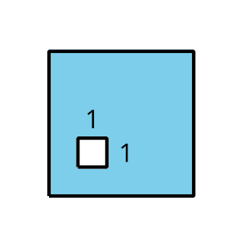

Figure C
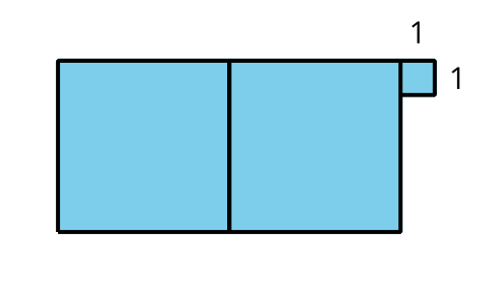
Write an expression to represent the area of each shaded figure when the side length of the large square is as shown in the first column.
side length of  large square | area of A | area of B | area of C
4
$x$
$4x$
$\left(x+3\right)$

2 Expanding Squares

Student Task Statement
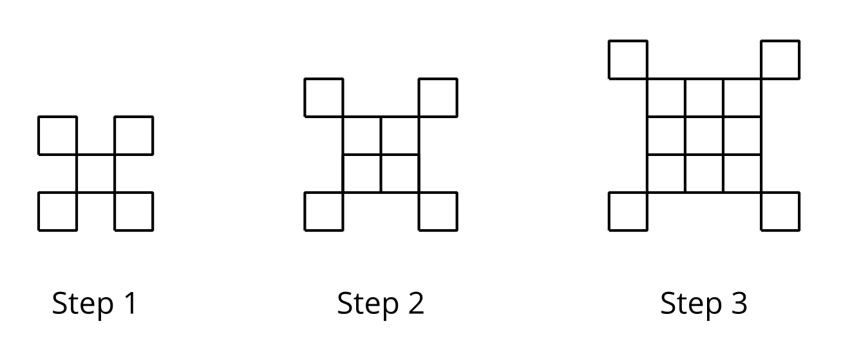
- If the pattern continues, what will we see in Step 5 and Step 18?
  - Sketch or describe the figure in each of these steps.
  - How many small squares are in each of these steps? Explain how you know.
- Write an equation to represent the relationship between the step number $n$ and the number of squares $y$. Be prepared to explain how each part of your equation relates to the pattern. (If you get stuck, try making a table.)
- Sketch the first 3 steps of a pattern that can be represented by the equation $y=n^{2}−1$.

3 Growing Steps

Student Task Statement
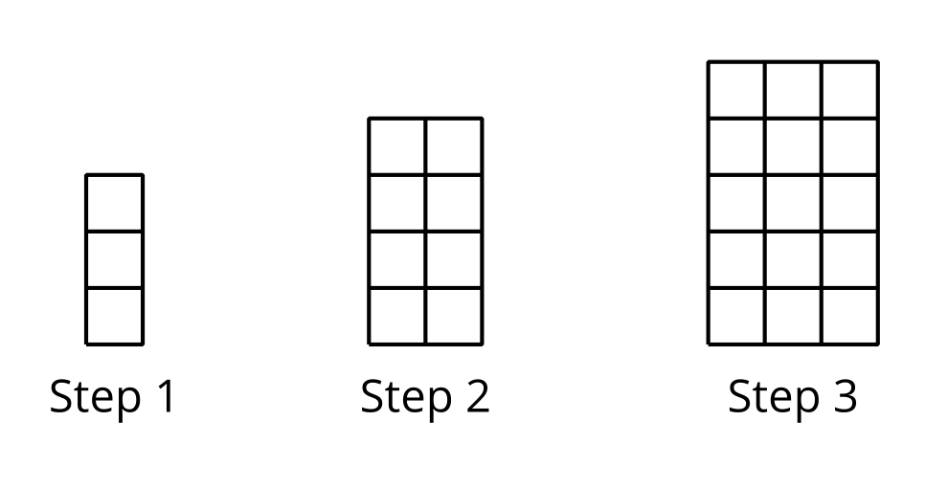
- Sketch the next step in the pattern.
- Kiran says that the pattern is growing linearly because as the step number goes up by 1, the number of rows and the number of columns also increase by 1. Do you agree? Explain your reasoning.
- To represent the number of squares after $n$ steps, Diego and Jada wrote different equations. Diego wrote the equation $f\left(n\right)=n\left(n+2\right)$. Jada wrote the equation $f\left(n\right)=n^{2}+2n$. Are either Diego or Jada correct? Explain your reasoning.
© CC BY 2019 by Illustrative Mathematics®

