Lesson 5 Practice Problems
- What is the measure of angle $A^{′}B^{′}C$?
- 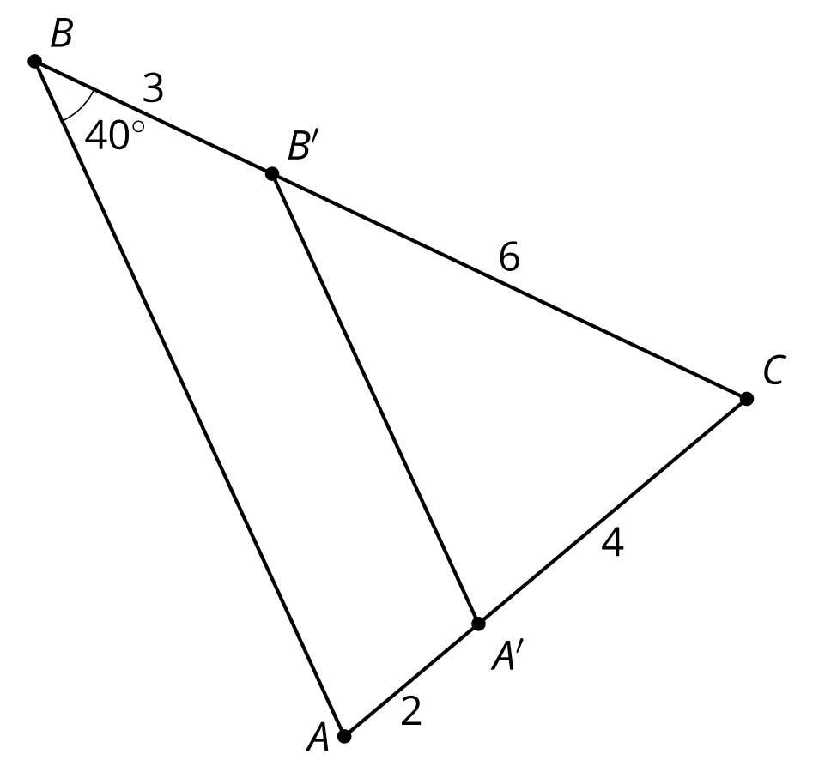
  - ${20}^{∘}$
  - ${40}^{∘}$
  - ${60}^{∘}$
  - ${80}^{∘}$
- Triangle $DEF$ is formed by connecting the midpoints of the sides of triangle $ABC$. The lengths of the sides of $DEF$ are shown. What is the length of $AB$?
- 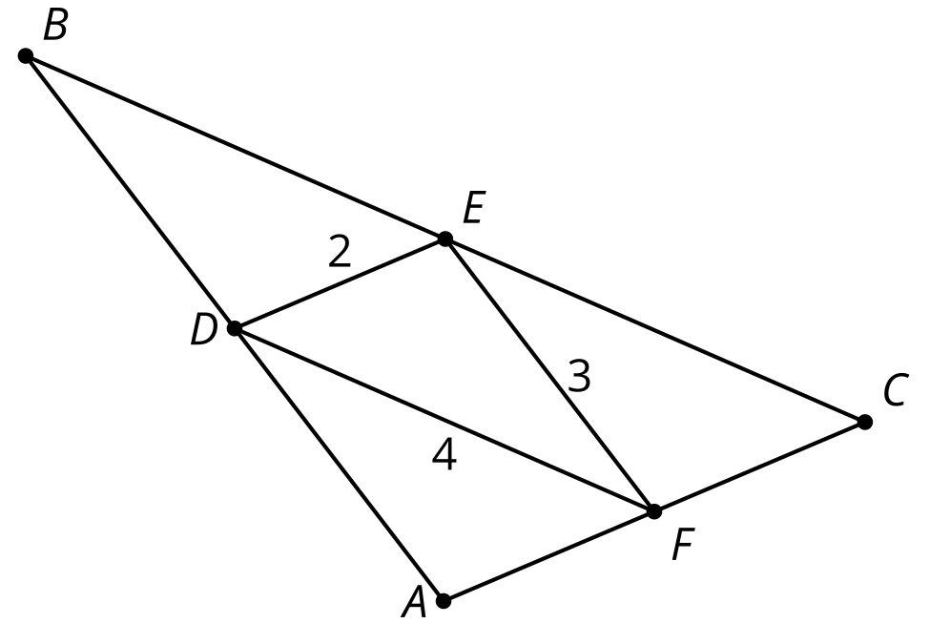
- Angle $ABC$ is taken by a dilation with center $P$ and scale factor $\frac{1}{3}$ to angle $A^{′}B^{′}C^{′}$. The measure of angle $ABC$ is ${21}^{∘}$. What is the measure of angle $A^{′}B^{′}C^{′}$?
- (From Unit 3, Lesson 4.)
- Draw 2 lines that could be the image of line $m$ by a dilation. Label the lines $n$ and $p$.
- 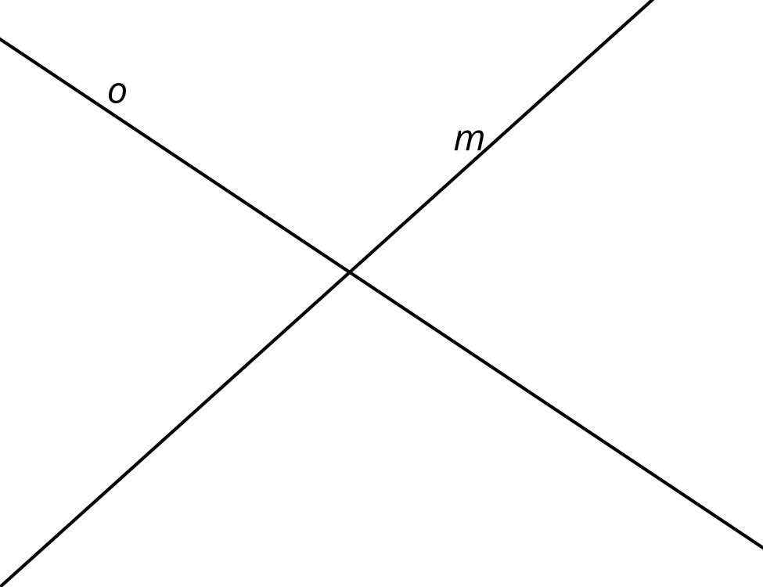
- (From Unit 3, Lesson 4.)
- Is it possible for polygon $ABCDE$ to be dilated to figure $VWXYZ$? Explain your reasoning.
- 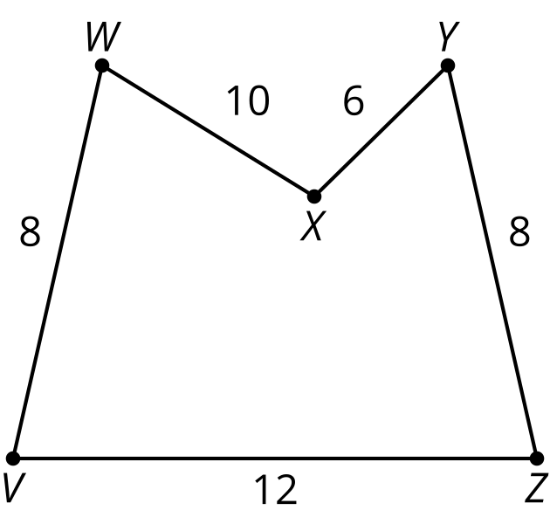
- 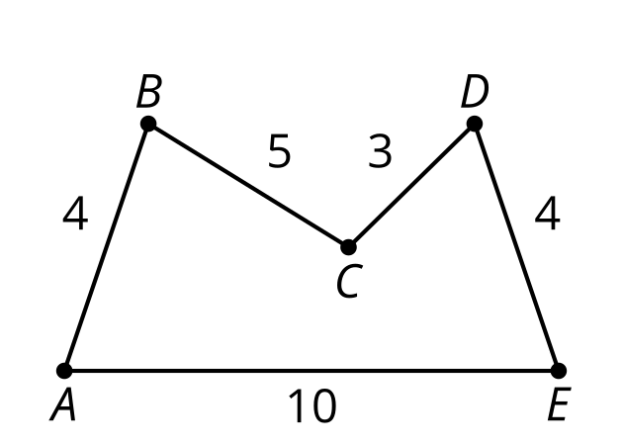

- (From Unit 3, Lesson 3.)
- Triangle $XYZ$ is scaled and the image is $X^{′}Y^{′}Z^{′}$. Write 2 equations that could be used to solve for $a$.
- 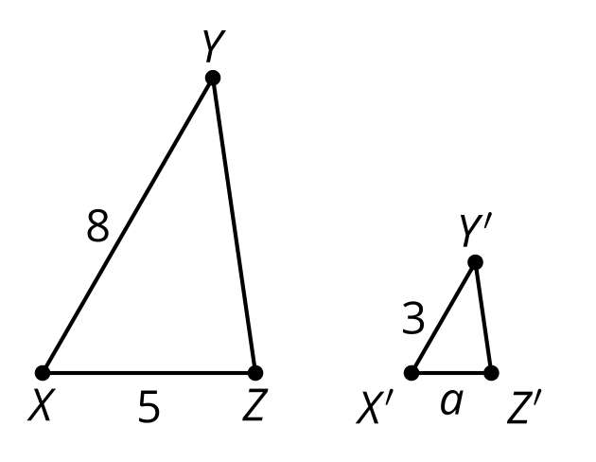
- (From Unit 3, Lesson 2.)

  - Lin is using the diagram to prove the statement, “If a parallelogram has one right angle, it is a rectangle.” Given that $EFGH$ is a parallelogram and angle $HEF$ is a right angle, write a statement that will help prove angle $FGH$ is also a right angle.
  - Han then states that the 2 triangles created by diagonal $EG$ must be congruent. Help Han write a proof that triangle $EHG$ is congruent to triangle $GFE$.
- 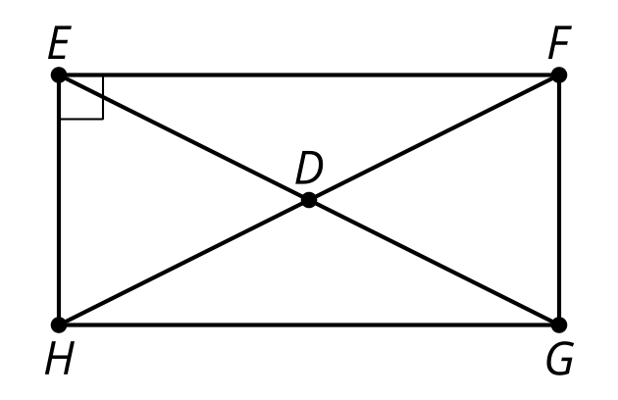
- (From Unit 2, Lesson 12.)
© CC BY 2019 by Illustrative Mathematics®

