Lesson 5 Practice Problems
- 50 students were asked two survey questions:
  - Do you have a dog?
  - Do you have a cat?
- Their responses are summarized in the Venn diagram.
- 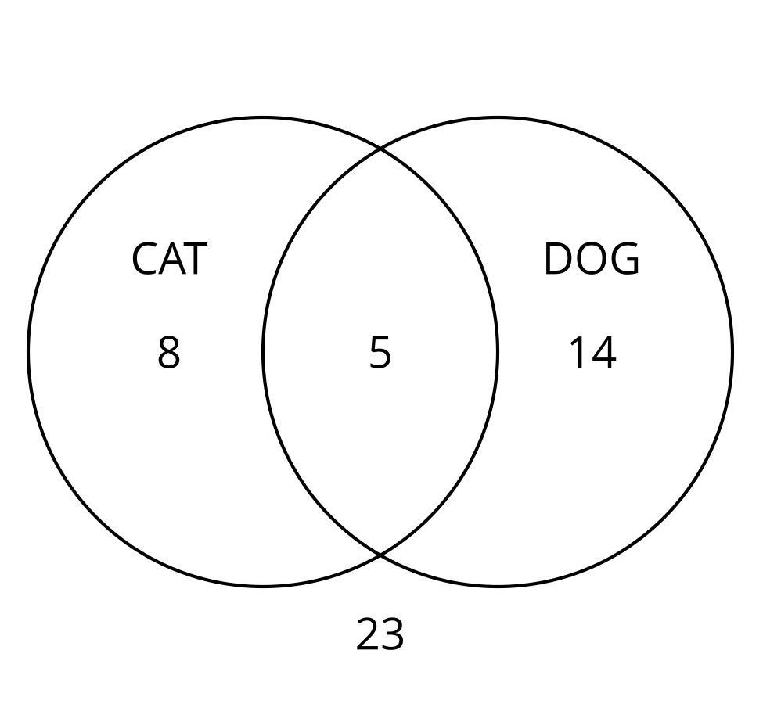
  - How many students have a cat?
  - How many students have a cat or a dog?
  - How many students have a cat and a dog?
  - How many students do not have a cat?
  - How many students do not have a cat or a dog?
- In the Venn diagram, the circle on the left represents all the whole numbers between 1 and 12 that are multiples of 2. The circle on the right represents all the numbers between 1 and 12 that are multiples of 3.
- 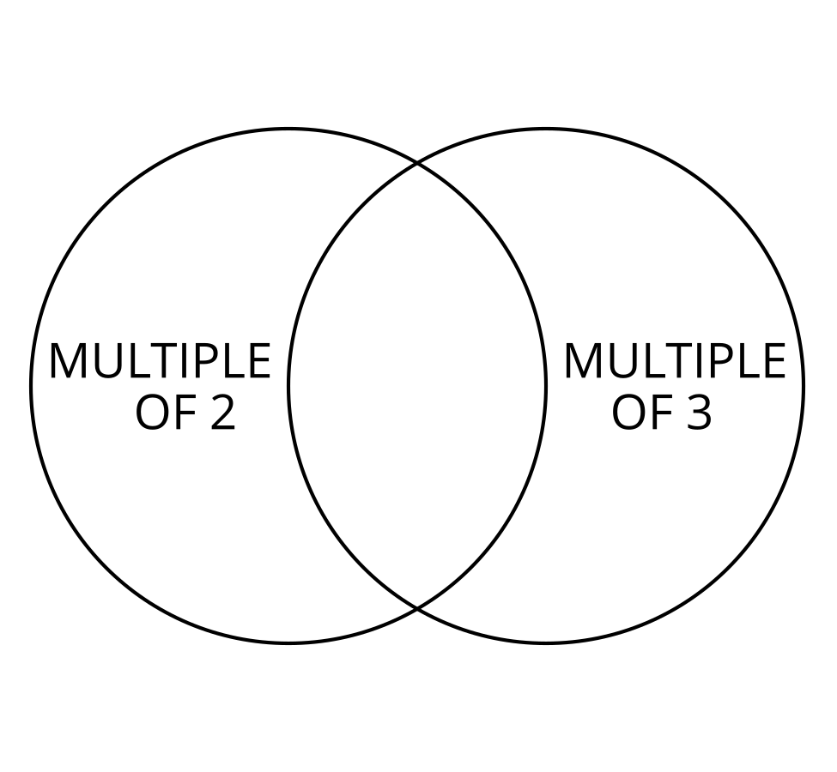
  - Which numbers are multiples of 2?
  - Which numbers are multiples of 3?
  - Which numbers belong in the region where the two circles overlap? Explain your reasoning.
  - Which whole numbers between 1 and 12 are not contained inside either circle in the Venn diagram?
  - What is the probability that a whole number between 1 and 12, selected at random, is a multiple of two or three?
  - What is the probability that a whole number between 1 and 12, selected at random, is not a multiple of 2?
- Two classes of elementary school students are going on a field trip, and they will be provided with a snack. Each student selects one snack option. The table summarizes the snack preference of each student in the class.
 | - apple | - carrot sticks | - peach slices
- class A | - 4 | - 6 | - 12
- class B | - 7 | - 3 | - 14
  - What is the probability that a student selected at random prefers peach slices as a snack?
  - What is the probability that a student selected at random prefers an apple or carrot sticks as a snack?
  - What is the probability that a student in class A selected at random prefers an apple as a snack?
  - What is the probability that a student selected at random is in class B and prefers carrot sticks as a snack?
- The table shows the results from a survey that asked 200 adults if they had a college diploma and if their annual income was more than $40,000.
 | - $40,000 or less | - more than $40,000
- college diploma | - 44 | - 101
- no college diploma | - 27 | - 28
- A person who took the survey is selected at random.
  - What is the probability that the person has a college diploma and makes $40,000 or less?
  - What is the probability that the person doesn't have a college diploma and earns more than $40,000?
- (From Unit 8, Lesson 4.)
- The table shows data from a science fair experiment that studied the average growth rate of 20 samples of fungus at 70 degrees Fahrenheit and 20 samples of fungus at 80 degrees Fahrenheit.
 | - 70 degrees | - 80 degrees
- above average growth rate | - 3 | - 8
- average growth rate | - 12 | - 11
- below average growth rate | - 5 | - 1
  - What percentage of the samples had an above average growth rate?
  - What percentage of the samples at 70 degrees had an above average growth rate?
  - What percentage of the samples were at 80 degrees?
  - What percentage of the samples that had an average growth rate were at 80 degrees?
- (From Unit 8, Lesson 4.)
- Here is a central angle that measures 1.5 radians.
- Select the statement that must be true.
- 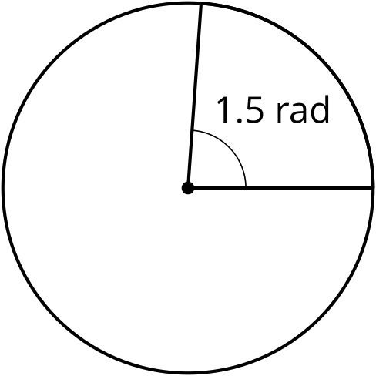
  - The area of the whole circle is 1.5 times the area of the slice.
  - The circumference of the whole circle is 1.5 times the length of the arc formed by the angle.
  - The length of the arc defined by the angle is 1.5 times longer than the radius.
  - The length of the arc is $1.5π$ units.
- (From Unit 7, Lesson 11.)
© CC BY 2019 by Illustrative Mathematics®

