Lesson 10: Represent Volume with Expressions

Standards Alignments
Addressing | 5.MD.C.5, 5.MD.C.5.c, 5.OA.A.1, 5.OA.A.2

Teacher-facing Learning Goals
- Write and interpret numerical expressions to represent the volume of a figure decomposed in different ways.

Student-facing Learning Goals
- Let’s write expressions for the volume of figures.

Lesson Purpose
The purpose of this lesson is for students to write, interpret, and evaluate numerical expressions that represent the volume of solid figures composed of two right rectangular prisms.
In previous lessons, students used formulas to find the volume of right rectangular prisms. They also learned to apply these formulas to find the volumes of figures made up of two non-overlapping right rectangular prisms. In this lesson, students use what they have learned to write and interpret numerical expressions in the context of finding the volume of figures composed of rectangular prisms (MP2).
Students recognize that subtraction can be used to find the volume of figures composed of two non-overlapping rectangular prisms.

Access for:

Students with Disabilities
- Action and Expression (Activity 2)

English Learners
- MLR8 (Activity 1)

Instructional Routines
5 Practices (Activity 2), Notice and Wonder (Warm-up)

Lesson Timeline
Warm-up | 10 min
Activity 1 | 10 min
Activity 2 | 25 min
Lesson Synthesis | 10 min
Cool-down | 5 min

Teacher Reflection Question
How did the work of the previous sections in the unit lay the foundation for students to be successful in this lesson?

Cool-down
(to be completed at the end of the lesson) 5min
Expressions as Volume

Standards Alignments
Addressing | 5.MD.C.5.c, 5.OA.A.2

Student-facing Task Statement
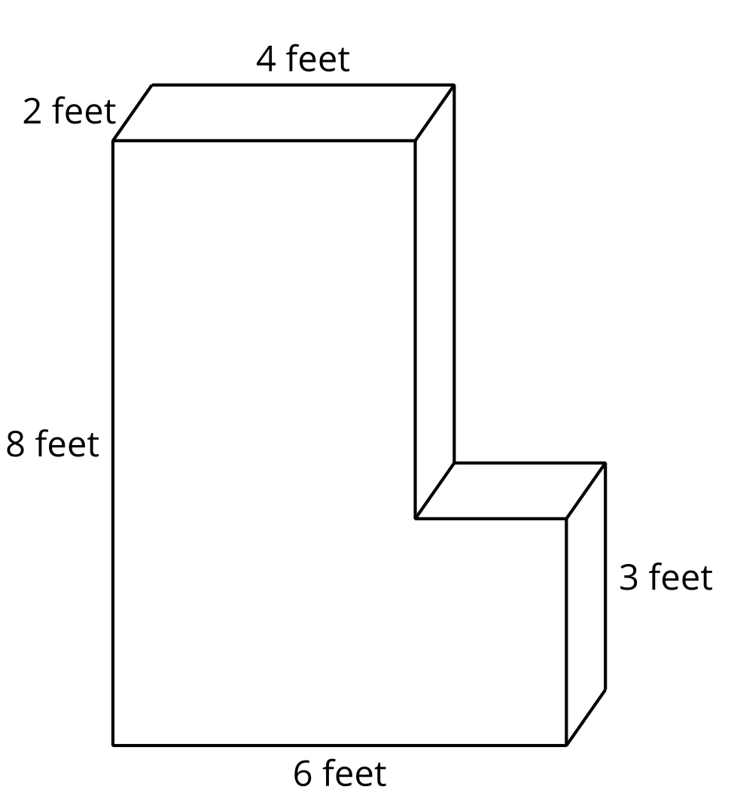
- Write an expression to represent the volume of the figure in cubic feet.
- Find the volume of the figure.

Student Responses
- $\left(4×8×2\right)+\left(2×3×2\right)$ or $\left(4×5×2\right)+\left(6×3×2\right)$ (or equivalent)
- 76 cubic feet

